Please remember to show ALL of your work on every problem.

Write the augmented matrix for the system. Do not solve the system.

1) 7x - 2y = 36
8x + 9y = 75

Use the Gauss-Jordan elimination method to solve the system of equations.

2) -2x - 7y = -5
-8x - 28y = 4

Use the Gauss-Jordan elimination method to solve the system of equations.

3) -6x + 6y = -36
3x - 3y = 18

Use the Gauss-Jordan elimination method to solve the system of equations.
4) 2x + 5y = -7
-6x - 15y = 21

For the following problem, set up the augmented matrix that describes the situation, and solve for the
desired solution.
5) John has a jarful of quarters and nickels. There are 104 coins in the jar. The value of the coins is $16.60. How many of each type of coin are there?

Graph the inequality and show (shade in) solution region.

6) 2y < - 4
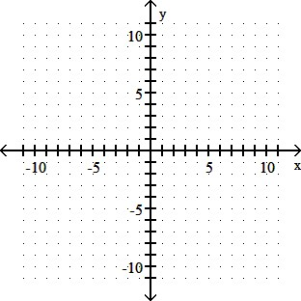

Graph the inequality and show (shade in) solution region.

7) x + 2y ≥ 6

Graph the inequality and show (shade in) solution region.

8) -2y + 4x ≤ 8

Graph the system of inequalities. Show (by shading in) the feasible region.

9) – x – y < 5 , x < 2y

Graph the system of inequalities. Show (by shading in) the feasible region. Identify the ordered-pair “corner points” that define the feasible region.

10) 3x + y ≥ 6, x + 2y ≥ 7, x ≥ 0, y ≥ 0

