MATH 107 QUIZ 2 September, 2016 Instructor: S. Sands
NAME: _______________________________
I have completed this assignment myself, working independently and not consulting anyone except the instructor.

INSTRUCTIONS
- The quiz is worth 100 points. There are 10 problems. This quiz is open book and open notes. This means that you may refer to your textbook, notes, and online classroom materials, but you must work independently and may not consult anyone (and confirm this with your submission). You may take as much time as you wish, provided you turn in your quiz no later than Sunday, September 11.
- Show work/explanation where indicated. Answers without any work may earn little, if any, credit. You may type or write your work in your copy of the quiz, or if you prefer, create a document containing your work. Scanned work is acceptable also. In your document, be sure to include your name and the assertion of independence of work.
- General quiz tips and instructions for submitting work are posted in the Quizzes module.
- If you have any questions, please contact me by e-mail or phone (540-338-7120).
1. (4 pts) Which of these graphs of relations describe y as a function of x?
That is, which are graphs of functions? Answer(s): ____________
(no explanation required.) (There may be more than one graph which represents a function.)

(A)  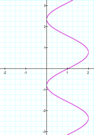 | (B)  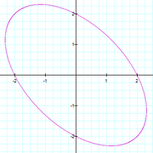 | (C)  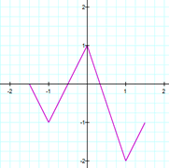 | (D)  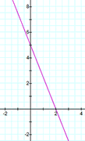

2. (10 pts) Consider the points (–7, 6) and (3, – 4).
(a) State the midpoint of the line segment with the given endpoints. (No work required)

(b) If the point you found in (a) is the center of a circle, and the other two points are points on the circle, find the length of the radius of the circle. (That is, find the distance between the center point and a point on the circle.) Find the exact answer and simplify as much as possible. Show work.

3. (12 pts) Consider the following graph. (no explanations required)

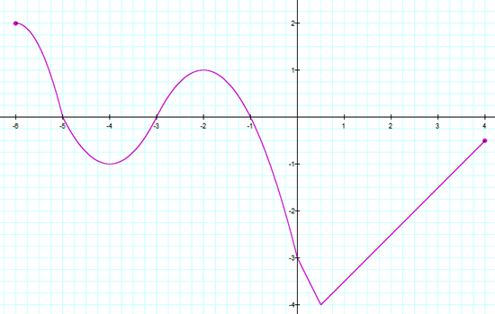 | (a) State the x-intercept(s).  (b) State the y-intercept(s).  (c) State the domain.  (d) State the range.

4. (8 pts) Let $f\left(x\right)$ = $\frac{x - 3}{x^{2}- 7x }$

(a) Calculate $f\left(2\right)$. (work optional)

(b) State the domain of the function $f\left(x\right)$ = $\frac{x - 3}{x^{2}- 7x }$

(c) Find $f\left(3a\right)$ and simplify as much as possible. Show work.

5. (7 pts) f is a function that takes a real number x and performs these three steps in the order given:
(1) Take the square root.
(2) Subtract 2 from the result.
(3) Take the reciprocal of the result.
(That is, make the quantity the denominator of a fraction with numerator 1.)

(a) Find an expression for f (x). (no explanation required)

(b) State the domain of f. (no explanation required)

6. (6 pts) Given $f\left(x\right)=x+1$ and $g\left(x\right)=\left|x\right|-5$, which of the following is the domain of the quotient function? Explain. 6._______
A. $\left(-∞, 5\right)∪\left(5, ∞\right)$
B. $\left(-∞, -5\right)∪\left(-5, 5\right)∪\left(5, ∞\right)$
C. $\left(-∞, -5\right)∪\left(-5, -1\right)∪\left(-1, 5\right)∪\left(5, ∞\right)$
d. $\left(-∞, -1\right)∪\left(-1, ∞\right)$

7. (6 pts) For income x (in dollars), a particular state's income tax T (in dollars) is given by

$$T\left(x\right)=\left\{\begin{matrix}0.012x & if 0 ≤x≤2,000 \\ 24+0.028(x-2,000) & if 2,000<x≤6,000 \\ 136+0.042(x-6,000) & if x>6,000\end{matrix}\right.$$

(a) What is the tax on an income of $5,500? Show some work.

(b) What is the tax on an income of $55,000? Show some work.

8. (20 pts) Let y = 4 − 4x².

(a) Find the y-intercept(s) of the graph of the equation, if any exist. (work optional)

(b) Find the x-intercept(s) of the graph of the equation, if any exist. (work optional)

(c) Create a table of sample points on the graph of the equation (include at least five points), and use them to help create a graph of the equation. (You may use the grid shown below, hand-draw and scan, or you may use the free Desmos graphing calculator described under Course Resource to generate a graph, save as a jpg and attach.)

x | y | (x, y)

(d) Is the graph symmetric with respect to the x-axis? _____ (yes or no). If no, state a point on the graph and state the appropriate reflection point which fails to be on the graph, as done in section 1.2 homework in the textbook.

(e) Is the graph symmetric with respect to the y-axis? _____ (yes or no). If no, state a point on the graph and state the appropriate reflection point which fails to be on the graph, as done in section 1.2 homework in the textbook.

(f) Is the graph symmetric with respect to the origin? _____ (yes or no). If no, state a point on the graph and state the appropriate reflection point which fails to be on the graph, as done in section 1.2 homework in the textbook.

9. (12 pts) Let f (x) = 5x² + 4x – 9 and g(x) = 1 – x.

(a) Evaluate the function g – f for x = –1. That is, find (g – f)(–1). Show work.

(b) Evaluate the function fg for x = –1. That is, find (f g)( –1). Show work.

(c) Find the difference function (f – g)(x) and simplify the results. Show work.

10. (15 pts) (See textbook page 82 for definitions of the economic functions used in this problem.)
The cost, in dollars, for a company to produce x widgets is given by C(x) = 1400 + 7x for
x ≥ 0, and the price-demand function, in dollars per widget, is p(x) = 16 − 0.01x for 0 ≤ x ≤ 1600.

(a) Find and interpret C(400).

(b) Find and interpret $\overline{C}$(400). (Note that $\overline{C}$(x) is the average cost function.)

(c) Find and simplify the expression for the revenue function R(x). (work optional)

(d) Find and simplify the expression for the profit function P(x). (work optional) Note that p(x) and P(x) are different functions.

(e) Find and interpret P(400), where P(x) is the profit function in part (d).

