1. Two 0.1 kg-masses are connected to a linear spring on a frictionless table. The center of mass of the 2-particle system is stationary. At the instant shown, the velocity is v¯1 = v¯2 = 0.1eˆr + 2.5eˆθ m/s and r=0.5 m. The spring constant, K=10 N/m, and the spring applies no force when the masses are at the origin, so F=2Kr.
a. Determine the maximum and minimum distances to the origin (rmin and rmax)
b. Determine the speed at these points, |v|, when r = rmin and when r = rmax
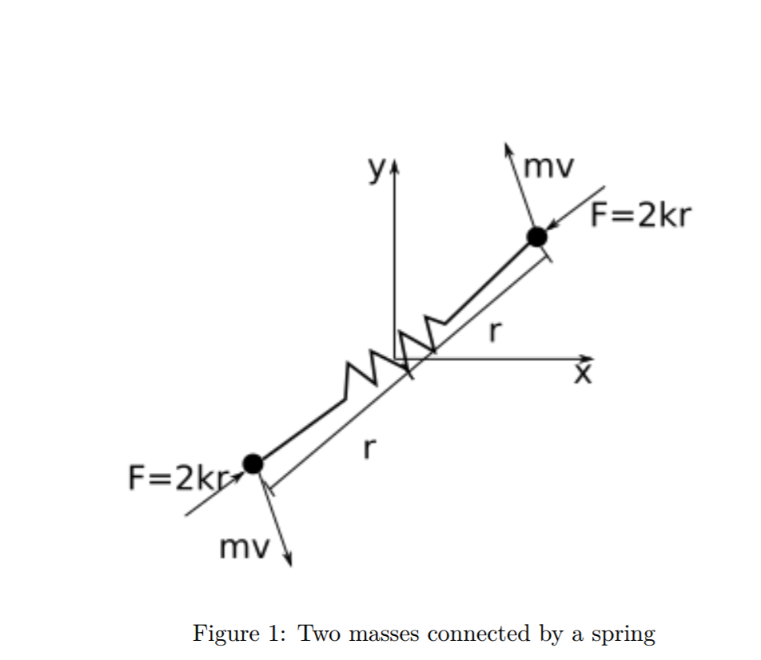

4. Two masses are connected by a 0.4-m-massless cord. Mass B is released when mass A is 135o from the horizontal axis and rotating at ω=-23.57 rad/s. There is a wall 10 m away from the center of mass, G, when the system was released. Mass A is 0.125 kg and mass B is 0.375 kg.
a. What is the angle of the cord when the center of mass is at its maximum height?
b. Which mass will impact the wall first?

