Assignment: Circle Equation Applications

Follow the directions to solve each problem. Show all work leading to your answer. Write explanations for your answers using complete sentences.

Suppose a telecommunications company has hired you as a consultant to test the coverage of their wireless network in a certain U.S. county. The company currently has cell phone towers in the locations described in the table below.

Cell phone radio towers broadcast a cell phone signal in a circular pattern. Think about how you could use the equation and graph of a circle to solve these problems.

Tower | Location | Coverage  Radius
A | Dale | 4 miles
B | 5 miles east  and 4 miles north of Dale | 3 miles
C | 4 miles east  and 4 miles south of Dale | 5 miles

Tower A is positioned in the town of Dale, which is in the center of the county.

1. On the coordinate plane below, graph and label the coverage circle for towers B and C. Label
Dale as the center of tower A’s coverage circle. Assume that each square on the graph
represents one mile. Moving in a positive direction on the x-axis shows movement to the east and
moving in a positive direction on the y-axis show movement to the north.

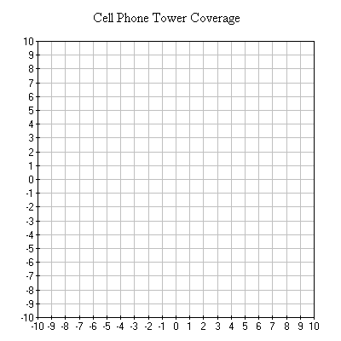

2. Write the general form equation for a circle that represents the coverage radius for each of the three towers. Hint: Start by writing the standard form equation for each circle and then transforming each equation into general form.

3. Other towns around Dale are listed in the table below. The location of each town is given in terms of miles and compass directions from Dale. Plot and label each town on the coordinate plane with the coverage circles of towers A, B, and C from problem 1.

Town | Directions from Dale
Mesa | 2 miles west and 5 miles north
Serra | 7 miles west and 9 miles north
Green | 7 miles west
Bay | 2 miles west and 6 miles south
Bend | 8 miles west and 7 miles south
Clark | 2 miles east and 2 miles north
Orr | 5 miles east and 6 miles north
Rose | 8 miles east and 6 miles south
Carr | 2 miles east and 8 miles south

4. Using your points plotted in the coordinate plane, list the towns that are and are not currently being covered by any of the three towers.

5. The company wants to ensure that all the towns you’ve plotted receive wireless service. Their construction budget has enough money to build two new towers: tower D, with a four-mile radius, and tower E, with a five-mile radius.

Based on your graph, what is the optimal location for each new tower? Complete the table to describe the location of each tower in terms of miles and compass directions from Dale.

Tower | Location | Coverage  Radius
D |  | 4 miles
E |  | 5 miles

6. Add the coverage circles for towers D and E to the coordinate plane plots.

7. Write the standard form equation for the coverage circles you developed for towers D and E.

