17–6 Governmental Hospital. During 2011, the following selected events and transactions were recorded by Nichols County Hospital.

- Gross charges for hospital services, all charged to accounts and notes receivable, were as follows:
2. After recording patient service revenues, it was determined that $52,000 related to charity care.
3. Additional information relating to current-year receivables and revenues is as follows:
4. During the year, the hospital received unrestricted cash contributions of $50,000 and unrestricted cash income from endowment investments of $6,500.
5. A federal cost reimbursement research grant of $350,000 was awarded. As of the end of the year, $200,000 in expenses related to the grant had been made. (Hint: See Chapter 4 for eligibility requirements.)
6. New equipment costing $39,000 was acquired from donor-restricted cash. An X-ray machine that cost $31,000 and had a book value of $2,400 was sold for $500 cash.
7. Vouchers totaling $1,340,200 were issued for the following items:
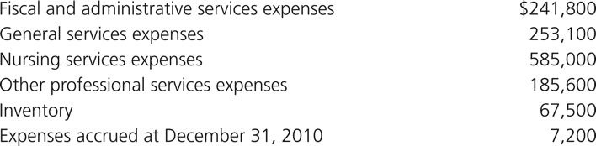
8. Collections of accounts receivable totaled $1,159,000. Accounts written off as uncollectible amounted to $11,900.
9. Cash payments on vouchers payable (paid to employers and suppliers) during the year were $1,031,200.
10. Supplies of $68,000 were issued to nursing services.
11. On December 31, 2011, accrued interest income on investments was $800.
12. Depreciation of buildings and equipment was as follows:
13. On December 31, 2011, closing entries were made in the general journal. Required

a. Show in general journal form the entries that should be made for each of the transactions and the closing entries in accordance with the standards for a governmental health care entity that follows proprietary fund accounting, as discussed in this chapter and Chapter 7.
b. Using the available information, calculate the net patient service revenue that would be reported on the statement of revenues, expenses, and changes in net assets.

