1. Give recursive definitions of each of the following sequences:
(a) 1, 5, 52, 53, 54, ..
(b) 1, 1, 1, 1, ...
(c) 1, −1, 2, −2, 3, −3, 4, −4, 5, −5, 6, ...
(d) 2, 1, 3, 4, 7, 11, 18, 29, 47
(e) 1, 2, 7, 20, 61, 182, 547, 1640, 4921, 14762, 44287, ...

2. 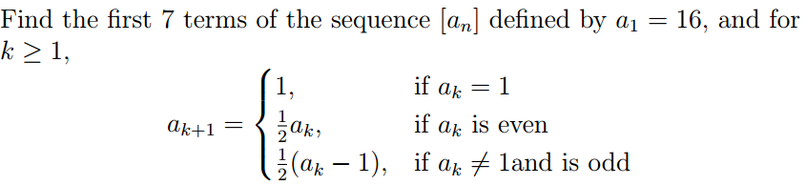

3. Let a1, a2 , a3, ... be a sequence given by a1 = 1 and an = 2an−1 + 1
Determine the first 6 terms of the sequence and the formula for an .

4. Let a1, a2 , a3, ... be a sequence given by a1 = 1 and an+1 = (n + 1)2 – an
Determine the first 6 terms of the sequence and the formula for an .

5. Let a1 , a2, a3 , ... be a sequence given by a1 = 0, a2 = 1 and an = 4an−2
Determine the first 6 terms of the sequence and the formula for an .

6. Rank the following by growth rate (prove any relations as needed):
n, n1/2, log n, log(log(n)), log2 n, (1/3)n , π, n!, en , n2

7.
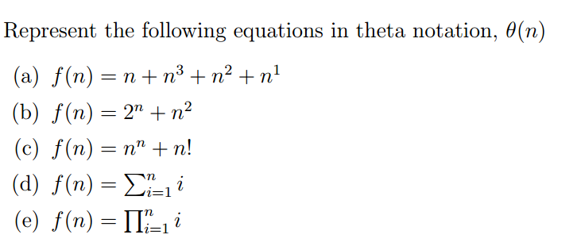

8.