Math 009 Introductory Algebra Name______________________________

Answer Sheet

Instructions:
This is an open-book exam. You may refer to your text and other course materials as you work on the exam and you may use a calculator. Record your answers and show your work on this document. You must show your work to receive credit: answers given with no work shown will not receive credit. You may type your work using plain-text formatting or an equation editor, or you may hand-write your work and scan it. If you choose to scan your work, note that most scanners have a setting that will allow you to create one PDF document from all of the pages of your Answer Sheet – please make use of this option if it is available on your scanner. Whether you type your work or write it by hand, show work neatly and correctly, following standard mathematical conventions. Each step should follow clearly and completely from the previous step. If necessary, you may attach extra pages.

Problem Number | Solution
1 | WORK:  ANSWER:
2 | WORK:  ANSWER:
3 | WORK:  ANSWER:
4 | WORK:  ANSWER:
5 | WORK:  ANSWER:
6 | WORK:  ANSWER:
7 | WORK:  ANSWER:
8 | WORK:  ANSWER:
9 | WORK:  ANSWER:
10 | WORK:  ANSWER:
11 | WORK:  ANSWER:
12 | WORK:  ANSWER:
13 | WORK:  ANSWER:
14 | WORK:  ANSWER:
15 | WORK:  ANSWER:
16 | WORK:  ANSWER:
17 | Use the “drag and drop” line and points to graph your line.  WORK:  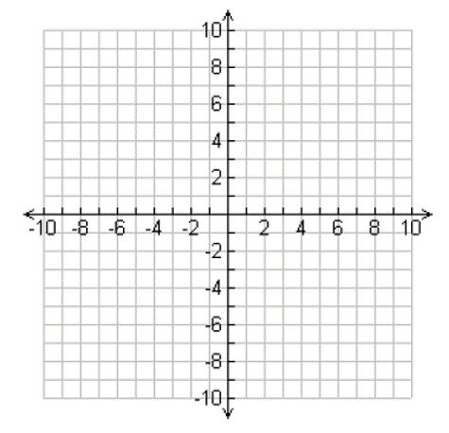  ANSWER:
18 | WORK:  ANSWER:
19 | WORK:  ANSWER:
20 | WORK:  ANSWER:
21 | WORK:  ANSWER:
22 | WORK:  ANSWER:
23 | WORK:  ANSWER:
24 | WORK:  ANSWER:
25 | WORK:  ANSWER:

