- You want to calculate the odds on winning the Powerball lottery before buying a ticket. There are 69 white balls numbered 1 to 69 and 26 red balls numbered 1 to 26 (called the powerballs). 5 white balls are chosen at random without replacement as well as 1 red ball. Your lottery ticket numbers must match the 5 white ball numbers in any order, and the 1 red ball number exactly.

- What is the probability that the red ball chosen will match your red ball number?
- What is the probability that the 1st white ball chosen will match one of your white ball numbers?
- Assuming that you lucked out in (b) and got a match, what is the probability that the 2nd white ball chosen will match one of your remaining numbers?
- Again, assuming you lucked out in (c) and got a match, what is the probability that the 3rd white ball chosen will match one of your remaining numbers?
- Let’s keep going. If you got another match in (d), what is the probability that the 4th white ball chosen will match one of your remaining numbers?
- Finally, assuming you got a match in (e), what is the probability that the 5th white ball will match your last number?
- Multiply the 6 numbers you derived in (a) to (f). Change the probability to “odds” by taking the reciprocal, i.e. P = ¼ is the same as 4 to 1 odds.
- Look up the Powerball odds on the internet. Do your odds equal the odds advertised by the Powerball Lottery? (yes or no)

2. Now let us do problem 1 in a slightly different manner by asking slightly different questions and using the combination formula _{n}C_{k} = $\frac{n!}{k!\left(n-k\right)!}$ .
- How many different ways, without regard to order, can I take out 5 balls from a bag containing 69 white balls?
- How many different ways can I take out 1 ball from another bag of 26 red balls?
- Using the multiplication axiom, how many different ways can I make a group of 6 which includes 5 white balls and 1 red ball?
- If I can pick one of these ways for my ticket, what are the odds that I will chose the winning set of numbers?
- Does your answer in (d) match your answer in problem 1? (yes or no)
3.There is a dice game called “craps”. The game is based on rolling 2 dice and seeing what total number comes up by summing the two faces of the dice. Use the following “tic-tac-toe” boards when doing the parts of this problem.
 | 1 | 2 | 3 | 4 | 5 | 6
1
2
3
4
5
6

- If you roll a 7 or 11 on the first throw, you win instantly. Put a “W” in the appropriate boxes of the above tic-tac-toe board. What is the probability that you will win on the first throw?
- If you roll a 2 (snake eyes), 3, or 12 (box cars) on the first throw, you lose instantly. Put a “L” in the appropriate boxes of the above tic-tac-toe board. What is the probability that you will lose on the first throw?
- If any other number is rolled instead (4,5,6,8,9,10), then a second throw is made. Suppose you roll a 4. Then if the second throw matches the first throw, in this case a 4, you win. If the second throw is a 7, then you lose. If any other number comes up, nothing happens. Instead you keep re-throwing until your original number comes up, in this case a 4, which means you win, or until a 7 comes up which means you lose. When a 7 comes up for the 2nd number, one is said to have “crapped out” when losing.
Fill in the tic-tac-toe board below with “W” for the number 4 and “L” for the number 7.
 | 1 | 2 | 3 | 4 | 5 | 6
1
2
3
4
5
6
- What is the probability that you will roll a 4 on the first throw? P(A) where A = { first throw = 4}
- What is the probability that you will roll a 4 on the second throw? Remember, this is now a conditional probability P(B|A), where A ={ first throw = 4} where all numbers are allowed on the first throw (2 to 12), B = {second throw =4} where on the 2nd throw only 4’s and 7’s are allowed.
- What is the probability that you will roll a 7 on the 2nd throw? In this case P(C|A), where C = {second throw = 7}.
- Are events (B|A) and (C|A) mutually exclusive? (yes or no)
- The probability that your first throw is a 4 is and will then go on to win is: P(A) * P(B|A). Compute this number.
- The probability that your first throw is a 4 is and will then go on to lose is: P(A) * P(C|A). Compute this number.

4.Baseball is sometimes a game of guessing between the pitcher and the batter. The ball is usually travelling so fast that the batter has no time to analyze the speed of the pitch. Rather he has to guess in advance whether the pitch will be a fast ball (F) or a curve ball (C). Suppose a pitcher is throwing fast balls 60% of the time and curve balls 40% of the time. On the other hand, the batter thinks he is throwing fast balls 55% of the time and curve balls 45% of the time.

- What are the following probabilities? The first letter is what the pitcher is throwing while the second letter is what the batter is thinking.
P(FF) = _______________
P(FC) = _______________
P(CF) = _______________
P(CC) = _______________

- If the batter guesses correctly, meaning the outcome is FF or CC, then he is likely to hit the ball solidly and possibly get on base.
What is P(FF + CC)? _______________

- If the batter guesses incorrectly, meaning the outcome is FC or CF, then he is likely to hit the ball weakly or miss it completely when he swings.
What is P(FC + CF)? _______________

- Annotate the tree diagram below and clearly show how you got your answers in part (a). Put in F’s, C’s, and the correct probabilities in your annotation.

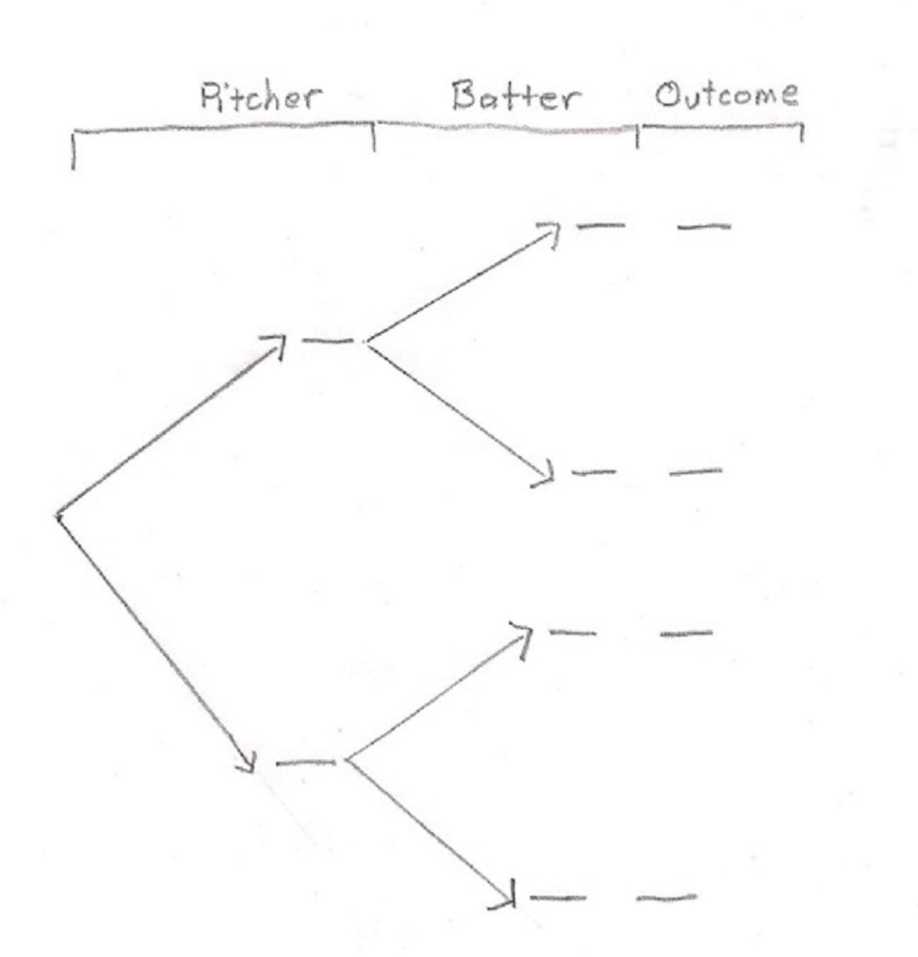

5.At a particular university, students are broken down into categories of standard student (S), athlete student (A), those who eventually graduate (G), and those who leave the school without getting a degree (N).

 | Athlete Student (A) | Standard Student (S) | Total
Will graduate (G) | 200 | 1800
Will not graduate (N) | 400 | 100
Total

- Fill in the blanks of the table with the proper numbers.
- If a student is picked at random, what is the probability that that student is a standard student?
P(S) = _________
- If a student is picked at random, what is the probability that that student will graduate?
P(G) = _________
- If a standard student is picked at random, what is the probability that that student will graduate?
P(G|S) = __________
- If an athlete student is picked at random, what is the probability that that student will graduate?
P(G|A) = __________
- If a student who graduates is picked at random, what is the probability that that student is an athlete?
P(A|G) = ___________
- Does P(G|A) = P(A|G) ? (yes or no)
- If a student is picked at random, what is the probability that that student is an athlete and will graduate?
P(A ∩ G) = __________
- Calculate P(G|A) using the conditional probability equation:
P(G|A) = P(G ∩ A)/P(A) = ____________
- Does your answer in (i) match your answer in (g)? (yes or no)

6.Use the table in problem 5 for this problem.

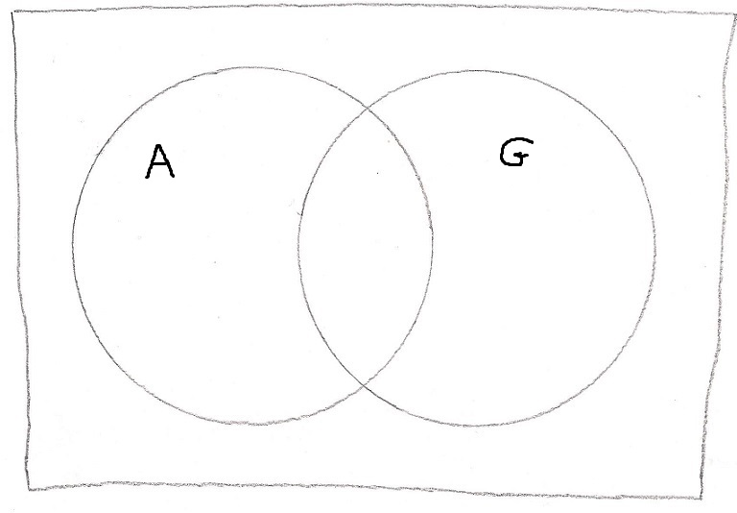
- Fill in the appropriate numbers in the Venn diagram.
- The two circles have labels “A” and “G”. While not labeled, the overlap region of the two circles would have the label “(A ∩ G)”. So what label should the region outside of the two circles have in set notation?

7.You need to take your car to get a state inspection. You estimate that the probability that it will pass the emissions test is P(E) = 0.80, that it will pass the brakes test is P(B) = 0.70, and that it will pass at least one of the tests is P(E Ụ B) = 0.94.

- Using the probability addition rule, calculate the probability that your car will pass both tests, i.e. P(E ∩ B) = _____________.
- Are events E and B independent of each other? (yes or no) Show mathematically how you derived your answer.
- Fill in the numbers for this problem in the Venn diagram shown below.

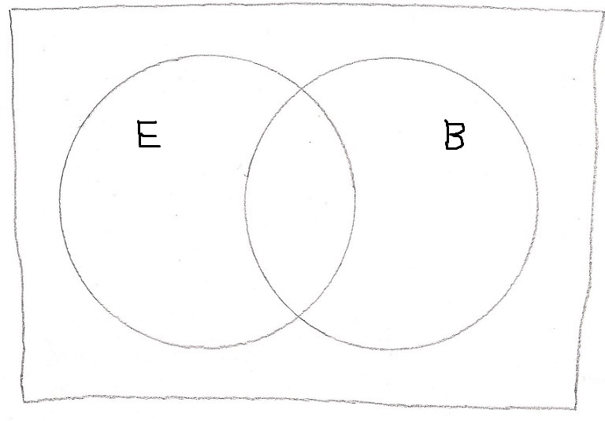

- What is the probability that your car will fail both tests?
P(E Ụ B)’ = _____________
- Using the numbers in the Venn diagram, show that P(E) = P(E|B) = 0.80 according to the conditional probability equation.

8.There are 38 numbers on the roulette wheel, 18 red, 18 black, and 2 green. Let us assume that each time you play, you place a $1 bet. Your expected winnings are calculated using the expected value formula

E = Payoff * P(win) – Bet * P(lose)

- Suppose you place your bet on 1 number only. The payoff is 35-to-1. What is E?
- Suppose you place your bet on red. The payoff is 1-to-1. What is E?
- Suppose you place your bet on the first two columns (#1 though 24). The payoff is 2-to-1. What is E?
- Suppose you place your bet on the 2 green (0 and 00) spaces. The payoff is 17-to-1. (Note: 0 and 00 do not count as Even numbers when a bet is place on all even numbers.) What is E?
- Suppose you place your bet on 3 numbers (a row of spaces). The payoff is 11-to-1. What is E?
- What is the most advantageous way to bet when playing roulette? (Choose from among “a” to “e”).

