Name:

BE SURE TO “SAVE AS” THIS DOCUMENT TO YOUR COMPUTER ON THE DESKTOP OR IN THE DOCUMENTS FOLDER BEFORE COMPLETING IT!!! (Otherwise you may not be able to find it to submit it or the changes you make will not be saved and you will submit a blank document)
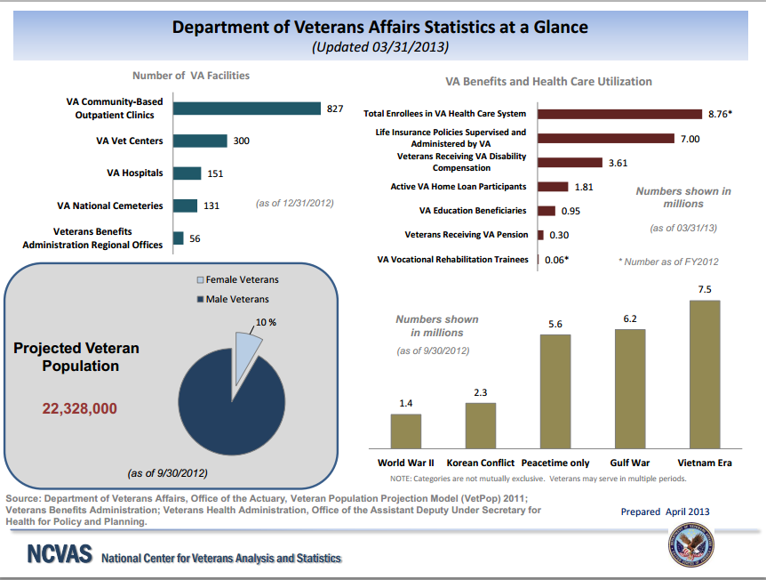

Directions: Answer the questions #1-6 using the graph above. Remember to SHOW ALL WORK!
- What was the total number of enrollees in the VA Health Care System on 3/31/2013?
- 8.76%
- 8,76
- 8.76 x 10⁶
- 8,760,000,000

- How many veterans were receiving VA disability compensation on 3/31/2013?
- 3.61%
- 3.61
- 3.61 x 10⁶
- 3,610,000,000

- What percent of total enrollees were receiving VA disability compensation on 3/31/2013?
  - 3.61%
  - 41.2%
  - 2.43%
  - 24.3%

- Among veterans detailed, how many were from the Vietnam Era on 9/30/2012?
  - 6.2 X 10³
  - 6,200,000
  - 7.5 x 10³
  - 7,500,000

- As of 9/30/2012, how many female veterans were projected among the US population?
  - 2,232,800
  - 10,000,000
  - 2.2328 x 10³
  - 22,328,000

- As of 9/30/2012, how many male veterans were projected among the US population?
  - 22,328,000
  - 90,000,000
  - 2.009520 x 10⁵
  - 20,095,200

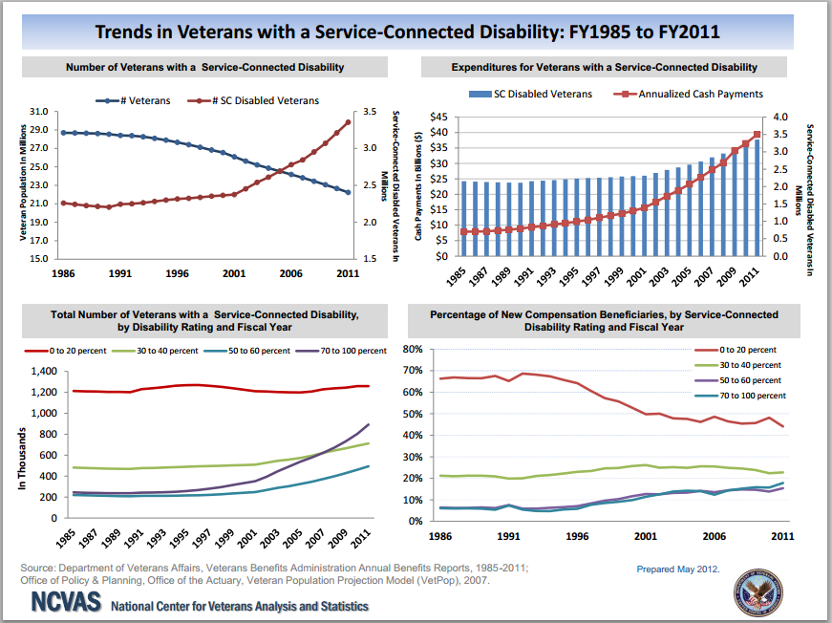

Directions: Answer the questions #7-13 using the graph. Remember to SHOW ALL WORK!
- Does the Number of Veterans with a Service-Connected Disability chart show where the number of veterans and the number of veterans with a service-connected disability are the same?
  - Yes
  - No

- In 2011, how many veterans were there?
  - 30 million
  - 3.4 million
  - 2.4 million
  - 22 million

- In 2011, how many service-connected veterans on disability were there?
  - 30 million
  - 3.4 million
  - 2.4 million
  - 22 million

- In 1991, what percent of veterans were service-connected disabled veterans?
  - 10.9%
  - 15.5%
  - 8.0%
  - 64.7%

- From the Percentage of New Compensation Beneficiaries, by Disability Rating and Fiscal Year chart, what percent disability range held steady in the number of recipients from 1985 to 2011 at about 1,200,000?
  - 0 – 20%
  - 30 – 40%
  - 50 – 60%
  - 70 – 100%

- From the Total Number of Veterans with a Service Connected Disability, by Disability Rating and Fiscal Year chart, what percent disability range increased the most from 1985 to 2011 in the number of recipients?
  - 0 – 20%
  - 30 – 40%
  - 50 – 60%
  - 70 – 100%

- From the Total Number of Veterans with a Service Connected Disability, by Disability Rating and Fiscal Year chart, what percent disability range increased the least from 1985 to 2011 in the number of recipients?
  - 0 – 20%
  - 30 – 40%
  - 50 – 60%
  - 70 – 100%

