Algebra I Midterm

Name/Student Number:__________________________

Score:_______/________

Directions: For each question show all work that is required to arrive at the solution. Save this document with your answers and submit as an attachment to be graded.

- Simplify the expression. Show your work.
- + (3² – 4²)

- Evaluate the expression for a = –1 and b = 5. Show your work.
5a – 7b + b²

- Simplify the expression.
9xy² – 11xy²

- Simplify the expression.
-3(b – 7)

- Solve the equation. Show your work. Check your answer.
4y + 5 = – 31

- Solve the equation. Show your work. Check your answer.
3x – 7 = 5x + 19

- A cheetah ran 300 feet in 2.92 seconds. What was the cheetah’s average speed in miles per hour? Show your work.

- Write a compound inequality that the graph could represent.

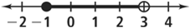

- Find the solutions of the inequality. Show your work.
4b – 3 > –1

- A taco stand sells tacos for $3.25 each. The stand’s expenses for the day are $210. Define your variables and write an inequality to represent the amount of tacos they need to sell per day to make a profit, and then solve the inequality. Provide your conclusion as a complete sentence.

- 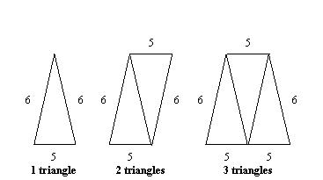
Represent the above relationship between the number of triangles and the perimeter of the figures they form by filling in the table below. Show your work.

Number of Triangles | Perimeter
1
2
3

Write the equation that represents the relationship between n the number of triangles and p the perimeter of the figures formed.

- Model the function rule y = -2x - 3 with a table of values. Show your work.

- For the function rule y = -2x - 3, provide the x-y coordinates of the y-intercept and the x-intercept. Show your work.

- Identify the domain and range of the relation.
{(-9, 2), (-4, 2), (3, 2), (9, 2)}

- The function g(t) = 2t represents the number of guitar lessons, g(t), you can complete in t months. How many guitar lessons can you complete in 7 months? Provide your conclusion as a complete sentence.

- The scatter plot below shows the height of a tree over time. What is the approximate height of the tree after 10 years?
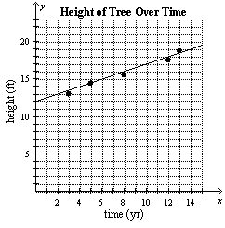

- Write an equation of a line whose graph is parallel to the graph of y = 3x – 10.

- Tom has a collection of 30 CDs and Nita has a collection of 18 CDs. Tom is adding 1 CD a month to his collection while Nita is adding 5 CDs a month to her collection. Find the number of months after which they will have the same number of CDs. Show your work.

- Determine the solution of the system. Show your work.
Y = 5x – 9
Y = 2x + 6

