Kaspersky vs. Norton
compare their functionality, cost, features and type of protection.
line for line/ feature by feature . In your own words write a summary and Recommendation based on ratings determined by weighted measures
500 words or more. References cited too please.
Using table in Word, create a weighted ranking according to your evaluation of the features and specifications of each software package. See sample below:
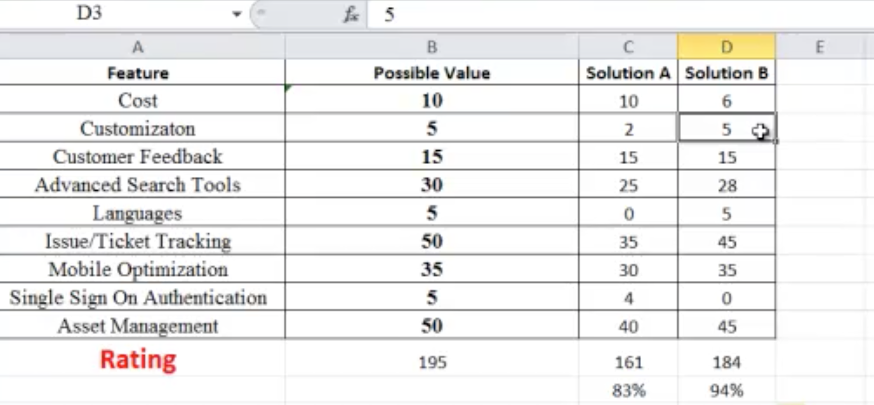
FEATRURE | Possible Value | Software Kaspersky | Software Norton
Cost | 10
Customization | 5
Customer Feedback | 15
Advanced Search Tools | 30
Languages | 5
Issue/Ticket Tracking | 50
Mobile Optimization | 35
Single Sign On Authentication | 5
Asset Management | 50
RATING | 195

