BIS2A section B (Britt) Practice Midterm 1
25 questions, each worth 4 pts (in 2013, exams will have 30 questions, 3 pt each)
an answer key will be provided next week

1. Which of the statements below best describes covalent bonds?
a. …the sharing of a hydrogen atom between two molecules
b. …the transfer of an electron from one atom to another; a relatively weak bond
c. … the transfer of an electron from one atom to another, a relatively strong bond
d. …the sharing of an electron pair between two atoms; a relatively weak bond
e. …the sharing of an electron pair between two atoms; a relatively strong bond

2. Which of the carbon atoms below is most oxidized?
a. CH₄
b. CH₃OH
c. CH₂O
d. CO₂
e. There’s no way to tell without seeing the structures

3. A person decides to get in better shape by eating less and exercising more. They lose weight- some of which is in a form of carbon. Where does the carbon go, and in what form?
a. Down the toilet, as excreted fats
b. Into the air, as CO₂
c. It is lost as energy (heat)
d. Into the intermembrane space, as protons.

4. Very early in the Earth’s history, there was no O₂ in the atmosphere. For this reason…
a. The evolution of the ETC (electron transport chain) did not occur until after the evolution of oxygenic photosynthesis
b. Fermentation could not occur
c. Electrons from respiration were delivered to a different terminal acceptor
d. Green plants were the first form of life to evolve
e. NAD+ could not be used as an oxidizing agent

5. A highly electronegative atom X meets a weakly electronegative atom Y. What will probably happen?
a. X will steal Y’s electron
b. Y will steal X’s electron
c. The two atoms will share an electron pair, but the electrons will spend more time with X
d. The two atoms will share an electron pair, but the electrons will spend more time with Y
e. Both a and c are possible

6. Hydrogen and carbon have very similar electronegativities (2.1, and 2.5, respectively). Which of the fuels below, when oxidized to completion, would release the most energy per molecule of C0₂ emitted?
a. C (coal- nothing but carbon)
b. CH₄ (natural gas)
c. CO₂
d. coal and natural gas would produce the same amount of energy per CO₂ emitted
e. CH₃OH

7. Respiration enables a cell to…
a. Use NADH as a terminal electron acceptor
b. Use NADH to reduce pyruvate
c. Convert photons to reducing power
d. Use oxidation of NADH to power a proton gradient
e. a, b, and d are all correct

8. ATP is called a “high energy compound,” because...
a. the activation energy for the formation of ATP is very high.
b. the activation energy for the hydrolysis of ATP is very high.
c. the ΔG for the formation of ATP is very negative.
d. the ΔG for the hydrolysis of ATP is very negative.
e. it is the primary storage form of energy in muscle cells.

9. Scientists make difficult witnesses at trials because:
a. They don’t believe in “evidence”.
b. They take too much on faith.
c. They think they’re smarter than lawyers.
d. They refuse to say that they are “absolutely certain” of something.
e. They refuse to “swear in”.

10. Salmonella causes intestinal diseases in many mammals. While infecting its host, Salmonella gets its energy by being a…
a. Phototroph
b. Lithotroph
c. Organotroph
d. Autotroph
e. Morphotroph

11. Consider the free energy diagram below, which describes the energy states of molecules undergoing the reaction X <-> Y. Adding a catalyst to this reaction would decrease the value of which arrow?
a. a
b. b
c. c
d. d
e. a catalysts cannot effect any of these values.

12. The reaction described above is begun at standard conditions: (1 Molar X and Y, 25˚ C, pH 7, in water, at 1 atmosphere pressure). When it finally reaches equilibrium, will we end up with mostly X, or mostly Y? Pick the best answer.
a. this can’t be determined from the diagram
b. mostly X
c. mostly Y
d. all molecules will end up as X
e. all molecules will end up as Y

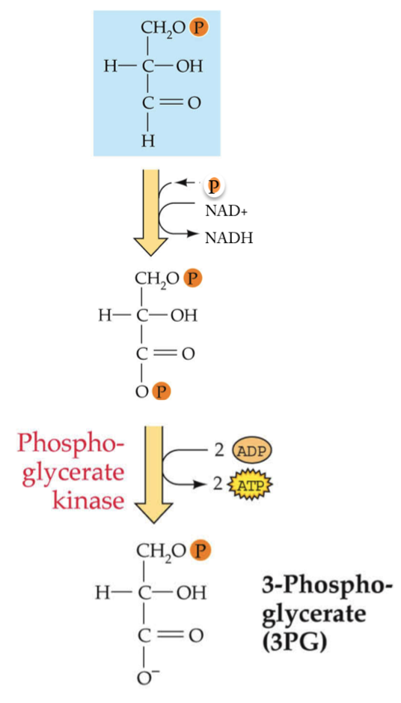
13. In the step of glycolysis illustrated here, the production of ATP from ADP and Pi is powered by…
a. The electron transport chain (ETC)
b. The proton motive force (PMF)
c. The Force
d. The oxidation of carbon
e. The hydrolysis of ATP to AMP + 2 Pi

14. In respiration, most of the ATP is generated as a result of…
a. Fermentation
b. Substrate-level phosphorylation, during glycolysis
c. Substrate-level phosphorylation, during the citric acid cycle
d. Oxidation of NADH via the ETC and PMF
e. Reduction of pyruvate

15. Both fermentation and respiration share the metabolic pathway termed “glycolysis”. They also share…
a. a step involving oxidation of pyruvate
b. a step involving reduction of pyruvate
c. oxidative phosphorylation of ATP
d. oxidation of NADH via the ETC
e. none of the above

16. When illuminated with white light, leaves look green because:
a. Green photons are more strongly absorbed by chlorophyll than other visible photons.
b. Green photons are more weakly absorbed by chlorophyll than other visible photons.
c. Green photons have the same energy as the difference between the ground state and first excited state of chlorophyll.
d. Green photons have the most energy of photons in the visible range.
e. Green photons have the least energy in the visible range.

17. Green plants…
a. Perform respiration and photosynthesis
b. Just perform photosynthesis
c. Just perform respiration
d. Have mitochondria and plastids
e. both “a” and “e” are true.

18. There was no O₂ in the early earth’s atmosphere because
a. O₂ poisonous to life
b. The early Earth was very hot, and O₂ is very reactive, so it reacted with other chemicals.
c. The element O was very rare on Earth, until there was photosynthesis.
d. It was devoured by early forms of life.

19. Using the electron tower provided, which of these compounds would be the strongest electron donor:
a. SO₄⁻
b. CO₂
c. H₂S
d. Fe³⁺
e. NO₃⁻

20. Which reaction would provide the most free energy for the cell?
a. H₂ + Fumarate²⁻ ____> Succinate²⁻
b. NADH + Ubiquinone_{ox} ____> NAD⁺ + Ubiquinone _{red}
c. H₂ + S₄O₆²⁻ ____> S₂O₃²⁻
d. NADH + NO³⁻ ____> NO²⁻ + NAD⁺

21. In noncyclic photosynthesis the excited electrons end up…
- back on chlorophyll
- being used to make ATP
- being used to reduce NADP
- being transported “to the other side of the membrane” to set up a proton motive force.
- Being used to directly make glyceraldehyde phosphate and other carbon molecules.

22. Which of the following is true for anoxygenic photosynthesis:
- only ATP can be formed- not NADPH.
- it represents an origin for the more complex oxygenic photosynthesis reactions.
- only NADPH can be formed- not ATP.
- it occurs only in green plants.
- B and D are both true.

23. A respiring organism that can utilize different terminal electron acceptors will
- have terminal reductase(s) that can interact with a variety of terminal electron acceptors.
- Have an NADH Q reductase that can oxidize a variety of substances
- be a strict aerobe.
- potentially be able to be live in the presence or absence of O₂.
- A and D are both true.

24. A key difference between respiration and fermentation is (are)
a. that for fermentation reactions the oxidation of NADH+H⁺ occurs in the absence of exogenous electron acceptors.
b. that in respiration, ATP is produced indirectly through a proton motive force created by transferring elections between several electon/H+ carriers, called an electron transport chain (ETC).
c. that in fermentation ATP is only obtained through substrate level phosphorylation and in respiration ATP is only obtained via a proton motive force generated by an electron transport chain.
d. A and B
e. All of the above

25. Reverse electron flow
a. is a mechanism to “run an electron transport chain backwards” to generate NADH+H⁺
b. is a means of oxidizing NADH+H⁺ to NAD and is limited to anoxygenic photosynthesis.
c. can occur only in phototrophs.
d. is a result of photosystem I and oxygenic photosynthesis.
e . all of the above

