Question 1
- Use the table below to answer the questions that follow.
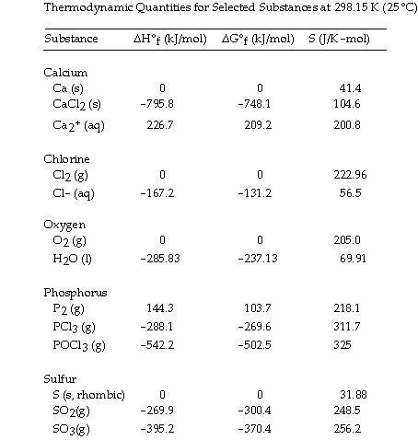
The value of G° at 25 °C for the decomposition of gaseous sulfur dioxide to solid elemental sulfur and gaseous oxygen,
SO₂ (g) S (s, rhombic) + O₂ (g)
is ________ kJ/mol.
+395.2
+269.9
-269.9
+300.4
-300.4

Question 2
- Use the table below to answer the questions that follow.
The value of G° at 25 °C for the decomposition of calcium chloride into its constituent elements,
CaCl₂ (s) Ca (s) + Cl₂ (g)
is ________ kJ/mol.
-795.8
+795.8
+763.7
+748.1
-748.1

Question 3
- Use the table below to answer the questions that follow.
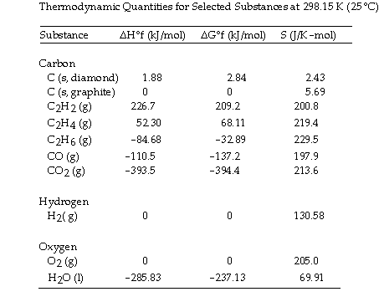
The combustion of ethane in the presence of excess oxygen yields carbon dioxide and water:
2C₂H₆ (g) + 7O₂ (g) 4CO₂ (g) + 6H₂O (l)
The value of S° for this reaction is ________ jk/mol.
+718.0
-620.1
-718.0
-151.0
+151.0

Question 4
- The value of G° at 261.0 °C for the formation of phosphorous trichloride from its constituent elements,
P₂ (g) + 3Cl₂ (g) 2PCl₃ (g)
is ________ kJ/mol. At 25.0 °C for this reaction, H° is -720.5 kJ/mol, G° is
-642.9 kj/mol and -263.7k/j
-579.6
6.81 × 10⁴
1.40 × 10⁵
-651.7
-861.4

Question 5
- Use the table below to answer the questions that follow.

The value of G° at 25 °C for the decomposition of phosphorous trichloride into its constituent elements,
2PCl₃ (g) P₂ (g) + 3Cl₂ (g)
is ________ kJ/mol.
-539.2
+539.2
-642.9
+642.9
-373.3

Question 6

Use the table below to answer the questions that follow.

The value of S° for the decomposition of POCl₃ into its constituent elements,
2POCl₃ (g) P₂ (g) + O₂ (g) + 3Cl₂ (g)
is ________ jk/mol.
+771.0
+442.0
-321.0
-771.0
+321.0

Question 7

Use the table below to answer the questions that follow.

The value of S° for the catalytic hydrogenation of ethene to ethane,
C₂H₄ (g) + H₂(g) C₂H₆ (g)
is ________ jk/ mol.
-101.9
-120.5
-232.5
+112.0
+101.9

Question 8
- Which of the following statements is true?
Processes that are spontaneous in one direction are spontaneous in the opposite direction.
Processes are spontaneous because they occur at an observable rate.
Spontaneity can depend on the temperature.
All of the statements are true.

Question 9

Consider the reaction:

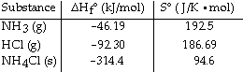
NH₃ (g) + HCl (g) NH₄Cl (s)
Given the following table of thermodynamic data at 298 K:
The value of K for the reaction at 25 °C is ________.
150
9.3 × 10¹⁵
8.4 × 10⁴
1.1 × 10⁻¹⁶
1.4 × 10⁸

Question 10
- The standard Gibbs free energy of formation of ________ is zero.
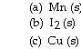
(a) only
(b) only
(c) only
(b) and (c)
(a), (b), and (c)

Question 11
- S is negative for the reaction ________.

Sr(NO₃)₂ (aq) + 2LiOH (aq) Sr(OH)₂ (s) + 2LiNO₃ (aq)

2H₂O (g) 2H₂ (g) + O₂ (g)

CH₃OH (l) CH₃OH (g)

LiOH (aq) Li⁺ (aq) + OH (aq)

C₆H₁₂O₆ (s) 6C (s) + 6H₂ (g) + 3O₂ (g)

Question 12
- Of the following, the entropy of ________ is the largest.
HI (g)
HBr (g)
HCl (g)
HCl (s)
HCl (l)

Question 13

Use the table below to answer the questions that follow.

The value of S° for the oxidation of carbon to carbon monoxide,
2C (s, graphite) + O₂ (g) 2CO (g)
is ________ jk/mol. Carbon monoxide is produced in the combustion of carbon with limited oxygen.
-12.8
+408.6
-408.6
+179.4
+395.8

Question 14

The equilibrium constant for the following reaction is 3.0 × 10⁸ at 25 °C.
N₂ (g) + 3H₂ (g) 2NH₃ (g)
The value of G° for this reaction is ________ kJ/mol.
22
-4.1
4.1
-48
-22

Question 15
- The vaporization of a substance at its boiling point is an isothermal process.
True
False

Question 16
- For a given reaction, S = +69.0 J/mol K, and the reaction is spontaneous at temperatures above the crossover temperature 439k. The value H= ?kj/mol assuming that H and S do not vary with temperature.
30.3
-30.3
1.57 × 10⁻⁴
-1.57 × 10⁻⁴
6.36 × 10⁻³

Question 17
- Which one of the following is always positive when a spontaneous process occurs?
S_{system}
S_{surroundings}
S_{universe}
H_{universe}
H_{surroundings}

Question 18
- Use the table below to answer the questions that follow.
The value of S° for the oxidation of solid elemental sulfur to gaseous sulfur trioxide,
2S (s, rhombic) + 3O₂(g) 2SO₃ (g)
is ________ jk/mol.
+19.3
-19.3
+493.1
-166.4
-493.1

Question 19

Use the table below to answer the questions that follow.

The value of S° for the catalytic hydrogenation of acetylene to ethane,
C₂H₂ (g) + 2H₂ (g) C₂H₆ (g)
is ________ jk/mol.
-76.0
+440.9
-232.5
+232.5
+28.7

Question 20
- Of the following, the entropy of ________ is the largest.
B₂F₄ (g)
BF₃ (g)
B₂H₆ (g)
BCl₃ (l)
B₂O₃ (s)

