Attached files in Excel Spreadsheet:
Activity.xlsx
Activity_resource.xlsx
Project.xlsx
Resource.xlsx
Resource_consumer.xlsx

Given the following ERD from a project management information system:
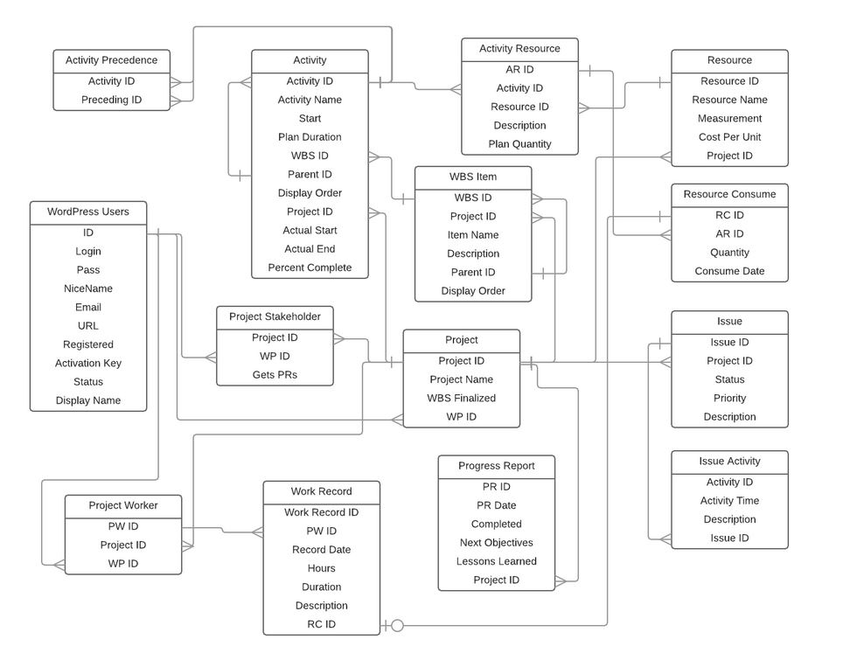

Do the following:
- Write Create Table statements for the following tables:
  - Project
  - Activity
  - Activity Resource
  - Resource
  - Resource Consume

- Write Insert statements to populate the tables using the data from the attached spreadsheets.

- Write a query to display the following information:
  - Project Name
  - Activity Name
  - Estimated Cost (total of Cost Per Unit multiplied by Plan Quantity for each activity)
  - Planned Start Date (Start)
  - Planned Finish Date (Start plus Plan Duration)
To write your SQL statements, I would suggest using a free online tool, SQL FIDDLE. You can write the Create Table and Insert statements in the Schema Panel and then run your query to accomplish the last part of the problem in the other panel.

