Project : Student Functionality Requirement
Students, Courses and Tutors Scenario
The following data model is designed to hold information relating to Students, Student Courses and Tutors who deal with these students. For this scenario we need to define the following facts:
The Entities required should include:
Student Information
Courses
Student Courses
Employees (Tutors)
Contact Information (Contact between the Student and the Tutor
by e-mail, phone, projects etc.)
Contact Types (e-mail, phone, projects, assessments)
The Entities are related based on the ER diagram below. Use it to determine table relationships. For example
One Student can enroll in or many Courses
One Course can have one or many Students enrolled in it.
One Student can have zero, one or many forms of contact with the
Course Tutor
One Employee (Tutor) can deal with many contacts
One contact Type (Phone, E-mail, Assessments, Projects etc.) can
have zero, one or many contacts
The design allows
• a Student to enroll in one or multiple Courses,
• a Course allowing one or more Students enrolled in it.
• a student may be in contact with the Course Tutor many times using many different forms of contact.
• a tutor will deal with many contacts involving many Students.

Use the following data model to create your tables.
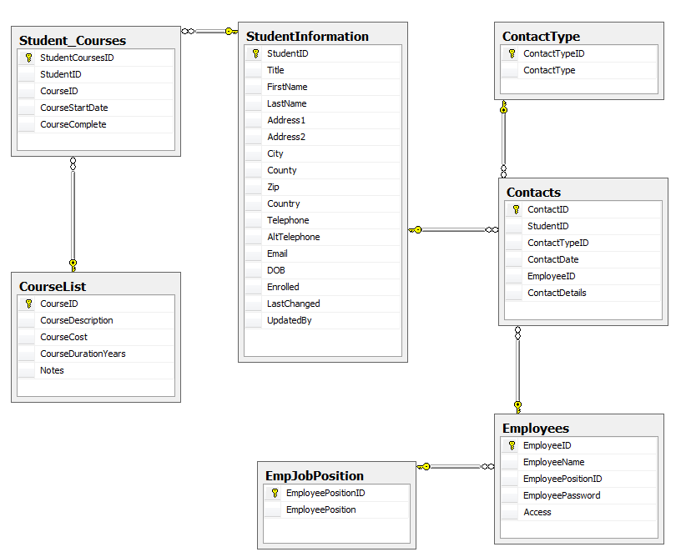

ASSIGNMENT TO COMPLETE
Write the SQL code to create the following:
1. Write sql code to create all tables shown in the ER diagram. Assign appropriate datatype for each field including which should allow NULLs, Primary Key and set as Identity
2. Write sql code for each table to create a Foreign key constraint on appropriate referenced table.
3. CreateINDEXonLastNamecolumninStudentInformationtable. Name the new INDEX “IX_LastName.”
4. Write code to ALTER Student Information table to ADD new column named CreatedDateTime with datatype as datetime.
5. Write code to ALTER Student Information table to create a DEFAULT on the Country field. Set default as ‘US’
6. Write code to ALTER Student Information table to DROP AltTelephone column.
7. Write sql code to create three stored procedures on the Student Information table:
a. Insert single student record stored procedure. Insert three sample student records.
b. Update Country with ‘Bruin Nation’ in single student record. Use StudentID in WHERE clause to update only one record.
c. Delete single student record. Use StudentID in WHERE clause
8. Write sql code to create a VIEW based on the StudentInformation table. Only return First Name and Last Name columns. Name the view DisplayName
9. Write sql code to create a VIEW based on the StudentInformation table. Concatenate First Name, Last Name and Title to create new virtual column with alias name of “StudentDisplayName.”
10. Create a trigger on the Student Information table to set Country field to UPPER case when new record added.
When submitting completed project just submit the SQL code in a word document or as a sql text file.

