**User Forms Exam Hands-On**

Assume that you own a small deli that sells bagels. Create a Visual Basic program that computes the price of a purchase based on what the customer orders, counts the customers and totals the amount of sales.

First, use your planning forms to prepare to create the user form. You do not need to turn in the first planning form (design interface). Be sure to turn the second 2 planning forms (design properties and design code) into the exam dropbox. **(25 pts)**

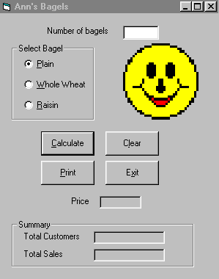The form will include:

* The caption of “*Your name* Bagels". **(2 pts)**
* A text box with a label for entering the number of bagels. **(2 pts)**
* A frame displaying “Select Bagel” that contains option buttons for the bagel selection**.** The plain option should be selected when the form loads.All options should have keyboard access. **(4 pts)**
* Display the price of each type of bagel when the user hovers over the option. **(2 pts)**
* An image of your choice. **(3 pts)**
* *Calculate*, *Clear*, *Print*, and *Exit* command buttons. Allow for keyboard access. *Calculate* is the default button and *Clear* is the cancel button. **(4 points)**
* A frame for summary information that contains labels for total number of customers and total sales amount.The frame should display “Summary”. **(3 pts)**

The ***Clear***command button resets the option buttons (plain is the default). It will clear the text box and clear the label for price. Do not clear the summary information. **(5 points)**

The ***Print*** command button will print an image of the form. **(3 points)**

The **Exit** command button will exit the program. **(3 points)**

The ***Calculate*** command button calculates and displays in a label the price of the sale. The price depends on how many bagels the customer orders and what kind of bagel the customer selects. You charge $1.75 for a plain bagel, $1.95 for a whole-wheat bagel, and $2.15 for a raisin bagel. Display the amount of the purchase in a currency format and right justified. **(15 pts)**

Calculate will also display the total number of customers and the total amount of sales. Assume there is a new customer each time the ***Calculate*** command button is clicked. Display the total amount of sales in a currency format and right justified. Display the Total Customers as a whole number. **(15 pts)**

Tabstops should be logical. The user should be able to tab to move only through the input objects from top to bottom, left to right. **(4 pts)**

Format the appearance of the form by resizing and aligning buttons, using readable and appropriately-sized fonts, wrapping text if needed, and making the display of the worksheet and the form attractive. **(5 pts)**

Create a command button on the first spreadsheet to open the user form. **(5pts)**

Include General Declarations, name constants, variables and controls well. Add comments throughout the code. **(5 pts)**