[ AN | CIS 407: Advanced Database  Data Modeling & Single Table Query  40 Points
 | Date Given: 3-8-17 Date Due: 3-13-17

I. DATA MODELING (20 Points)

CASE STUDY:
ACME Inc. is a small consulting company with 4 employees. ACME’s employees assist many local clients in the successful design and implementation of their projects. A client has one or more projects contracted with ACME. An employee can work on one or more projects.

To keep track of the client and project data, Zac, an employee at ACME, created the following database model (PKs are underlined):

PROJECT |  |  |  | EMPLOYEE |  |  |  | CLIENT
PID | PNAME | EID |  | EID | ELNAME | EFNAME |  | CID | CNAME | EID
PH | Hurricane | E1 |  | E1 | Sutton | Sue |  | C1 | Alpha | E2
PT | Tornado | E1 |  | E2 | Doe | Jane |  | C2 | Beta | E1
PC | Cyclone | E2 |  | E3 | Byte | Bill |  | C3 | Gamma | E1
PM | Monsoon | E1 |  | E4 | Blow | Joe |  | C4 | Theta | E2
PS | Storm | E2 |  |  |  |  |  | C5 | Kappa | E1

Do you think Zac’s design can answer each of the following three questions (a, b, and c) precisely and without ambiguity? Do not just answer YES or NO. You must justify your answer with an example.

- Which employee works on which projects? Give a specific example to justify. (2 points)

Sue Sutton (E1) works on projects: Hurricane, Cyclone, and Monsoon. While Jane Doe (E2) works on projects: Cyclone and Storm.

b) Which employee is helping which clients? Give a specific example to justify. (2 points)

Sue Sutton (E1) is helping clients: Beta, Gamma, and Kappa. While Jane Doe (E2) is helping: Alpha and Theta.

c) Which projects belong to which clients? Give a specific example to justify. (2 points)

There is no way to know with Zac’s design, which projects belong to which clients without some ambiguity. We could say that since we know Sue works on three projects, and that she helps three clients that the projects belong to those clients and likewise with Jane Doe. We can make that assumption but we still don’t know which specific project belongs to which specific client.

d) If you consider that Zac’s design is flawed and could not answer some or all of the above queries, what would you suggest? How would you modify the above model? Draw an ERD (must show PK and FK and all relevant attribute in the entities to get maximum credit) that you would recommend to ACME so that all the above relevant queries can be answered precisely and without any ambiguity. (HINT: The design is indeed flawed). (10 Points)

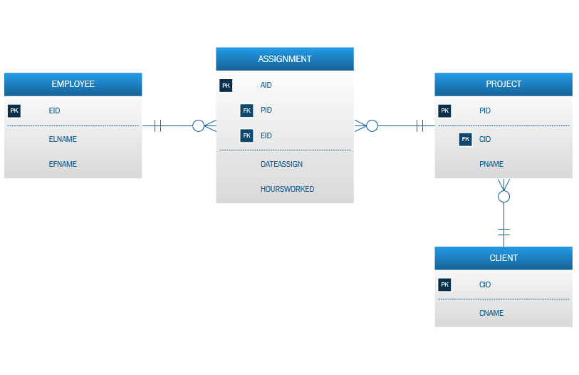

e) Convert each entity in your ER diagram above to a database relational table and enter the actual correct data under each field. You must juggle and use the original given data in the new tables appropriately. If needed, make up your own new attributes that will prove that your database design is correct. You must show PK and FK wherever relevant and maintain both integrities to get maximum credit. (4 Points)

EMPLOYEE |  |  |  | PROJECT |  |  |  | CLIENT
EID | ELNAME | EFNAME |  | PID | PNAME | CID |  | CID | CNAME
E1 | Sutton | Sue |  | 001 | Hurricane | C2 |  | C! | Alpha
E2 | Doe | Jane |  | 002 | Tornado | C3 |  | C2 | Beta
E3 | Byte | Bill |  | 003 | Cyclone | C1 |  | C3 | Gamma
E4 | Blow | Joe |  | 004 | Monsoon | C5 |  | C4 | Theta
 |  |  |  | 005 | Storm | C4 |  | C5 | Kappa

ASSIGNMENT
AID | DATEASSIGN | HOURSWORKED | PID | EID
1000 | 02-12-2017 | 10 | 001 | E1
1001 | 02-06-2017 | 12 | 002 | E1
1002 | 02-28-2017 | 8 | 003 | E2
1003 | 03-03-2017 | 4 | 004 | E1
1004 | 01-01-2017 | 130 | 005 | E2

II. SQL CODING: Single Table Query (20 Points)

- To submit your source SQL code, simply copy the SQL code from the QUERY area of the COB-SQLSERVER and paste it into the Word document.
- To submit the result of the SQL query, this is what you do:
  - Click on the RESULTS TO TEXT icon at the top of the query window before you run your query. This way you will get an output that will allow you to capture all the column headers as well as the data under the columns. See images below. After running the query, copy the result and paste it into the Word document. (Alternatively, use Print Screen together with the Paint program to copy and paste the result).

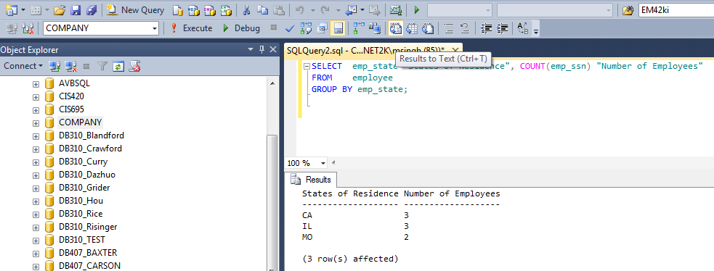
Copy this output and paste. You may submit screen shot of the output.
Copy this source code and paste so that I can copy and run it again on COB-SQLServer to counter check for partial credit purposes. Do not submit a screen shot (image) of SQL codes. Thanks!

Write correct SQL codes for the following reports. You will be using the database named HOSPITAL that is posted on the COB-SQLServer. You have read-access only to this database. In the following, some sample images are shown for column headers reference. All queries are single-table queries. No JOINs are required.

Even if you query does not run completely and correctly, please copy and paste the error message (in addition to your code) so that I will be aware of the extent of the error. Remember, partial credit will be given based on the degree of severity of the error. So, do not forget to copy and paste the error.

1. | Find the average age (as of today) in number of years of all the current patients in the HOSPITAL.  OUTPUT:  - The final output is a single Scalar numeric quantity that must have exactly one decimal place (such as 45.5 or 47.0 or 54.3 etc.)  - Use an alias “Average Age” for the column name.  SELECT CONVERT(decimal(4, 1),AVG(DATEDIFF("yyyy", pat_date_of_birth, GETDATE()))) AS [Average Age]  FROM patient  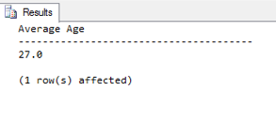
2. | Write a query to display the date on which each staff member has completed or will complete 20 years of service experience at the HOSPITAL.  - Display the following column headers in the given sequence in the output.  - The value for the “Name” column should be in the format: “Lastname, Firstname”.  - The date fields must not display the time component.  - Display the date in the fashion, for example: 14 Dec 1999  - The output must be sorted on the date-hired field in ascending order.  SELECT staff_ssn AS [SSN], (staff_last_name + ', ' + staff_first_name) AS [Name], CONVERT(VARCHAR(11),date_hired, 106) AS [Date Hired], CONVERT(VARCHAR(11),DATEADD(yyyy, 20,date_hired), 106) AS [Date with 20 Years Experience]  FROM staff  ORDER BY date_hired  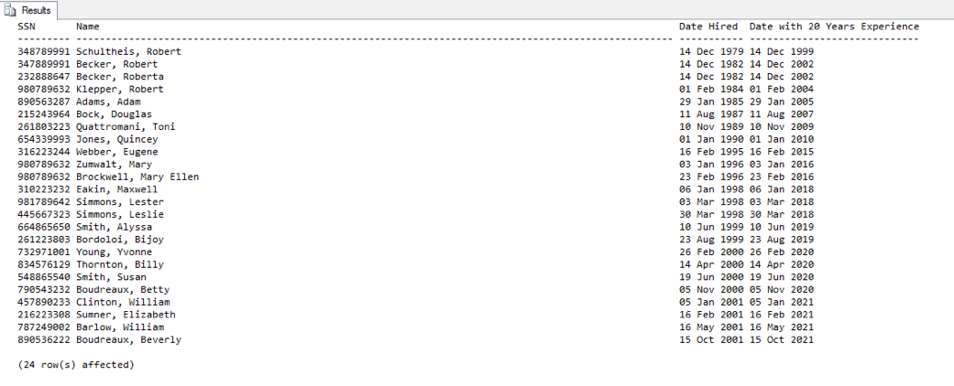
3. | The HR manager needs a listing of services provided by the HOSPITAL, but only for “surgical” types of services.  - Include the following column headers in the output.  - Instead of displaying the coded catalog ID used (i.e., SUR) in the table, your output must display the full term “Surgical” in the output under the header “Service Type”.  - Order the display in increasing order of service ID.  SELECT service_id AS [Service ID], service_description AS [Service Description], REPLACE(service_cat_id,'SUR','Surgical') AS [Service Type]  FROM service  WHERE service_cat_id = 'SUR'  ORDER BY [Service ID]  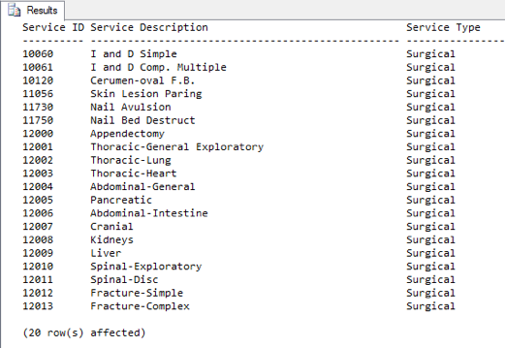
4. | A listing is desired that focuses on the count of all available beds in the ER rooms only. However, display those situations in which the count number of available beds is greater than one (not inclusive).  - Include the following headers.  - Order by room id in ascending order.  SELECT room_id AS [Room ID], bed_type_id AS [Bed Type], COUNT(CASE WHEN bed_availability = 'Y' THEN 1 ELSE 0 END) AS [Number Available]  FROM bed  WHERE bed_type_id LIKE 'E_'  GROUP BY room_id, bed_type_id  HAVING COUNT(*) > 1  ORDER BY room_id  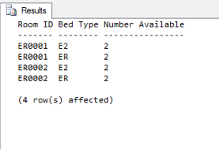
5. | Find the total number of patients in each city who were born in the month of June. However, in the final output, display only those results where the count is greater than 2 (inclusive).  - Use the following headers.  - Order the result by descending order of count.  SELECT pat_city AS [Patient City], COUNT(DATENAME(MONTH, pat_date_of_birth)) AS [Count of June Births]  FROM patient  WHERE Month(pat_date_of_birth) = 6  GROUP BY pat_city  ORDER BY [Count of June Births] DESC  