Question One
You have the following classes:
- ATM
- CardReader
- WithdrawMoney
- CustomerInformation
- Balance

Draw a diagram that explains the responsibilities and collaborators for each class (if any). An example is shown below, where B is a collaborator of A:

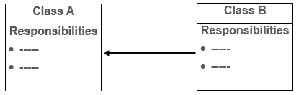

Question Tow
Briefly, explain what infinite recursion is, and what causes it to happen? Support your answers with examples.

Question Three
Using recursion, write a complete java program that reads an integer from the user and prints only the factorial of the even input.

Question Four
You have the following numbers in an array:
8, 17, 12, 64, 3, 79, 44, 38
Write a program that will sort them in ascending order using Selection Sort.

