P5.1 Given the following student class interface, a) implement all member functions of the class, b) implement all non-member external functions of the class, and c) write a main() function to generate an output similar to the sample output appeared after the class interface. Notice that not all pre- and post-conditions for functions are provided; some are intentionally left out for you to fill in.
// **** student class interface for P4.1 ****
class student
{
public:
student();

student(string, int, double);

void inputStuRec();
// prompts the user to enter name (for simplicity, last name only), credits completed and GPA
// Postcondition: Data mambers of the calling object is filled with values entered by the user

void outputStuRec();
// Postcondition: contents of the calling object is displayed in a format shown in the sample output

void setName(string& str);
// "Mutator" or "mutator function"
// Postcondition: data member name of the calling object has been set to str

void setCredits(int);

void setGPA(double);

void setStuRec(string, int, double);

bool comapreName(student& obj2);
// Name of the calling object is comapare to that of obj2
// Postcondition: if calling object > obj2, returns true; otherwise, return false
bool compareGPA(student& obj2);
// GPA of the calling object is comapare to that of obj2
// Postcondition: if calling object > obj2, returns true; otherwise, return false
void swap(student& obj2);
// Postcondition: contents of the calling object and obj2 are swapped
private:
string name; // Last name only
int credits;
double GPA;
};
// **** External functions ****
int fillStuArray(student[], int size);
// prompt the user to enter up to “size” (the capacity of the array) student records
// Postcondition: student array has been filled with n records with values entered by the user, where n <= size; the value of n is returned

void sortStuArrayByName(student[], int n);
// Postcondition: student array has been sorted by student name in alphabetical order

void displayStuReport(student[], int n);
// Postcondition: n student records stored in the student array are displayed

Sample output:

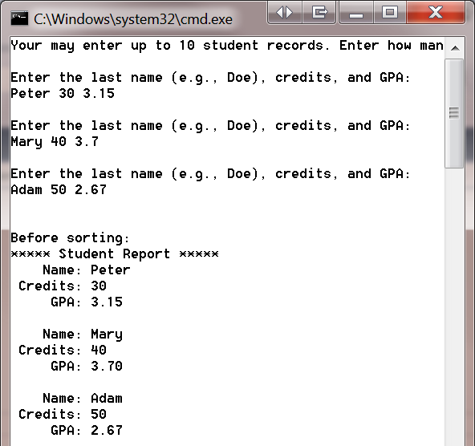
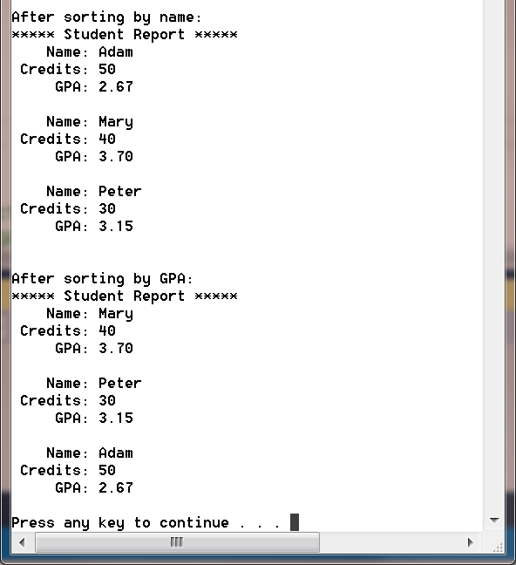

P5.2 Given the following student class interface, a) implement all member functions of the class, b) implement all non-member external functions of the class, and c) write a main() function to generate an output similar to the sample output appeared after the class interface. Notice that not all pre- and post-conditions for functions are provided; some are intentionally left out for you to fill in.
// **** student class interface for P4.2 ****
#include <iostream>
#include <string>
#include <iomanip>
using namespace std;

class student
{
public:
student();
student(string, int, double);
string getName();
// "Accessor" or "accessor function"
// Postcondition: returns the GPA of the calling object

int getCredits();

double getGPA();

void setName(string& str);
// "Mutator" or "mutator function"
// Postcondition: data member name of the calling object has been set to str

void setCredits(int);

void setGPA(double);

void setStuRec(string, int, double);

private:
string name; // Last name only
int credits;
double GPA;
};

// **** External functions for P4.2 ****
void inputStuRec(student& obj);
// prompts the user to enter values to fill obj
// Postcondition: obj is filled with user entered values

void outputStuRec(student& obj);
// Postcondition: contents of obj is displayed

int fillStuArray(student[], int size);

void sortStuArrayByName(student[], int n);

void displayStuReport(student[], int n);

void swap(student&, student&);

bool compareName(student& obj1, student& obj2);

bool compareGPA(student& obj1, student& obj2);

P5.3 Enhance either P4.1 or P4.2 by allowing the user to enter full name for each student in the format of Last-name, First-Name, e.g., Doe, John.

