1. Cloud Applications are run on some ________________application server in the internet.

2. _____________________________ Architectures implement the CPU in such a way that more than one instruction can be performed (completed) at a time

3.In a ____________ system there are multiple processors that share other all other system resources (memory, disk, etc).
.
4.What is the value of the following signed integer 1010 1001

5. _________________ is the most common method of transferring data directly between a peripheral and system RAM.

6.An instruction that only the operating system can execute is called a____________ instruction.

7.What is the value of the following 2’s complement number

1111 1111 1101 1011

8.What technique is being utilized when high performance is obtained by subdividing the clock cycle into a number of sub-intervals

9.When a computer starts up, it begins to load information from the hard disk into its ________________ memory?

10.Who was the scientist who conceived the concept of a stored programmed control computer?

11. Express the base 10 number 21₁₀ as a base 4 number____________.

12. Only seven bits are needed to encode the complete ASCII character set. What is the 8th bit used for when encoding the ASCII symbol @ into an 8 bit word?

13.In a monochrome bitmap how many bits are needed to stored the color of a pixel.

14.What type of compression algorithm is used when creating a JPEG image?

15.What is value of the 1’s complement integer 1001 1101?

16.There are usually four stages in an instruction cycle. Name the first stage.

17.File descriptors are an index into a file-descriptor table stored by the ___________.

18.In lossless data compression, the _______________ of data is preserved

19.The elementary component of a Quantum computer is a _________

20. What type of data formatting is used in the image below:
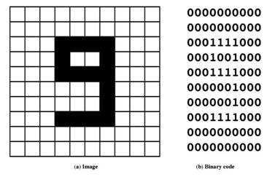

21.If you have a true color display using 8 bits for the intensity of each primary color. How many colors can you create for the display

22. Encode -2 ¾ as a 32 bit IEEE binary number?

23.Encode the symbol for 5 in binary so it can be printed on the console screen?

24. Convert the Octal number 24₈ to a HEX number

25.The ____________ is an in-memory buffer that connects two processes together

