- Problem Description
For this lab, assume we created the following ERD model for the Syracuse Airways database (see below).

As the model shows: the company has many airplanes which are of different specifications (e.g. Boeing 777, Airbus A320, and so on). Each aircraft specification has the same attributes, such as aircraftVersion, cabin number of seats and fuel capacity. The airplanes are assigned to diverse flight routes. Each flight route has a unique flight number, departs and arrives at particular airports at different cities in scheduled time. Every day the airplanes work according to their flight routes, but the flight schedule may be affected by flight statuses (on time, delay, or cancelled).

- Instruction
Imagine you are hired to implement t new database to support this business. Please use SQL DDL and DML to provide the following deliverables that satisfy the requirements.

- Create tables:
Create the eight tables following the ERD above. Copy and paste the complete create statements to your lab report. Make sure you set up correct constraints for the primary keys and foreign keys. Also the following domain constrains are required in the creating:
States Table
Primary/Foreign Key | Attribute | Data Type | Required | Domain Constraint
PK | stateAbbr | VARCHAR(2) | Y
 | stateName | VARCHAR(20) | Y

City Table
Primary/Foreign Key | Attribute | Data Type | Required | Domain Constraint
PK | cityKey | CHAR(8) | Y
 | cityName | VARCHAR(25) | Y
FK | stateAbbr | VARCHAR(2) | Y

Airport Table
Primary/Foreign Key | Attribute | Data Type | Required | Domain Constraint
PK | airportID | CHAR(3) | Y
 | airportName | VARCHAR(45) | Y | UNIQUE
FK | cityKey | CHAR(8) | Y

FlightRoute Table
Primary/Foreign Key | Attribute | Data Type | Required | Domain Constraint
PK | flightNumber | VARCHAR(6) | Y
FK | departAirport | CHAR(3) | Y
FK | arriveAirport | CHAR(3) | Y
 | scheduledDepartTime | TIME | Y
 | scheduledArrivalTime | TIME | Y

FlightSchedule Table
Primary/Foreign Key | Attribute | Data Type | Required | Domain Constraint
PK, FK | flightNumber | VARCHAR(6) | Y
PK | flightDate | DATE | Y
FK | statusID | CHAR(1) | Y | Value=”O”, “D” or “C”
FK | airplaneID | CHAR(8) | Y
 | delayDepartTime | TIME | N
 | delayArrivalTime | TIME | N

Status Table
Primary/Foreign Key | Attribute | Data Type | Required | Domain Constraint
PK | statusID | CHAR(1) | Y | Value=”O”, “D” or “C”
 | description | VARCHAR(20) | Y

Airplane Table
Primary/Foreign Key | Attribute | Data Type | Required | Domain Constraint
PK | airplaneID | CHAR(8) | Y
FK | aircraftTypeID | CHAR(8) | Y
 | purchaseDate | DATE | Y | Default=”01/02/2014”

AircraftSpecs Table
Primary/Foreign Key | Attribute | Data Type | Required | Domain Constraint
PK | aircraftTypeID | CHAR(8) | Y
 | aircraftVersion | VARCHAR(10) | Y
 | cabinNumOfSeats | INT | N
 | fuelCapacity | INT | Y

- Insert data:
Insert the following data (shown in the screenshots) to the tables. Copy and paste all insert statements to the lab report. You need to insert exact data as shown, because the same data will be used in future labs.

- Select data:
Select all content of each table to prove the success of creating tables and inserting data. Include the screenshots of the select results in the lab report. The select results should look like follows:
States table:
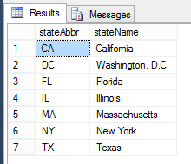

City table:
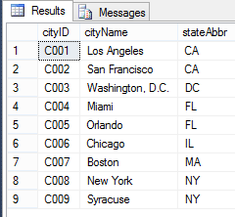
Airport Table:
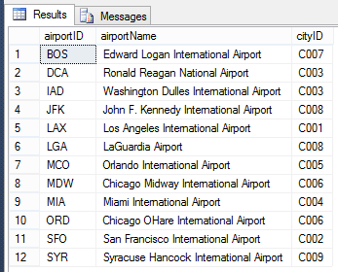

FlightRoute table:
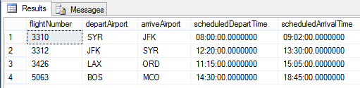

Status table:
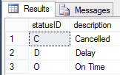
AircraftSpecs table:
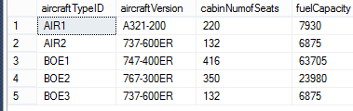
Airplane table:
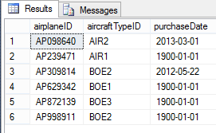
FlightSchedule table:
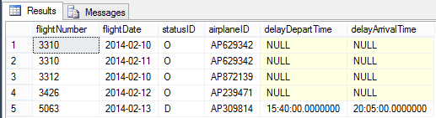

Submission instruction
Please submit your lab report (including SQL statements, and the screenshots of SQL statements and their results) in one PDF. Make sure your screenshots have good resolution. Remember to add comments to your SQL statements to explain the purpose of the code blocks.

