5.

A company has just negotiated a contract to produce a part for another firm. In the process of manufacturing the part, the inside diameter of successive parts becomes smaller and smaller as the cutting tool wears. However, the specs are so wide relative to machine capabilities that it is possible to set the diameter initially at a large value and let the process run for a while before replacing the cutting tool.
The inside diameter decreases at an average rate of .001 cm per part, and the process has a standard deviation of .05 cm. The variability is approximately normal. Assuming a three-sigma buffer at each end, how frequently must the tool be replaced if the process specs are 3 cm and 3.5 cm. Use (Number of shafts) n = 1.
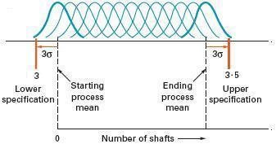
Determine how many pieces can be produced before the LCL just crosses the lower tolerance of 3 cm. (Do not round your intermediate calculations.)

After pieces the cutting tool should be replaced.

