DEVIL DOG DAIRY
OOHRAH STUDIOS | 4/24/17 | [Edition 1, Volume 1]

INTRODUCTION
  - 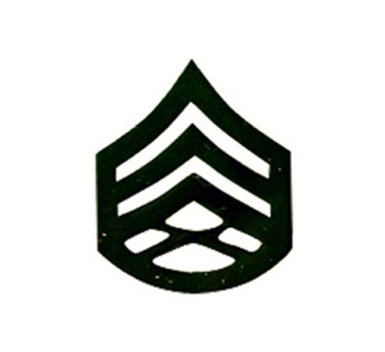
Introduction
This newsletter is to inform and entertain. The information that will be put on this letter will benefit the reader in a professional capacity. It will demonstrate how to write a resume and finish with a resume letter. There will parts that will make readers consider information that they read. It will be very thought provoking and contain a mental stimulus. The rest of the newsletter will incorporate entertainment by having a section in which the writer will describe themselves and the family. The writer will also incorporate stories about the Marine Corps

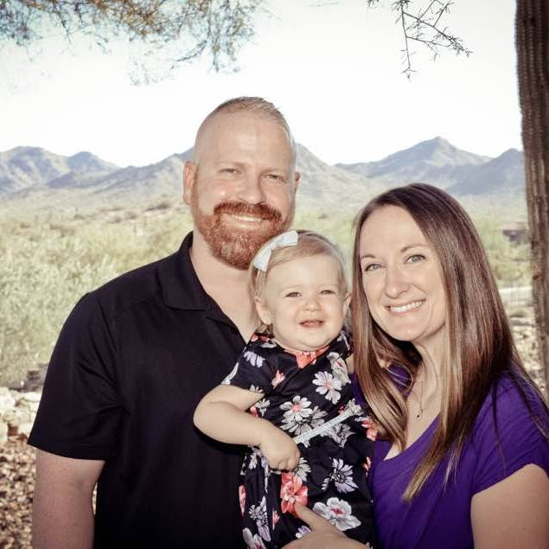
THE HESSE CLAN

My name is Daniel Hesse. I would say there are many things that describe me as a person. The first thing is that I am a father of a beautiful baby girl who is almost 2. I never knew that you could love unconditionally and then she’s here and I am a sack of emotions all the time. I would not change that for the world. A recent Marine Corps retiree, I am trying to find my path outside that of the warrior. I am going to school to be a Global Logistics Manager. I only have 1 year left and then off to kick the door in for my career. I am also a devoted husband to my wife Emily. We have all the necessary tools to make this marriage work and I am excited what the next 50 years will be like

Emily Hesse is a woman that no words can ever describe how perfect she is. She is Navy veteran and continues to wear that pride everywhere she goes. She also is a recent graduate of University of San Diego and received her Bachelor’s Degree in Business Administration. Right now, she is a stay at home mother and believe it or not it is the hardest job on the planet. Kudos to my lovely wife to keep the house and child in shape while I am gone studying. Love you

Loren Hesse is my daughter of almost two years. She is the sunshine to my rain and all that other cheesy sayings. She is the best thing that has ever happened to me. She is starting to become a little girl and her personality is tagging right along. She is fond of Disney movies and Nick Jr. shows. She is wrecking ball and she is insanely smart and very beautiful. Love you LO LO.

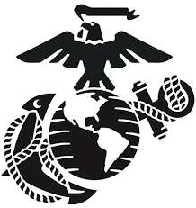
THE UNITED STATES MARINE CORPS

The Marine Corps is a military organization that was founded November 10, 1775. That’s right, a little less than a year from when our country became the United States of America. The Marine Corps is an organization that primarily focuses on combat and mission accomplishment. The President of the United States of America call the Marine Corps up to accomplish any job that the nation needs. We are the nation’s 911 force. The Marine Corps has fought in every major conflict the United States has ever seen. We have fought in the Revolutionary War, Civil War, WWI, WWII, Korea, Vietnam, Desert Strom, Afghanistan and Iraq. There have also been skirmishes along that route that we also took care of, the Banana Wars and saving the Pasha of Tripoli from the Barbary Pirates. Our motto, Semper Fidelis, is latin for Always Faithful. We are driving by our core values, Honor, Courage and Commitment. Once a Marine always a Marine. Marines are trained in three places: Marine Corps Recruit Depot San Diego, Marine Corps Recruit Depot Parris Island and Officer Candidate School in Quantico, Virginia. Our history is always being written and our legacy will always be alive if the United States stays alive.
There are many moving parts in the Marine Corps and someone must lead from the front. That person is the Commandant of the Marine Corps. His soul purpose is to be buffer between Congress and the Marines. He is the highest-ranking Marine in the Marine Corps and oversees everything within that branch of service. The Marine Corps also has an individual that is the highest ranking enlisted member and he is the Sergeant Major of the Marine Corps. He is the buffer between the enlisted troops and the officers. He is the literally and figuratively the right-hand man of the Commandant of the Marine Corps.
The history of the Marines can span millions of books. There have been individuals who have done great things within the Marines. There have also been battles in which the Marines have solidified their place in America. November 10, 1775 is the birthday of the Marine Corps. It has been celebrated every year since its inception. The Marine Corps holds the highest pride on this day. No matter where a Marine is rather it be in harm’s way, in garrison, retired or honorably discharged, we will always have a cake waiting to be cut. The Marine Corps fought in WWI in the Aragon Forrest in France against the German Army. The Germans would say that we fought like Teufelhunden which translates to Devil Dog. We fought on the islands of the Pacific. Most notably, the island of Iwo Jima. This is where the Marines put up the American Flag aboard Mount Surabachi. The Marines have fought in Korea at the Chosin Reservoir. The Marines have fought in Khe Sanh and Da Nang in the country of Vietnam. We fought in Granada and the deserts of Kuwait. Finally, we are continuously fighting the enemy in the mountains of Afghanistan and the hot barren sands of Iraq.

