Data Storage
Name: ________________________
Note: Questions/cases provided by the EMC Academic Alliance

Part I: Multiple Choice Questions (Each correct answer 1.5 points)
1. What is an example of semi-structured data?
- Database
- Spreadsheet
- Image
- PDF file
2. Why do organizations seek to store, protect, optimize, and leverage information?
- To derive new business opportunity
- To increase dependency on fast and reliable access to information
- To promote growth of digital information
- To reduce the investment in deploying security
3. What is a benefit of Big Data analytics?
- Enables mobile access to information
- Enables data-driven decision making
- Enables IT as a service
- Enables elimination of IT silos
4. What is a benefit of virtualization?
- It enables maintaining conformance to resource configuration standards
- It automatically configures and provisions resources to support services
- It consolidates and improves the utilization of physical IT resources
- It ensures continuous availability of services in the event of a failure
5. Which statement is true about solid-state drive?
- Stores data on a circular disk with a ferromagnetic coating
- Stores data on a semiconductor-based memory
- Stores data on a polycarbonate disc with a reflective coating
- Stores data on a thin plastic film with a magnetic coating
6. Which storage architecture does the graphic represent?
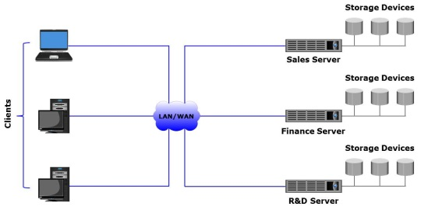
- Information-centric
- Network-centric
- Application-centric
- Server-centric
7. Which factors affect the performance of a disk drive?
- Rotational latency, number of platters, and data transfer time
- Seek time, rotational latency, and number of read/write heads
- Seek time, rotational latency, and data transfer time
- Data transfer time, number of cylinders, and rotational latency
8. Which component of an intelligent storage system performs functions such as provisioning, tiering, and cache management?
- Controller
- Solid-state drive
- Flash cache
- Host bus adapter
9. Which is the time taken by the platter of a hard disk drive to position data under the read/write head?
- Seek time
- Disk service time
- Data transfer rate
- Rotational latency

10. In the graphic, A1, A2, A3; B1, B2, B3; and C1, C2, C3 represent data.
Ap, Aq, Bp, Bq, Cp, and Cq represent parity. Which RAID level does the graphic represent?
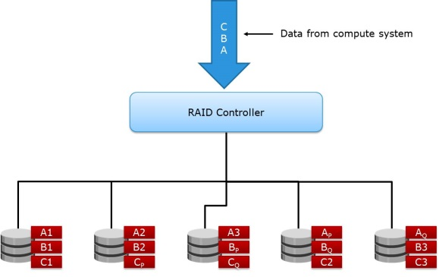
- RAID 5
- RAID 6
- RAID 3
- RAID 4
11. Which type of metaLUN provides only additional capacity without improving performance?
- Striped
- Mirrored
- Concatenated
- Parity
12. Which technology provides performance acceleration for read-intensive workloads and avoids network latencies associated with I/O access to a storage array?
- Inter-array storage tiering
- Intra-array storage tiering
- Storage flash caching
- Server flash caching
13. Which type of write cache implementation does the graphic represent?
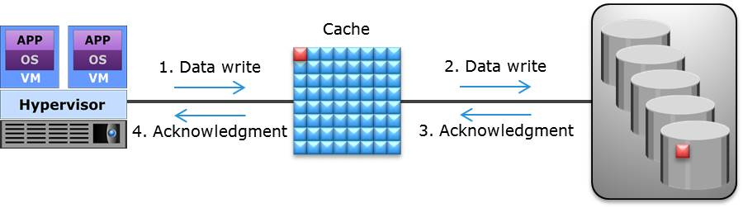
- Write-back cache
- Write-through cache
- Low watermark cache
- High watermark cache
14. Which best describes Network-attached Storage (NAS)?
- Stores data in the form of objects on flat address space based on its content
- Provides compute system with block-based access to storage
- An IP-based, dedicated, high-performance file sharing and storage device
- A single integrated storage infrastructure that consolidates block, file, and object access
15. Which is true about scale-out NAS?
- Pools multiple nodes in a cluster to work as a single NAS device
- Scales performance and/or capacity non-disruptively of a single NAS system
- Consolidates file, block, and object access
- NAS systems have a fixed capacity ceiling
16. What is a benefit of SAN?
- Enables consolidation and sharing of storage resources
- Enables creating a server-centric storage environment
- Consolidates LAN and WAN traffic into a common IP infrastructure
- Enables high-speed data transmission between client workstations
17. Which is an accurate statement about software-defined networking?
- Controller integrates the data plane and the control plane of network components
- Controller performs physical cabling between network switches
- Controller resides on the data plane of network components
- Controller sends instructions for data plane to handle network traffic
18. Which fabric service distributes Registered State Change Notifications (RSCNs) to the node ports?
- Management Server
- Name Server
- Fabric Controller
- Fabric Login Server
19. What enables network traffic from multiple virtual SANs to traverse a single interswitch link?
- Link aggregation
- N_Port virtualization
- Zoning
- Trunking
20. Which iSCSI network component performs both iSCSI and TCP/IP processing?
- iSCSI HBA
- Software iSCSI adapter
- TCP Offload Engine NIC
- Standard NIC
21. Which is an accurate statement about switch aggregation?
- It enables ports in both the switches to forward network traffic simultaneously
- It combines VLANs that are created on both the switches
- It creates a trunk link between the switches to transfer untagged frames
- It allows transmission of tunneling data between FC SAN islands
22. Which accurately describes a stretched VLAN?
- It is a VLAN that spans across multiple sites over a WAN connection
- It is a logical network that is created across multiple VLANs
- It is a physical LAN that is created across two FC SAN islands
- It is a VLAN that allows an Ethernet switch to join the VLAN automatically
23. Which component of an FCoE SAN provides functionality of both NIC and FC HBA?
- VF_Port
- Ethernet Bridge
- Converged Network Adapter
- Fibre Channel Forwarder
24. What is enabled by the congestion notification functionality of a Converged Enhanced Ethernet network?
- A switch to send a signal to other ports that need to stop their transmissions
- A CNA to convey and configure its features with the other CNAs in the network
- A name server to notify switches on the allocation of network bandwidth
- A VF_Port to send PAUSE frames across eight virtual network links
25. Which layers of FC protocol stack are replaced with Ethernet according to FCoE protocol specification?
- FC-0, FC-1, and FC-2
- FC-2 and FC-4
- FC-0 and FC-1
- FC-1, FC-2, and FC-4
26. Which best describes recovery-time objective (RTO)?
- Point-in-time to which data must be recovered after an outage
- Time available for a system or component to perform its normal operations between failures
- Time within which systems and applications must be recovered after an outage
- Amount of data loss that a business can endure
27. Which statement is true if the recovery-point objective (RPO) of an application is 2 hours?
- Time to resume application operations must be less than 2 hours
- Time to resume application operations must equal to 2 hours
- No more than 2 hours of production data can be lost
- Mean time between application failure is 2 hours
28. Which is true about business impact analysis?
- Identifies which business units and processes are essential to the survival of the business
- A part of business continuity process, which involves a set of policies and procedures for restoring IT infrastructure
- Defines the time window during which information must be accessible for business operations
- Estimates the total cost of ownership for each business function
30. What is a key advantage of compute clustering?
- Increases the number of VMs running on a compute system
- Improves the speed of a compute system
- Enables service failover in the event of compute system failure to another system
- Reduces the storage required for a compute system
31. What best describes graceful degradation?
- Provides the capability to run VM without any downtime, even if the hypervisor fails
- The ability of an application to maintain limited functionality even when some of the modules are not available
- A key mechanism in an application design that implement retry logic within a code, in order to handle a service that is temporarily down
- Provides the capability to run VM without any downtime even if the storage is not available
32. What is the role of a backup client?
- Gathers the data that is to be backed up and send it to the storage node
- Manages the backup operations
- Sends tracking information to the backup server about the data written to the backup device and controls one or more backup devices
- Maintains the backup catalog
33. What is an advantage of incremental backup?
- Requires lesser time to restore than cumulative backup
- Requires less time to backup
- Eliminates data deduplication
- Increases backup window
34. When deploying a cold backup solution, what should be considered?
- Application must be shut down during the backup process
- Incremental backup cannot be performed
- An open file agent must be deployed to perform the backup
- Deduplication cannot be performed during the backup process
35. Why replica must be consistent with the source volume in a replication environment?
- To ensure the usability of the replica
- To reduce the size of the replica
- To increase the retention period of the replica
- To improve the performance of the replica
36. What is an advantage of implementing virtual machine (VM) clone?
- Increases the performance of the source VM
- Allows to restore VM to any previous PIT
- Minimizes the total cost of ownership
- Reduces the time required to deploy a new VM
37. What is true about pointer-based virtual replication?
- Replica is immediately accessible when the replication session is started
- Size of the replica should be greater than the size of the source volume
- Replica and source must be in different storage system
- Source need not to be healthy when restoring data from replica
38. In a CDP replication, which determines how far back the recovery points can go?
- Type of the write splitter
- Size of the journal volume
- Size of the source volume
- Type of the appliance
39. Which goal of information security ensures that authorized users have reliable and timely access to resources?
- Availability
- Confidentiality
- Integrity
- Auditing
40. Which type of attack prevents legitimate users from accessing resources?
- Account Hacking
- Media Theft
- Spoofing DR Site Identity
- Denial of Services
41. Which are the four entities involved in the OAuth control mechanism?
- Resource owner, resource server, client, and resources
- Authorization server, compute system, client, and resources
- Resource owner, resource server, client, and authorization server
- Authorization owner, authorization server, client, and resources
42. Which security control has the ability to remotely wipe the data on the enrolled devices when a threat is detected?
- Mobile device management
- Malware protection software
- Intrusion Detection and Prevention System
- Demilitarized zone
43. Which statement is true about data shredding?
- It is a process of deleting data or residual representation of data and making it unrecoverable on storage media
- It is a cryptographic technique in which data is encoded and made indecipherable to eavesdroppers or hackers
- It is a security control designed to examine data packets traversing a network and compare them to a set of filtering rules
- It is a security tool that automates the process of detecting and preventing events that can compromise the confidentiality, integrity, or availability of IT resources
44. Which characteristic of the storage infrastructure management provides automated arrangement and coordination of component functions?
- Service-focused approach
- Software-defined infrastructure-aware
- End-to-end visibility
- Orchestrated operations
45. Which is an example of monitoring capacity?
- Examining the free space on a storage pool
- Measuring the throughput of an HBA
- Tracking unauthorized access to a storage system
- Identifying orchestration failure
46. Which management process maintains information on the inter-relationships among infrastructure components?
- Configuration management
- Change management
- Problem management
- Monitoring
47. Which is an example of performance management?
- Architecting a multi-site continuous data protection solution
- Detecting and recording all unplanned events that degrade service quality
- Separating sequential and random I/Os to different disk drives
- Approving a request for modification of a service’s attributes

48.How vulnerabilities can be reduced in an IT environment?
A. By maximizing attack surface and minimizing work factor
B. By minimizing attack surface and maximizing work factor **
C. By maximizing both attack surface and work factor
D. By minimizing both attack surface and work factor
49.Which SAN security mechanism prevents a switch port from being enabled even after a switch reboot?
A. Port lockdown
B. Persistent port disable **
C. Port binding
D. Port zoning
50.Which security mechanism ensures that a port can only be initialized with a specific port type?
A. Port lockdown **
B. Persistent port disable
C. Port binding
D. Port zoning

