We Are Parties, INC is using a paper based system to keep track of the supplies ordered for events and the location of events they cater. They would like you to develop a system that automates the process. Entities and their attributes that they need to keep track of include (but may not be limited to)

Supplies

- Consumable/beverage items

- Tabletop supplies

- Display/Décor Items

- Cooking/Holding Supplies

- Furniture

Trucks

- Fleet Number

- Vehicle type (15 character string, ex. Tracker Trailer)

- Driver (last name)

- Fuel (5 digit numeric, ex. 50000)

Destination/Location of Event

- Title (3 digit alphanumeric, ex. NWK)

Drivers

- Driver name

- Loader name

Content of Vehicle

- Skid ID number (4 digit numeric)

- Skid weight (4 digit numeric)

- Skid contents

Relations

- Vehicle to/from Destination

- Driver driving vehicle

Vehicle carry cargo

Part I: ER Diagram

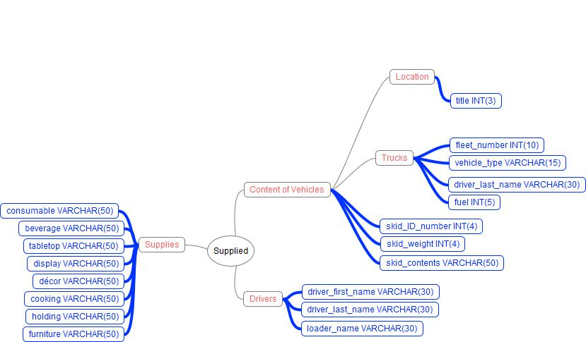

Answer the following Question

i. Generate the data dictionary required for your database

ii. Generate the necessary data flow diagrams for your system

