Heartland Express, Inc. Enterprise Analysis
Contents
Background and History of the Enterprise 2
Brief History of Enterprise 2
Industry & Markets 3
Products & Services 4
Management 4
Acquisitions and Divestitures 5
Financial Analysis and Trends – 8
Balance Sheets 8
Balance Sheet Narrative Comments 11
Income statements 13
Income statements and Narrative Comments 14
Cash Flow statements 16
Cash Flow statements and Narrative Comments 20
Graphical comparisons and comments & peer group comparisons and comments 21
SWOT Analysis of Enterprise 28
Enterprise and Management Assessment – 32
Enterprise culture and reputation 32
Strategic competitive advantages and disadvantages 32
Summary and Opinions - Student contribution. 35
References 36

Background and History of the Enterprise

Brief History of Enterprise
The origins of Heartland Express can be traced to 1955, when Scott's Transportation Services of Cedar Rapid, Iowa, began as a hauler for the recently launched Whirlpool line of washing machines. The company remained small for the next two decades, growing to a fleet of 16 trucks by the late 1970s. In 1978 Russell A. Gerdin bought the company, renamed it, and relocated it to Coralville, Iowa. By then, Gerdin, whose father had owned a small trucking company, had more than a dozen years of experience in the trucking industry.
Heartland became a publicly listed company on the NASDAQ (HTLD) in 1986 and has grown to produce over $582.25 million in total revenue (2013). The company continued to grow slowly but steadily through the first half of the 1980s, despite the nationwide recession of the period. More and more manufacturers began to automate production and turn to “just in time” inventory systems, supplying production lines with materials and parts only at the time they were actually needed, which enabled manufacturers to decrease their reliance on costly warehousing. In turn, the manufacturers became more reliant on short-haul shippers to meet their inventory needs.
Heartland had doubled its revenues by 1986, to nearly $22 million. The company's string of profits also continued, reaching $3 million that year. By November 1986 Heartland was prepared to step up its expansion. Gerdin took the company public, selling 1.5 million shares at $10 per share. Most of the shares sold were Gerdin's, reducing his control of the company to about 65 percent. Portions of the proceeds from its initial public offering (IPO) went to expanding the company's fleet. (Cohen)

Industry & Markets
Heartland Express, Inc., is one of the leading trucking companies serving the short-to-medium-haul truckload market in the United States. Based near Liberty, Iowa, Heartland's operations focus on trips within a 400-mile radius of regional terminals like those that are primarily concentrated within the region east of the Rockies. The company focuses especially on the Midwest and southeast regions. It also offers limited but expanding service to the West and East Coast regions and serves all 48 states in the contiguous United States.
Heartland owns and operates one of the youngest fleets in its industry. Although owner-operators once supplied more than half its tractors, by 2006 the number of independent drivers had slipped below 10 percent. The average haul of a Heartland Express truck covered 513 miles in 2009. In addition to its headquarters facility in Liberty, Iowa, the company operates 11 regional distribution facilities in Fort Smith, Arkansas; O'Fallon, Missouri; Atlanta, Georgia; Columbus, Ohio; Jacksonville, Florida; Kingsport, Tennessee; Olive Branch, Mississippi; Chester, Virginia; Carlisle, Pennsylvania; Phoenix, Arizona; and Seagoville, Texas. Service from these regional centers focuses on short-haul freight runs for major customers in each region. For the purpose of this analysis I will be focusing on local transportation when doing competitive analysis sand industry comparisons, as this fits the business model. Some long distance trucking companies will be used as industry indicators. (Cohen)

Products & Services
Customers include retailers, manufacturers and third party logistic providers. The company attempts to operate its tractors while under warranty to minimize repair and maintenance costs and reduce service interruptions caused by breakdown. Preventive maintenance programs minimize equipment downtime and enhance trade value when equipment is sold. Heartland also contracts with independent carriers to provide flexible resources in response to fluctuations in shipper demand.
Focusing on short hauling permits the company to use single drivers and to dispatch most trailers directly from origin to destination without equipment change. Heartland also targets freight that requires little or no handling. (Cohen)

Management
Russell Gerdin's son Michael became president of the holding company in May 2006. Michael Gerdin had been working for the company since 1983 and most recently had been vice president of regional operations. His father, who remained chairman and CEO, had survived a heart attack in 2000 and was being treated for liver cancer. The publicity-shy Russell Gerdin was named to the Iowa Business Hall of Fame in 2006.
In May 2007 Heartland paid out more than half of its $365 million in cash reserves to shareholders in a special $2 per share dividend. The Gerdin family then owned a little more than 40 percent of the firm's common stock. The company relocated its headquarters from Iowa City to a new facility on I-380 near North Liberty, Iowa, in July 2007. In August 2008 Heartland bought a terminal in Seagoville, Texas, near Dallas. This, its 10th regional facility, became operational in January 2009. The company had 2009 revenues of $459.5 million, down from $625.6 million the previous year. Heartland Express was able to maintain its margins during the economic slowdown, although net income fell from $70 million to $57 million. There were about 2,800 employees at year-end, 500 fewer than the year before. (Cohen)

Acquisitions and Divestitures
By 1993 Heartland revenues had jumped to $115 million. The following year, Heartland moved to double the size of the company by acquiring Munson Transportation Inc., a struggling trucking company based in Monmouth, Illinois. Under the conditions of the acquisition, Munson received shares of Heartland stock, then worth $73 million, while Heartland assumed Munson's $55 million debt. In addition to acquiring Munson's aging fleet and facilities, Heartland gained access to Munson's northeast and West Coast markets, expanding Heartland to a national trucking line.
After attempting to merge Munson's operation into the company, Heartland finally consolidated both companies, closing Munson's Illinois facilities and moving its operations to Heartland's Coralville, Iowa, headquarters. The company also sold off most of Munson's aging, diversified trailer fleet, returning the company to its uniform, 53-foot aluminum plate fleet of trailers.
A booming year for trucking in 1994 helped Heartland overcome the challenges of the Munson acquisition. By the end of 1995, Heartland had wiped out its entire debt. As a company posting nearly $200 million in sales, with a net income of more than $20.5 million, Heartland had taken its place as one of the top 10 truckload carriers in the United States. (Cohen)
The trucking boom extended into the late 1990s and led to a driver shortage. At this time about 60 percent of the company's drivers owned their own rigs. Mechanics were also scarce. A&M Express Inc. of Kingsport, Tennessee, was acquired in July 1997. It had annual revenues of $28 million. (Cohen)
Virginia-based Great Coastal Express Inc. was acquired in June 2002. In 2005 Heartland expanded to the West by adding a leased regional base near Phoenix, Arizona. It built its own facility there, which opened two years later. (Cohen)
In Nov. 2013 Heartland Express acquired Gordon Trucking to increase their west coast operations. Just as they did with their southern operations when acquiring Munson’s. Gordon trucking west to east coast split is 77% west coast and 23% east coast, Heartland Expresses west to east coast split is 82% east coast and 18% west coast. When combined Heartland Express with have a 585% east coast and 42% west coast presence. (Heartland Trucking, Inc.)
The Gordon trucking acquisition has increased their nationwide presence and increased their companies portfolio or commodities and lines of business all while keeping to their local short run business model. (See next chart)
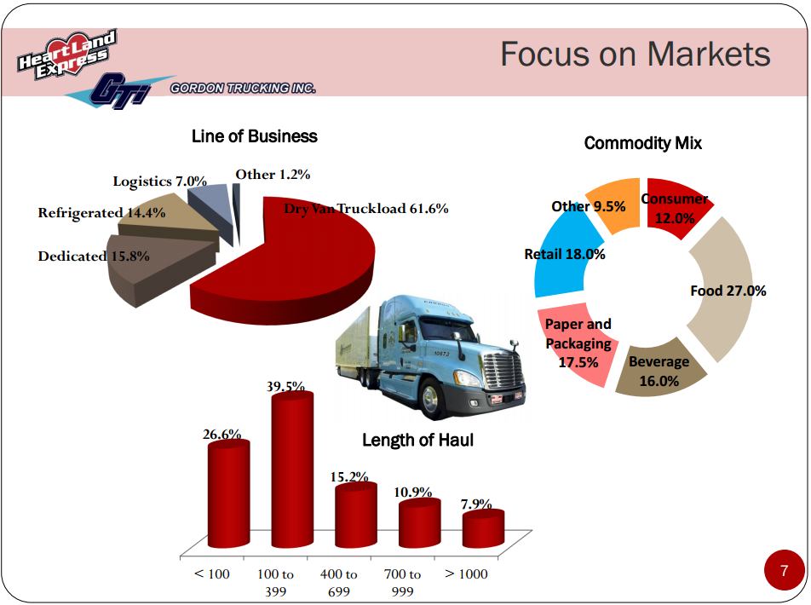
(Heartland Trucking, Inc.)

Financial Analysis and Trends –

Balance Sheets
 | 2013 | 2012 | 2011 | 2010
 | Year 4 | Year 3 | Year 2 | Year 1
BALANCE SHEET
Assets
Cash in Bank on Hand | $ 17,763 | $ 119,838 | $ 139,770 | $ 121,120
short term investments | $ - | $ - | $ - | $ 8,300
Trade Receivable, net | $ 84,400 | $ 46,555 | 44,198 | 41,619
prepaid tires | $ 6,999 | $ 6,603 | 12,820 | 6,570
pre-paid shop supplies | $ 4,194 | $ - | - | -
Other Current assets | $ 11,061 | $ 2,281 | 1,932 | 1,725
income tax receivable | $ 5,706 | $ 2,351 | 314 | 2,052
Prepaid Expenses | $ 14,177 | $ 13,797 | 14,401 | 12,400
Total Current Assets | $ 144,300 | $ 191,425 | $ 213,435 | $ 193,786
Land | 17,069 | 17,451 | 17,451 | 17,442
Building (const in prog) | 27,813 | 26,761 | 26,761 | 26,761
Furniture & Fixtures | 1,829 | 2,269 | 2,269 | 2,269
Equipment | 10,604 | 7,266 | 7,324 | 6,462
Leasehold Improvements | 16,134 | - | -
Vehicles | 549,415 | 378,583 | 355,905 | 333,254
Accumulated Depreciation | (173,605) | (189,959) | (161,269) | (165,736)
Total Fixed Assets | $ 449,259 | $ 242,371 | $ 248,441 | $ 220,452
Goodwill | 98,686 | 4,815 | 4,815 | 4,815
Long Term Investments | - | 20,016 | 50,569 | 80,394
Organizational Costs (other intangible) | 18,746 | - | - | -
Other Assets | 13,850 | 9,110 | 8,406 | 6,588
Total Assets | $ 724,841 | $ 467,737 | $ 525,666 | $ 506,035
Liabilities
Accounts Payable | $ 26,912 | $ 7,583 | $ 9,088 | $ 10,972
Comp and Benefits Payable | 28,084 | 16,409 | 15,493 | 14,823
Insurance Accruals | 20,945 | 13,924 | 13,997 | 16,341
Other accruals | 12,627 | 7,439 | 7,085 | 6,764
Deferred Revenue
Total Current Liabilities | $ 88,568 | $ 45,355 | $ 45,663 | $ 48,900
Income taxes payable | 20,089 | 23,122 | 24,077 | 27,313
long-ter debt | 75,000 | - | - | -
deferred income taxes, net | 61,948 | 51,306 | 57,661 | 40,917
insurance accruals less current portion | 67,965 | 57,590 | 57,494 | 54,718
Other long term Liabilities | 13,618 | - | - | -
Total Liabilities | $ 238,620 | $ 132,018 | $ 139,232 | $ 122,948
Stockholder's Equity
Capital Stock | 907 | 907 | 907 | 907
Paid-in-Capital | 5,897 | 2,968 | 589 | 439
Treasury Stock + other loss | (41,185) | (80,540) | (56,350) | -
accumulated other comprehensive loss | - | (1,284) | (3,081) | (3,081)
Retained Earnings | 432,034 | 368,313 | 398,706 | 335,922
Total Equity | $ 397,653 | $ 290,364 | $ 340,771 | $ 334,187
Total Liabilities & Equity | $ 724,841 | $ 467,737 | $ 525,666 | $ 506,035

Balance Sheet Narrative Comments

Heartland Express’s total assets have stayed steady in the last four years. However the quick acid test that has fallen shows that they may be entering into a cash on hand issues. If this number from the acid test drops below one it could be bigger issues when needing to meet their financial obligations. Two actions can account for the drastic drop in this acid test ratio. The3 numbers show that they acquired Gordon Trucking in Nov. of 2013 and assumed its debt and used cash to make the purchase. Another action that can account for the decrease of cash this year is the purchase of 400 new tractor and 500 new trailers in 2013 as Heartland increases its fleet and moves away from operators owning their own trucks (Heartland Trucking, Inc.) . Taking on the risk and financial burden is one of the greatest industry road blocks to the trucking industry is the rising cost to own and operate a tractor. With the current driver shortage and slow come back from our recession, I believe that Heartland has done the right thing. Another action that has affected these ratios and comparisons is that Heartland has taken on a $75,000,000 unsecured revolving line of credit on Dec. 31st 2013 to help offset the acquisition of Gordon Trucking debt.

Income statements
 | 2013 | 2012 | 2011 | 2010
 | Year 4 | Year 3 | Year 2 | Year 1
INCOME STATEMENT
Gross Sales or Revenue | $ 582,257 | $ 545,745 | $ 528,623 | $ 499,516
Net Sales | 582,257 | 545,745 | 528,623 | 499,516
Gross Profit | 582,257 | 545,745 | 528,623 | 499,516
Operating Expenses:
Sales & Market Expense | 3,552 | 2,953 | 2,957 | 3,187
General & Admin. Move to cost of service provided (wages+rent+fuel+op&main+op tax+insurace claims+depreciation+other+gain) | 466,401 | 447,891 | 419,109 | 404,880
Total Oper. Expense | 469,953 | 450,844 | 422,066 | 408,067
Operating Income | 112,302 | 94,901 | 106,557 | 91,449
Other Income & (Expenses) | 254 | 674 | 773 | 1,424
Net Income Before Taxes | 112,556 | 95,575 | 107,330 | 92,873
Income Taxes ( | 41,974 | 34,034 | 37,398 | 30,657
Net Income + other income net of tax | $ 71,866 | $ 63,338 | $ 69,932 | $ 64,461

Income statements and Narrative Comments

Heartland Express is looking good in this category. With revenue and profit up and operating expense staying neutral it looks favorable. In 2010 and 2012 there was a decrease in total net income plus other income net of tax, but when compared to industry standard they fared well. Heartland is a steady company with good return on investment. Even with a strong and increasing profit margin on services provided. I am concerned however the cash flow statements show that they are consuming their cash on hand. An action that can account for this flux is that Heartland Express used cash on hand to purchase trucks for their local runs, allowing them the ability to hire drivers that do not want to take the financial risk with increased truck prices. Heartland also likes to purchase trucks and operate them while under warranty to avoid costly repairs.

Cash Flow statements
CASH FLOW STATEMENT | 2013 | 2012 | 2011 | 2010
Cash Flow from Operations | Year 4 | Year 3 | Year 2 | Year 1
Cash Inflows:
Net income | $ 70,582 | $ 61,541 | $ 69,932 | $ 62,216
depreciation and amortization | $ 69,649 | $ 57,821 | $ 57,876 | $ 61,949
deferred income taxes (+) | $ 10,262 | $ - | $ 14,743 | $ -
loss on sale of investments | $ 200 | $ - | $ - | $ -
amortization of stock-based comp | $ 1,184 | $ 2,379 | $ 150 | $ -
trade receivable (+) | $ 7,834 | $ - | $ - | $ -
prepaid exp and other current assets (+) | $ 904 | $ 5,688 | $ - | $ 252
accounts payable, accrued liabilities, and accrued exp (+) | $ - | $ 953 | $ - | $ 1,609
Int & Div's Collected
Other Oper. Receipts
Cash In from Operations | 160,615 | 128,382 | 142,701 | 126,026
Cash Outflows:
Gain on disposal of property and equipment | -33270 | -15109 | -32133 | -13317
accounts payable, accrued liabilities, and accrued exp (-) | -9722 | 0 | -952
accrued income taxes | -6388 | -2992 | -1498 | -1404
deferred income taxes (-) | 0 | -5751 | 0 | -8440
trade receivable (-) | 0 | -2357 | -2579 | -4258
prepaid exp and other current assets (-) | 0 | 0 | -6459 | 0
Other Operating Pmts | 0 | 0 | 0 | 0
Cash Out for Operations | (49,380) | (26,209) | (43,621) | (27,419)
Net Cash from Operations | 111,235 | 102,173 | 99,080 | 98,607
Cash Flows from Investing
Sale of Fixed Assets | 92313 | 29184 | 73018 | 21649
Maturity, calls and sales of investments | 21100 | 32350 | 38125 | 79225
Acquisition of business, net of cash acquired | -110900 | 0 | 0 | 0
other | -825 | -704 | -1818 | -217
Purchase of investments | 0 | 0 | 0 | -18000
Purch. of Fixed Assets | -135195 | -66811 | -126257 | -14551
Net Cash from Investing | $ (133,507) | $ (5,981) | $ (16,932) | $ 68,106
Cash Flows from Financing
Repayment of debt assumed | -147942 | -24190 | -56350 | 0
Proceeds from LT Debt | 75000 | 0 | 0 | 0
Dividends Paid | -6861 | -91934 | -7148 | -97944
Net Cash from Financing | -79803 | -116124 | -63498 | -97944
Net Increase/(Decrease) in Cash | (102,075) | (19,932) | 18,650 | 68,769
Beginning Cash Balance | $ 119,838 | $ 139,770 | $ 121,120 | $ 52,351
Ending Cash Balance | $ 17,763 | $ 119,838 | $ 139,770 | $ 121,120

Cash Flow statements and Narrative Comments

As in the other statements the cash flow statement is no different. All show the impact of the Gordon trucking acquisition. The benefit of the acquisition clearly out weights the negative impact to cash flow. You need to break a few eggs to make an omelet. The greatest impact to the cash flow statements was the assumption of Gordon Trucking’s debt. Based on the above I do not see any issue with their cash flow statement.

Graphical comparisons and comments & peer group comparisons and comments
Heartlands top competitors:
- Covenant Transport Group Inc.
- Knight Transportation Inc.
- Old Dominion Freight Line Inc.
- Swift Transport Co.
  - (Higher Revenue than Heartland Express and used as a market indicator in my report)
- Werner Enterprise Inc.
  - (Higher Revenue than Heartland Express and used as a market indicator in my report)
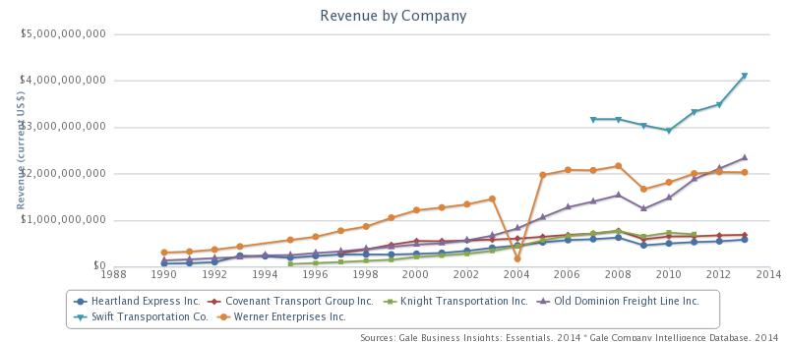
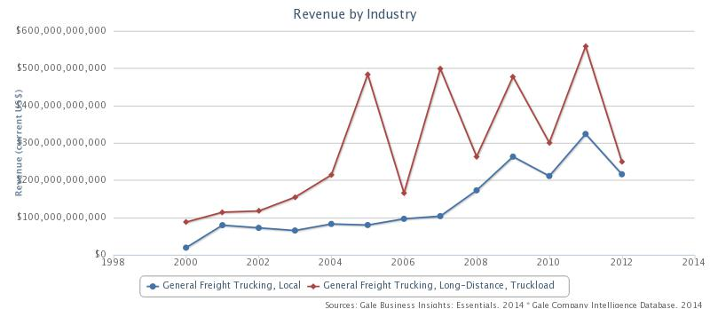
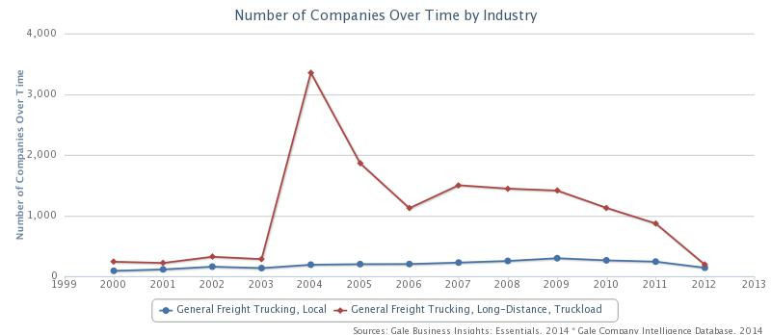
The trucking industry was greatly impacted by the 2008 recession. I have selected competitors that have similar revenue and two that have revenue higher than Heartland to show that the trucking industry as a whole was affected. There has been a steady decline in the number of total trucking outfits in the United States since the early 2000’s due to inflated gas prices and acquisitions. Larger trucking companies are acquiring smaller outfit to increase shipments and increase customer base of offset the decreased profit margins affecting the industry as a whole.
The industry has low market share concentration, with the top four players accounting for 7.2% of total industry revenue in 2014. Moreover, the 50 largest companies in the industry account for less than 30.0% of industry revenue. This low concentration is due to the relative ease of entry into the industry. Owner-operators dominate the freight trucking landscape, as over 90.0% of all operators in this industry are nonemployers. With little capital expenditure, a truck driver can get a loan to purchase a truck and start a freight trucking business. Despite the large number of owner-operators, these firms generate only a fifth of total revenue. Major players contribute a lower percentage of revenue individually, but they maintain significant market power by securing large contracts with major manufacturers and retailers, such as Walmart. These larger industry participants also subcontract owner-operators to transport goods, which increases their ability to set rates and standards.
Market concentration in the industry has declined over the five years to 2014. In 2009, market concentration was about 7.7% as nonemployer’s exited the industry due to decreasing demand. During this time, the larger companies began increasing their acquiring and merging activities to take advantage of the devaluation of smaller companies. Since, industry revenue has grown in every subsequent year; this has resulted in the number of enterprises growing every year after 2009. This influx of new entrants has taken away from the market share of each major player. (IBIS)
The trucking industry's operating profit (earnings before interest and taxes) is traditionally low, largely due to the highly competitive nature of the industry, which has a large number of operators. The majority of companies are small, owner-operator businesses with little price-setting power. About 87.0% of companies operating in the local freight trucking industry are nonemployers who generally compete for the same business. In 2014, IBISWorld estimates that industry profit margins will represent 6.5% of industry revenue.
In the five years to 2014, fuel price volatility has caused profit margins to fluctuate. Despite fuel surcharges implemented by many industry operators, the high fuel prices in 2008, along with the drop in demand due to the recession, caused some operators to report losses for the year. Although fuel prices eased the following year, a continued decline in demand kept industry profit below average in 2009. Profitability will improve in 2014 as freight volumes and demand continue to grow and allow players to charge higher fuel surcharges. (IBIS)
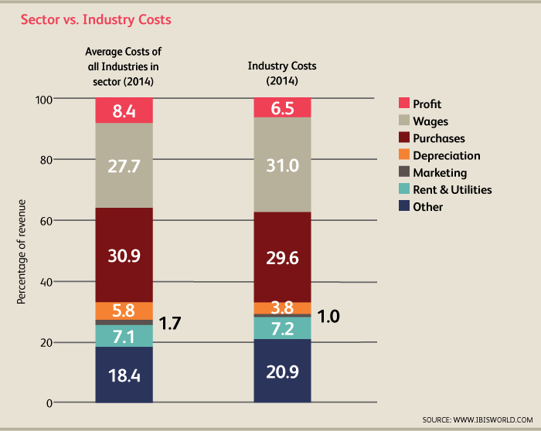

Competition is higher among industry players due to low barriers to entry, a factor that has resulted in downward pressure on freight rates. Competition is based on a variety of factors, including freight rates, quality of service, reliability, transit times and scope of operations. During the past decade, large industry operators have acquired companies in related industries in order to provide more value-added services, such as warehousing, packaging and logistics. Operators providing such services have a competitive advantage, as clients are likely to opt for a company that can provide all of their transportation needs.
The high number of industry operators also contributes to the industry's high level of competition. The majority of enterprises are nonemployers, many of which are contracted by larger transportation companies. Small companies have relatively little market power, leaving no room for competition between large and small operators. Periods of overcapacity in the Local Freight Trucking industry have also intensified competition and price discounting, resulting in decreased margins and a significant number of business failures.
Shippers have certain expectations when using the services of the Local Freight Trucking industry, including shipments being delivered in full and on time. Similarly, many of the trucking industry's clients have adopted just-in-time (JIT) inventory management. Methods such as JIT delivery can significantly reduce inventory storage costs, especially for perishable merchandise because it allows companies to purchase only the raw materials needed immediately, rather than purchasing inventory and storing it. Those companies consequently need freight trucking services more often, boosting industry demand. As such, industry operators need to be flexible and provide an adequate level of service to retain customers. (IBIS)
External competition, operators face competition from other industries, such as the Rail Transportation industry and the Local Specialized Freight Trucking industry; however this competition is limited. Transportation alternatives to local freight trucking are not direct substitutes, as some customers must use trucking based on cost, time and infrastructure constraints. Trucking is less efficient than rail in terms of fuel consumption and price per ton, which encourages some customers to opt for rail transportation to save costs, especially when fuel prices are high. However, competition among these three industries is limited because railroads have a limited geographic reach and specialized freight trucks typically transport different types of freight than operators in the Local Freight Trucking industry.
Water transportation is also a threat to freight trucking due to its safe and reliable nature and its ability to move a large amount of cargo. However, competition from water transportation is limited, as weather events can hamper inland water transportation and most ocean going trade is international in nature, which does not infringe of the Local Freight Trucking industry's business. (IBIS)
The industry also competes with airfreight. Customers who are moving small-volume, time-sensitive and valuable freight generally prefer airfreight. However, the cost of airfreight is relatively expensive and is generally not used for local transportation, which limits this competition. However, competition from package carriers that have less-than-truckload segments, including FedEx, UPS and DHL, is expected to increase. Competition can also arise when potential customers choose to run their own in-house transportation service.
Besides other forms of transportation, industry operators also compete with in-house trucking operations. Large businesses like Pepsi and Walmart have thousands of trucks serving their own distribution network. Moreover, some of these in-house operations also provide trucking services for other companies. Consequently, in-house trucking operations compete with industry companies both because they exclude operators from a potentially large market (according to the Transportation Research Board of the National Academies, private trucking accounts for about 50.0% of all trucking operation in the United States) and because they at times attempt to grab customers outside their own distribution network. However, over the past five years, many companies have been outsourcing their trucking operations as they attempt to focus on their core business and avoid dealing with an increasingly complex supply chain.
(IBIS)
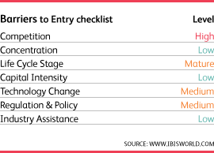
In the general freight transportation sector, barriers to entry are low. It is not difficult for people with little capital, experience or expertise to enter the industry. Local Freight Trucking industry operators generally need only a commercial driver's license (CDL) and a truck.
The relative ease with which a new competitor can enter the industry causes there to be a large number of small operators and sole proprietors. In turn, the industry's low concentration increases competition and minimizes industry profit. As such, owner-operators are advised to develop strategic links with larger operators or freight forwarders. Although operators tend to target specific areas or types of work, the nonspecialized nature of the vehicles used means operators can accept a variety of business. Because nonspecialized vehicles are used, it is even easier for companies to enter the industry. However, the competitive nature of the business might deter some from entering.
Small operators cannot directly compete with large companies upon entering the industry. Instead, nonemployers often work with large companies as contractors. Developing such relationships can take time, and often depends on the two parties' needs. Barriers to entry are expected to remain steady during the five years to 2019. (IBIS)

SWOT Analysis of Enterprise
Strengths – Internal Factors  - Freight portfolio - Clear definition of market segment  - Management  - Acquisitions  - Safety record | Weaknesses – Internal Factors  - Small carrier  - Management retirement
Opportunities – External Factors  - Acquisitions  - Just in time freight  - Oil prices  - Technology upgrades to tractors | Threats – External Factors  - DOT regulations  - Oil Prices  - Transport taxation  - Driver shortages  - Competition

With reliability more than ever a critical factor in a manufacturer's shipping needs, Heartland's reputation for dependability helped the company secure its growing position in the trucking industry. Another factor in Heartland's success was its high trailer to tractor ratio. By maintaining on average twice as many trailers as tractors, Heartland was able to station some of its trailers at its customers' plants. This had two benefits. Trailers could be loaded and unloaded by the manufacturers, cutting down on time between shipments. Meanwhile, Heartland's tractors were free to haul other loads. (IBIS)
Strengths – Internal Factors
- Freight portfolio - Clear definition of market segment
  - Heartland focuses on smaller runs that allows their drivers to be home at night. This offsets the potential for driver shortages.
- Management
  - Great leadership that know the industry and gives good direction on investments and focuses on paying off debt.
- Acquisitions
  - Recent acquisitions have strengthened their market share and market presence.
- Safety record
  - Heartland has an impeccable safety and reliability rating form industry research companies.
Weaknesses – Internal Factors
- Small carrier
  - Being a small carrier can put them at a disadvantage and may cause them to rely on larger companies for contract work. This is being mitigated by the acquisition of Gordon Trucking.
- Management retirement
  - Not a current concern, but always a factor to consider.
Opportunities – External Factors
- Acquisitions
  - Because of Heartlands profitability they should consider more acquisitions in the future after they pay off the debt assumed during the Gordon Trucking acquisition.
- Just in time freight
  - This can pose a benefit for the trucking industry as a whole. This is a large factor for the smaller carrier with a local deliver business model.
- Oil prices
  - As prices fall to a four year low, trucking companies can take advantage of lower operating cost to improve their finical statements. This however will not go unnotice as we are all subject to this decreased price. This can also increase customer spending and increase the flow of good. This could be a double uptick for the trucking industry. (TruckingInfo.com)
- Technology upgrades to tractors
  - As tractors get more efficient the price to purchase will go up the cost of operate them will go down. This should make for longer usage rates and overall decrease the need for new trucks unless they fall out of the current business model that has heartland using trucks only under warranty.
Threats – External Factors
- DOT regulations
  - Regulations can always affect the trucking industry, including taxation and other trade partnerships between states.
- Oil Prices
  - Historically we’ve see prices drop and increase within days. What is an opportunity is also a threat. (TruckingInfo.com)
- Transport taxation
  - State to state taxation can impact transportation profitability.
- Driver shortages
  - Shortage of driver that want to travel beyond home is decreasing. A need for drivers and skilled drivers is a concern. Having company owned trucks can help mitigate this and can increased wages.
- Competition
  - Competition level are high because of lower barriers for entry into the market. This can hinder growth and decrease the amount of smaller jobs. It is difficult for one trucking company to enter the market and take over an entire segment because many of the smaller companies work as contractors for the larger companies so growth is awarded to both companies.

Enterprise and Management Assessment –

Enterprise culture and reputation
Heartland boasts high employee retention rates in an industry beset with high driver turnover. The company encourages driver loyalty by maintaining short-distance runs and regularly scheduling drivers to return home; Heartland drivers tend to return home weekly, compared with industry-wide returns of up to six weeks. Heartland drivers, almost all of whom are nonunion, are also compensated for “deadhead” or empty miles. In addition, the company provides college scholarships to the children of all of its employees based on their length of service with the company.

Strategic competitive advantages and disadvantages
Background, quality and stability of management
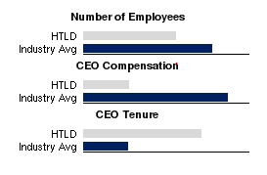
Heartland has a solid and steady leadership team, with four of the five top executives having been with the family company since at least 1983, giving Heartland Express a competitive edge and consistent vision. Each of these top executives have been promoted from within and have held various positions within the company and have conservative salaries as compared to the industry average. Much of Heartland’s success can be tracked to the current chairman’s vision of operating a debt free company.
Current Chairman Michael J. Gerdin was named Chairman and Chief Executive Officer of Heartland Express, Inc. on September 2, 2011. He has served as President of Heartland Express, Inc. since May 2006, and as a Director since 1996. Prior to, Mr. Michael Gerdin served as Vice President, Regional Operations of Heartland Express from January 2001 until May 2006. In addition, he previously served as President of A & M Express, Inc., a subsidiary of Heartland Express, Inc., from September 1998 through December 2000. From July 1997 to September 1998, Mr. Gerdin coordinated the operations departments of Heartland Express and A & M Express. From 1992 until July 1997, Mr. Gerdin held a variety of positions within Heartland Express, Inc., including positions in the operations, sales, safety, and driver recruiting departments. Mr.Gerdin is the son of Russell A. Gerdin. Mr. Gerdin is a Trustee for Grantor Retained Annuity Trusts for the benefit of Russell and Ann Gerdin. He is also a current Director of West Bancorporation, Inc. and West Bank. (Mergent Online)
A 2001 profile in the Wall Street Journal detailed the unglamorous yet effective working methods of company head Russell Gerdin. The key was a weekly spreadsheet of thousands of routes run and associated revenues and other statistics. The company continued to focus on short, routine hauls for large customers that could be handled by single drivers rather than teams.
Russell Gerdin's son Michael became president of the holding company in May 2006. Michael Gerdin had been working for the company since 1983 and most recently had been vice president of regional operations. His father, who remained chairman and CEO, had survived a heart attack in 2000 and was being treated for liver cancer.
The publicity-shy Russell Gerdin was named to the Iowa Business Hall of Fame in 2006. In addition to starting the company's own tuition program for children of employees 20 years earlier, he and his wife Ann had donated millions to Iowa State University and the University of Iowa.
Our financial strength, approach to customer service, and the winning attitudes of our employees will help us remain in the forefront of our industry. Our focus remains on customer service and the continued improvement of our organization.
Gerdin graduated from Moorhead State University in Minnesota in 1965 and went to work for his father's company. However, Gerdin and his father could not agree on the best way to run the family's business. Their conflict centered especially on the best way to increase the company's fleet of trucks. As Gerdin later told Investor's Business Daily in 1996, “I watched Dad work on those trucks and pay interest all his life. As soon as he got a dollar, he would buy a new one and take on more interest. I said: ‘I'll buy one truck and, when I get that paid off, I'll buy another one’—exactly different from Dad.”
Gerdin and his father were unable to resolve their different visions for the company. Gerdin left his father's business after only six months to go into business for himself. He bought his own trucking line in 1966, Great Plains Transportation, a small company based in Nebraska. Over the next decade, Gerdin would own or partly own five more trucking companies, all of which were based in the Midwest. (Cohen)

Summary and Opinions - Student contribution.
Heartland Express Inc. has had a long history of being a family company with Russell Gerdin purchasing the company in 1978. In 1986 the company became publicly traded as HTLD and has grown to a $580 million dollar company since then. This is in part to the consistent vision of the Gerdin family over site.
Mr. Gerdin’s vision for a debt free company is evident in how they handle acquisitions and pay off debt. After the Munson Trucking acquisition in 1997 they were able to pay off all debt in two years. This paired with their asset management and warranty operation model for tractors can help them weather unknowns like the economic down turn of the mid 2000’s. That is why I feel confident that even with an upset cash flow and balance sheet centered on long term debt and low cash on hand scenarios that Heartland Express will use the low fuel cost headwinds moving into 2015 as a boost to their debt free business model.
Quick review of their balance sheet shows this past year has not been as steady as the previous years and if we were to review just the balance sheet without taking into account the Chairman’s narrative we could misinterpret the numbers and might assume that they have placed themselves into serious debt and are at risk of not having enough cash on hand to cover their debts. The quick acid test shows that they have gone from a very strong 3.5-4 ration down to a 1.15 ratio. This is still very strong, but the latest acquisition of Gordon trucking has placed strain onto their financial statements.
When you take into account the headwinds from fuel costs and the company’s history of running debt free operations paired with the overall expansion of operations that the latest acquisition afforded them, I feel they will be a strong player in the trucking industry into the future.

References
Cohen, M. L. Heartland Express, INC. International Directory of Company Histories, Ed. Tina, Grant Vol. 120, pg. 163-167. Detriot: St. James Press, 4 Dec 2011. Web Based.
Gordon Trucking. Gordon Trucking blog , http://blog.gordontrucking.com/bid/154328/Gordon-Trucking-Acquired-by-Heartland-Express-Inc. Nov 2013. PDF. 18 Dec 2014.
Heartland Express Inc. "Annual Report 2010." Report. 2011. PDF.
—. "Annual Report 2011." Report. 2012. PDF.
—. "Annual Report 2012." Report. 2013. PDF.
—. "Annual Report 2013." Report. 2014. PDF.
Heartland Trucking, Inc. "http://www.heartlandexpress.com/uploadedFiles/Investor/Investor%20Slides%2011.11.13.pdf." 11 November 2013. Heartland Trucking Inc. PDF. 18 Dec 2014.
IBIS. IBIS World http://clients1.ibisworld.com.ezproxy.stthomas.edu/reports/us/industry/competitivelandscape.aspx?entid=1150. 18 Dec 2014. PDF. 18 Dec 2014.
Mergent Online. Mergent Online.com / http://www.mergentonline.com.ezproxy.stthomas.edu/companyreports.php. Dec 2014. PDF. Dec 2014.
TruckingInfo.com. Fuel Smarts, Trucking Info . Com http://www.truckinginfo.com/channel/fuel-smarts/news/story/2014/12/average-diesel-cost-lowest-in-nearly-four-years-at-3-419.aspx. 15 Dec 2014. website. 18 Dec 2014.

