 | Company | Quarter | Turnover | Absenteeism | Well-Being | Productivity
 | Company 02 | 0 | 0.180 | 360.00 | 0.550 | 40.000
 | Company 02 | 1 | 0.166 | 333.40 | 0.576 | 42.388
 | Company 02 | 2 | 0.164 | 320.86 | 0.581 | 42.238
 | Company 02 | 3 | 0.149 | 292.90 | 0.614 | 45.200
 | Company 02 | 4 | 0.139 | 270.45 | 0.642 | 47.929
 | Company 02 | 5 | 0.126 | 244.44 | 0.677 | 51.471
 | Company 02 | 6 | 0.116 | 223.99 | 0.711 | 54.532
 | Company 02 | 7 | 0.104 | 201.67 | 0.756 | 58.890
 | Company 02 | 8 | 0.092 | 178.20 | 0.807 | 64.157

Key Performance Indicators | Baseline | Critical performance goals Q8 | Stretch performance golas Q8
Absenteeism | 360 day | 200 | 120
Productivity | 40 index units | 63 | 76
Turnover | 18% | 12% | 6%
Well-Being | .55 index units | .70 | .95

Example:

Turnover
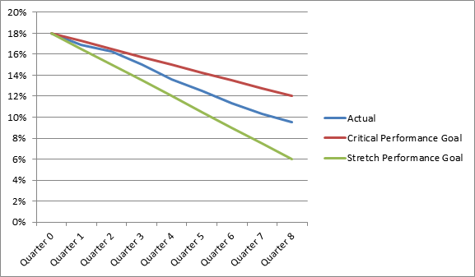

Final Turnover: 9.5%
Class Average: 9.5%

