IT 337 Data Storage
Midterm Exam
Name: ________________________
Part I: Multiple Choice Questions (Each correct answer 2 points)
1. Which management process involves continuously gathering of information on the various resources in a data center?
- Planning
- Reporting
- Monitoring
- Maintenance
2. What is an example of semi-structured data?
- Database
- Spreadsheet
- Image
- PDF file
3. Why do organizations seek to store, protect, optimize, and leverage information?
- To derive new business opportunity
- To increase dependency on fast and reliable access to information
- To promote growth of digital information
- To reduce the investment in deploying security
4. Which data center characteristic ensures that data is stored and retrieved exactly as it was received?
- Scalability
- Data availability
- Performance
- Data integrity
5. What is a benefit of Big Data analytics?
- Enables mobile access to information
- Enables data-driven decision making
- Enables IT as a service
- Enables elimination of IT silos
6. What is a benefit of virtualization?
- It enables maintaining conformance to resource configuration standards
- It automatically configures and provisions resources to support services
- It consolidates and improves the utilization of physical IT resources
- It ensures continuous availability of services in the event of a failure
7. Which data center deployment option involves the integration of infrastructure components purchased from different vendors?
- Converged infrastructure
- Best-of-breed infrastructure
- Distributed infrastructure
- Siloed infrastructure
8. Which application virtualization technique aggregates an application into a standalone executable package?
- Application encapsulation
- Application presentation
- Application streaming
- Application bursting
9. Which statement is true about solid-state drive?
- Stores data on a circular disk with a ferromagnetic coating
- Stores data on a semiconductor-based memory
- Stores data on a polycarbonate disc with a reflective coating
- Stores data on a thin plastic film with a magnetic coating
10. Which storage architecture does the graphic represent?
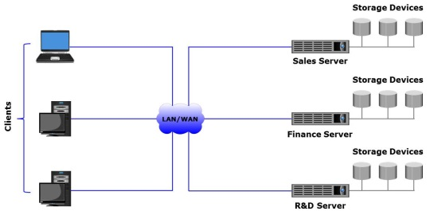
- Information-centric
- Network-centric
- Application-centric
- Server-centric
11. Which factors affect the performance of a disk drive?
- Rotational latency, number of platters, and data transfer time
- Seek time, rotational latency, and number of read/write heads
- Seek time, rotational latency, and data transfer time
- Data transfer time, number of cylinders, and rotational latency
12. Which component of an intelligent storage system performs functions such as provisioning, tiering, and cache management?
- Controller
- Solid-state drive
- Flash cache
- Host bus adapter
13. Which is the time taken by the platter of a hard disk drive to position data under the read/write head?
- Seek time
- Disk service time
- Data transfer rate
- Rotational latency

14. What is accurate about scale out storage architecture?
- Involves adding controllers within a storage system
- Involves adding storage media within a storage system
- Involves adding nodes to a cluster to increase capacity
- Involves scaling the capacity of only a single storage system
15. In the graphic, A1, A2, A3; B1, B2, B3; and C1, C2, C3 represent data.
Ap, Aq, Bp, Bq, Cp, and Cq represent parity. Which RAID level does the graphic represent?
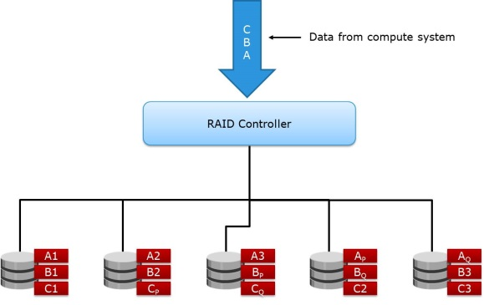
- RAID 5
- RAID 6
- RAID 3
- RAID 4
16. Which type of metaLUN provides only additional capacity without improving performance?
- Striped
- Mirrored
- Concatenated
- Parity
17. Which EMC product is a block-based SSD only storage system?
- VNX-F
- XtremSF
- VMAX
- Isilon
18. Which technology provides performance acceleration for read-intensive workloads and avoids network latencies associated with I/O access to a storage array?
- Inter-array storage tiering
- Intra-array storage tiering
- Storage flash caching
- Server flash caching
19. Which process restricts access to volumes by unauthorized compute systems?
- Tiering
- LUN masking
- Shredding
- Concatenation
20. Which type of write cache implementation does the graphic represent?
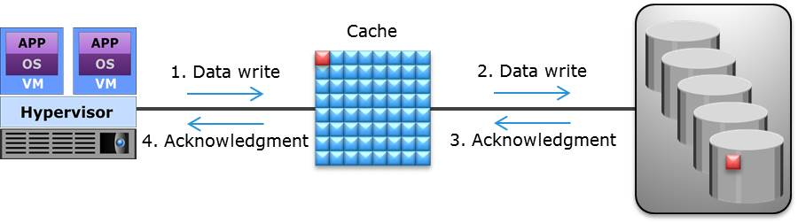
- Write-back cache
- Write-through cache
- Low watermark cache
- High watermark cache
21. Which best describes Network-attached Storage (NAS)?
- Stores data in the form of objects on flat address space based on its content
- Provides compute system with block-based access to storage
- An IP-based, dedicated, high-performance file sharing and storage device
- A single integrated storage infrastructure that consolidates block, file, and object access
22. Which eliminates dependency between data accessed at the file-level and the location where the files are physically stored?
- File-level storage tiering
- File-level virtualization
- Hierarchical storage management
- NAS head
23. Which is true about scale-out NAS?
- Pools multiple nodes in a cluster to work as a single NAS device
- Scales performance and/or capacity non-disruptively of a single NAS system
- Consolidates file, block, and object access
- NAS systems have a fixed capacity ceiling
24. What parameters can be used to define storage tiers?
- Security, cost, and reliability
- Performance, scalability, and availability
- Cost, performance, and availability
- Security, reliability, and cost
25. Which EMC product provides a solution for scale-out NAS?
- VNX
- VMAX3
- Isilon
- XtremIO
26. What is a benefit of SAN?
- Enables consolidation and sharing of storage resources
- Enables creating a server-centric storage environment
- Consolidates LAN and WAN traffic into a common IP infrastructure
- Enables high-speed data transmission between client workstations
27. Which is an accurate statement about software-defined networking?
- Controller integrates the data plane and the control plane of network components
- Controller performs physical cabling between network switches
- Controller resides on the data plane of network components
- Controller sends instructions for data plane to handle network traffic
28. Which is a characteristic of a Fibre Channel (FC) director?
- It has a modular architecture
- It implements Fibre Channel Arbitrated Loop
- It has SCSI-to-FC processing capability
- It provides limited scalability
29. Which fabric service distributes Registered State Change Notifications (RSCNs) to the node ports?
- Management Server
- Name Server
- Fabric Controller
- Fabric Login Server
30. What enables network traffic from multiple virtual SANs to traverse a single interswitch link?
- Link aggregation
- N_Port virtualization
- Zoning
- Trunking
31. Which iSCSI network component performs both iSCSI and TCP/IP processing?
- iSCSI HBA
- Software iSCSI adapter
- TCP Offload Engine NIC
- Standard NIC
32. Which is an example of iSCSI name?
- FFFFFC
- WWN 10:00:00:00:C9:20:DC:82
- Domain 01
- eui.0300732A32598D26
33. Which is an accurate statement about switch aggregation?
- It enables ports in both the switches to forward network traffic simultaneously
- It combines VLANs that are created on both the switches
- It creates a trunk link between the switches to transfer untagged frames
- It allows transmission of tunneling data between FC SAN islands
34. Which port is configured on both the ends of an FCIP tunnel to merge fabrics?
- VF_Port
- EX_Port
- VE_Port
- N_Port
35. Which accurately describes a stretched VLAN?
- It is a VLAN that spans across multiple sites over a WAN connection
- It is a logical network that is created across multiple VLANs
- It is a physical LAN that is created across two FC SAN islands
- It is a VLAN that allows an Ethernet switch to join the VLAN automatically
36. Which component of an FCoE SAN provides functionality of both NIC and FC HBA?
- VF_Port
- Ethernet Bridge
- Converged Network Adapter
- Fibre Channel Forwarder
37. Which Converged Enhanced Ethernet functionality creates eight virtual links on a single physical link?
- Priority-based flow control
- Enhanced transmission selection
- Congestion notification
- Data center bridging exchange protocol
38. What is enabled by the congestion notification functionality of a Converged Enhanced Ethernet network?
- A switch to send a signal to other ports that need to stop their transmissions
- A CNA to convey and configure its features with the other CNAs in the network
- A name server to notify switches on the allocation of network bandwidth
- A VF_Port to send PAUSE frames across eight virtual network links
39. Which layers of FC protocol stack are replaced with Ethernet according to FCoE protocol specification?
- FC-0, FC-1, and FC-2
- FC-2 and FC-4
- FC-0 and FC-1
- FC-1, FC-2, and FC-4
40. Which is an accurate statement about fabric-provided MAC address (FPMA)?
- FCoE switches provide MAC addresses to VN_Ports during node login
- Compute systems provide MAC addresses to VN_Ports during port discovery
- FCoE switches provide MAC addresses to FC switch ports during port discovery
- Compute systems provide MAC addresses to VF_Ports and VE_Ports during fabric login

Part II – Storage Design Calculations (Each correct answer 10 points)
- Case Scenario
An organization is deploying a new business application in their environment. The new application requires 1TB of storage space for business and application data. During peak workload application is expected to generate 4900 IOPS (I/O per second) with typical I/O size of 4KB.
The available disk drive option is 15,000 rpm drive with 100 GB capacity.
Other specifications of the drives are:
Av. Seek time = 5 millisecond
Data transfer rate = 40MB/sec

Task:
You are asked to calculate the required number of disk drives that can meet both capacity and performance requirements of an application.

Students must provide all steps in the calculation process:

1. Calculate time required to perform one I/O, which depends on disk service time.
Hint: Disk service time= Av. seek time + rotational latency + data transfer time

- Maximum number of IOPS a disk can perform,
Hint: Max Number of IOPS = 1/Disk Service Time

- Acceptable response time disk controller utilization must be less than 70%, therefore maximum number of IOPS a disk can perform at 70% utilization is _________

- Now calculate number of disk required to meet:

- Application’s performance requirement = _____ disks

- Application’s capacity requirement = _______ 10 disks
c. Finally, disk required = Maximum (Capacity, Performance)
Maximum (____, _____) = _____ disks

2. Case Scenario
A telecom company, involved in mobile wireless services across the country, has about 5000 employees worldwide. This company has 7 regional offices across the country. Although the company is financially doing well, they continue to feel the competitive pressure. As a result, the company needs to ensure that the IT infrastructure takes advantage of fault tolerant features.
Current Configuration and Challenges:
• The Company uses an accounting application that is hosted on an individual server with disks configured as RAID 0.
• It is now the beginning of a new financial year and the IT department has an increased budget. You are called in to recommend changes to their database environment.
• You investigate their database environment closely and observe that the data is stored on a 6-disk RAID 0 set. Each disk has an advertised formatted capacity of 200 GB and the total size of their files is 900 GB.
• The amount of data is likely to change by 30 % over the next 6 months and your solution must accommodate this growth.
• The application performs around 40% write operations and the remaining 60 % are reads.

Tasks:
- Recommend a RAID level that the company can use to restructure their environment and fulfill their needs.

- What is the cost of the new solution?

3. Justify your choice based on cost, performance, and data availability of the new solution.

Note: A new 200 GB disk drive costs $1000. The controller can handle all commonly used RAID levels, so will not need to be replaced.

