GUI design practice states that any GUI should include elements to allow/perform five basic tasks: (1) user input, (2) system output, (3) user guidance, (4) interaction control and (5) organize GUI appearance. In this context:
a. Think of a simple GUI (such as Hotel Registration GUI, Conference Payment GUI, etc.). Your GUI is: ___________________
b. Choose the appropriate components and other resources that should be used to achieve each of the first four basic elements (1-4) of the considered GUI. Using paper and pencil design the GUI layout, scan it and attach it to your post. For each component indicate whether it is used for user input, system output, user guidance or interaction control.
c. Describe how it works and give details about user – GUI interaction.
d. Identify the layout manager(s) which is (are) appropriate to use for your GUI elements organization.

***An example is on the next page.

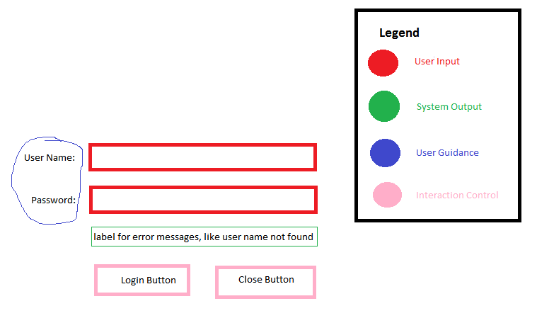
My GUI is a log in dialog. I've included a color-coded legend on my image to label each piece as one of the 4 basic elements.
I have textboxes for entering a user name and password (user input). I have a label for showing
errors messages (system output). I have 2 more labels that describe what the textboxes are for (user guidance).
Then I have 2 buttons for logging in or closing out of the dialog (interaction control).

When the User clicks the Login button, it will validate the user name and password. If the validation fails,
then the reported reason for the failure will be displayed in the error message label. If the validation passes,
then the dialog would close and the next window would open. At any time the User could click the Close button,
which will close this dialog and exit.

I organize this dialog as shown in my sketch, I would need several different layout managers and panels.
Working from the individual controls up, I would have:

1) UserNamePanel: BorderLayout with User Name label = WEST and textbox = EAST

2) PasswordPanel: BorderLayout with Password label = WEST and textbox = EAST

3) MessagePanel: BorderLayout with error message label = EAST

4) ButtonPanel: FlowLayout = RIGHT with both buttons.

5) JFrame: BoxLayout = Y_AXIS with all 4 of the above panels.

What the BoxLayout on the JFrame does is stack all 4 sub-panels vertically.

I've also attached source files that give his layout without any other functionality.

