Class Restaurant Outing
Gabrielle Rodriguez, Sophie Calverley, Reynaldo Portillo, Mr. Kate
Montclair State University

Introduction
“90% of Americans enjoy going to restaurants” (https://pos.toasttab.com/blog/restaurant-management-statistics).

H1 - Key Factors
Kate Paragraph 1 - Price per person, Yelp score, Fees (The general information about the data of all restaurants and why we felt those 3 key points to include)
Gaby Paragraph 2 - Location, Parking, Distance

While looking for a great places to eat location, parking and distance from your home area are heavily weighted.

Sophie Paragraph 3 - Decorations. Food type, # of Courses, Drinks Included
Some of the keys to the most ideal end-of-year class party are the smaller details about restaurant. This includes the food type, the number of courses and if drinks are included or not. Food type is essential to consider as it is important to ‘give the people what they want’; the class is going to the dinner party to eat so they should be given food that they want. It was decided that the best way to decide on the food type was to let the class choose by having the classmates participate in a survey which included the categories: American, Asian, Irish, Italian, Latin, Mediterranean, Seafood and Steakhouse. The number of course and if drinks are included were two more keys as they were seen as ‘more bang for your buck’. If the class can be provided a meal choice with multiple courses for a good prices versus a restaurant that will only serve them one course at a high price, it will be a waste of time and money. And if the class has to be paying a high fee just to get a drink with their meal, it will also be a waste of time and money. A dinner party has to be worth it in all quantities, food and drink, so these were two criteria to consider. Another thing to consider is if the restaurant has decorations for the dinner party. Decorations bring a better setting for the class while they kick back, relax and enjoy a meal with friends to celebrate the end of the school year.

Rey Paragraph 4 - Seating, Entertainment, Private room

H2 - Party Proposal
Where?
Brix Restaurant - 371 Franklin Ave, Belleville, NJ - 8 miles from school
Cost?
yelp score - price pp - fee amount (to talk about particular restaurant and his factors; yelp score, price per person, fee amount)
Whats included?
Included in our dinner party at Brix Restaurant are a four-course exquisite Italian meal, parking availability, drinks included, available entertainment and outdoor seating.

H3 - Why we chose this location?
[Include a period at the end of a run-in heading. Note that you can include consecutive paragraphs with their own headings, where appropriate.]

H4 - Conclusion
[When using headings, don’t skip levels. If you need a heading 3, 4, or 5 with no text following it before the next heading, just add a period at the end of the heading and then start a new paragraph for the subheading and its text.] (Last Name, Year)

[Heading 5].
[Like all sections of your paper, references start on their own page. The references page that follows is created using the Citations & Bibliography feature, available on the References tab. This feature includes a style option that formats your references for APA 6th Edition. You can also use this feature to add in-text citations that are linked to your source, such as those shown at the end of this paragraph and the preceding paragraph. To customize a citation, right-click it and then click Edit Citation.] (Last Name, Year)
References
Yelp scores
Tables
Table 1
[Table Title]
Column Head | Column Head | Column Head | Column Head | Column Head
Row Head | 123 | 123 | 123 | 123
Row Head | 456 | 456 | 456 | 456
Row Head | 789 | 789 | 789 | 789
Row Head | 123 | 123 | 123 | 123
Row Head | 456 | 456 | 456 | 456
Row Head | 789 | 789 | 789 | 789
Note: [Place all tables for your paper in a tables section, following references (and, if applicable, footnotes). Start a new page for each table, include a table number and table title for each, as shown on this page. All explanatory text appears in a table note that follows the table, such as this one. Use the Table/Figure style, available on the Home tab, in the Styles gallery, to get the spacing between table and note. Tables in APA format can use single or 1.5 line spacing. Include a heading for every row and column, even if the content seems obvious. A default table style has been setup for this template that fits APA guidelines. To insert a table, on the Insert tab, click Table.]
Figures title:
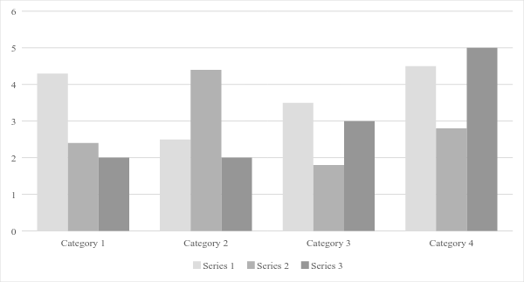
Figure 1. [Include all figures in their own section, following references (and footnotes and tables, if applicable). Include a numbered caption for each figure. Use the Table/Figure style for easy spacing between figure and caption.]
For more information about all elements of APA formatting, please consult the APA Style Manual, 6th Edition.

