This assignment is due no later than May 6, 2017 @ 9pm Pacific Standard time
Please include citations and references

Chapter 12, Problem 1: Managing and Pricing Deposit Services

Rhinestone National Bank reports the following figures in its current Report of Condition:
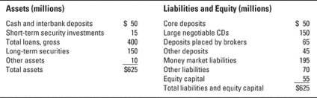
a. Evaluate the funding mix of deposits and nondeposit sources of funds employed by Rhinestone. Given the mix of its assets, do you see any potential problems? What changes would you like to see management of this bank make? Why?
b. Suppose market interest rates are projected to rise significantly. Does Rhinestone appear to face significant losses due to liquidity risk? Due to interest rate risk? Please be as specific as possible.

Chapter 13, Problem 6: Managing Non-deposit Liabilities and Other Sources of Borrowed Funds

Thyme Bank of New York expects new deposit inflows next month of $265 million and deposit withdrawals of $425 million. The bank’s economics department has projected that new loan demand will reach $400 million and customers with approved credit lines will need $175 million in cash. The bank will sell $450 million in securities, but plans to add $60 million in new securities to its portfolio. What is its projected available funds gap?

Please include Evaluates the mix of funding sources in a managing and pricing deposit service problem; recommends best practice for managing variety of sources. Analyzes potential losses based on increased interest rates in managing a bank funding sources problem; supports statements with relevant real-life examples. Calculates projected available funds gap in a non-deposit liabilities problem; shows processes taken to calculate. Analyzes sources of risk for market participants holding Eurodollars; recommends strategies for mitigating risk.

