BUSINESS-PROPOSAL Assignment
Study case :
While in college, you develop an actuator that can be used in semiconductor processing equipment to significantly improve performance. The actuator features a unique acceleration-control design that transfers wafers more rapidly without breaking them. Quantitative performance and cost information is given in the accompanying spreadsheet.
You have just been granted a patent and would like to form a company (Motion Company) to commercialize the actuator. In order to raise the necessary capital, you propose that a large potential customer (Semi Corporation) provide a 7-year, interest-only loan in return for a special price that gives Semi significant economic benefits.
Required Outline - This should be a proposal from Motion Company to Semi Company and be entitled: “Motion Company Business Proposal to Supply Advanced Wafer-Lift Actuators to Semi."
- 1) Introduction - Summarize the key points of your proposal as compellingly and succinctly as possible in one paragraph. (If it is too short, Semi executives may not comprehend the advantages. If it is too long, they are unlikely to read it at all.) Be salesy!
- 2) Product Description – Describe your product and its advantages. Be Salesy!
- 3) Product Economic Value – Describe your estimates and how the product would improve Semi profitability. Also propose are reasonable selling price that fairly apportions the economic benefits between Semi and Motion. It should be higher in price than their existing actuator. Do not “give away the farm” with a low price.
- 4) Motion Company – Describe proposed finances and ratios that demonstrate financial viability.
- 5) Proposed Semi Loan Financing – Indicate the amount and discuss Semi’s IRR on the project. This should include: loan amount, loan repayment after 5 years, annual interest payments, and annual economic benefits. It should persuasively demonstrate that this is a great deal for Semi.
- 6) Negotiating Strategy: Concessions Motion will ask Semi to make – At least three ideas for commitments Semi could make that would reduce Motion Working Capital requirements. (~2 sentences each. Assume this section will not be seen by Semi Corporation)
- 7) Counter-offers for onerous demands anticipated from Semi – At least three ideas that could soften demands such as a lower sell price, exclusivity (preventing sales to Semi competitors), and lower loan amount or duration, or licensing for Semi in-house production. Be sure to calculate how these would affect Motion and Semi financial performance. (~2 sentences each. Assume this section will not be seen by Semi Corporation)
Grading Rubric- Each numbered section in the text and each section of the spreadsheet will be graded on the quality and quantity of thought demonstrated: from 5-substantial to 1-little and 0-missing.
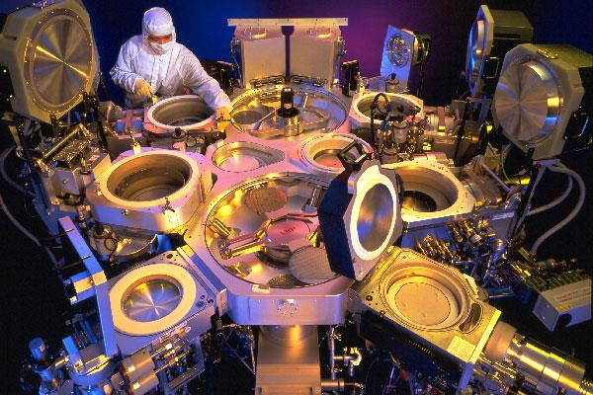
Typical Semi Co semiconductor production tool showing central robotic handlers surrounded by process modules. During operation, all modules are sealed and under high vacuum.
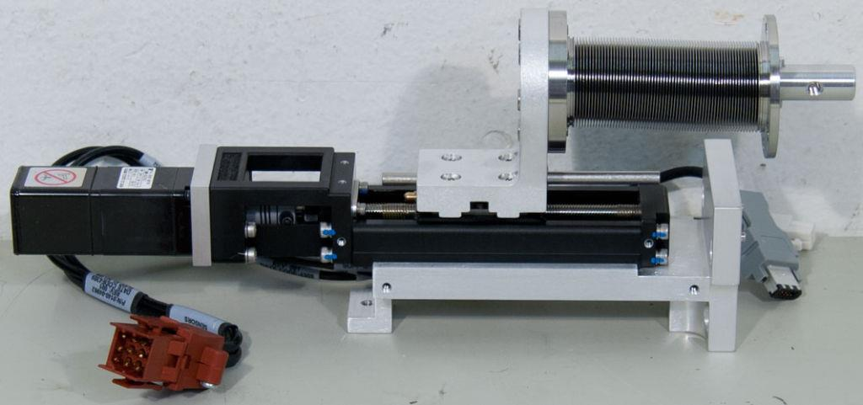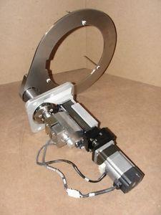
Pin-lift actuator, which is mounted beneath the platen in each process module

