- Briefly discuss the differences between translating a program and interpreting it (assume that the program is written in language L1 and that you want to execute it on a computer that can only understand programs written in its machine language L0).

- Convert the following numbers from binary to hexadecimal (Learn more):

  - 1100 0110 1101 0110
  - 1011 1001 1010 1011
  - 1101 1110 1001 0001

Note: Every row is a 16-bit binary number.

- Represent the following decimal numbers in 8-bit 2’s complement numbers:

- -120

- -24

- 24

- Compute the results of the following operations with 8-bit 2’s complement numbers:

- 00110110 + 01001111

- 01000000 - 11100000

- 01110100 + 01010001
- Fill in the truth table below for the boolean function implemented by the transistor circuit shown above. Explain how you obtained it (i.e. for each input value combination for A and B, which transistors are on and which ones are off, which input becomes the final output (C), etc.).
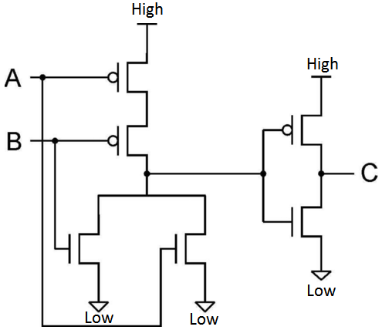

A | B | C (output)
0 | 0
0 | 1
1 | 0
1 | 1

- Assume that A and B are 32 bits wide. Write the result stored in B after each one of these operations (for each line, assume B has the value assigned to it by the previous operation). Write your results using hexadecimal notation. Initial value of A is 0x12345678. (Learn more).

  - B = A XOR 0xAAAAAAAA
  - B = B AND 0x98765432
  - B = B OR A
  - B = NOT B

Note: Hexadecimal numbers are usually prefixed with “0x”. You can just ignore it and treat 0xABCD as ABCD which is equal to 1010 1011 1100 1101 in binary.

- Write a piece of x86 assembly code that counts number of 1s in the binary representation of the value stored in eax and saves the result in edx.

- Assume a computer that has 16 8-bit registers, 64kB byte-addressable memory (meaning that each byte has a unique address) and can perform 128 distinct operations. Given the following register-memory instruction format:

OP | REG | MEM

how many bits are needed to properly express such an instruction?

Note: OP stands for the code of the operation to be performed, REG stands for the index of the register to be used and MEM stands for the address of the 8-bit memory words to be used.

- For the Boolean function:
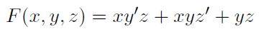
- Fill in its truth table below:

X | Y | Z | F

- Build a circuit that implements the function. Use 2-input AND, 2-input OR and NOT gates only.

- What is the equivalent Boolean expression for this circuit?
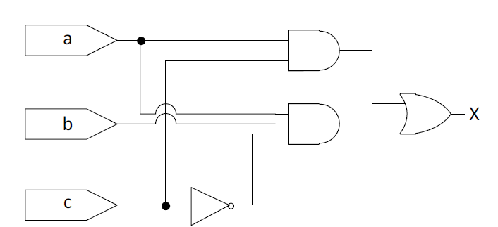

- Convert the following C code snippet to x86 assembly.

While ( c > 0 ) {

if ( a == b ) {
b = 5 * b;
}
else if ( a > b ) {
a = a - b;
}

c--;
}

