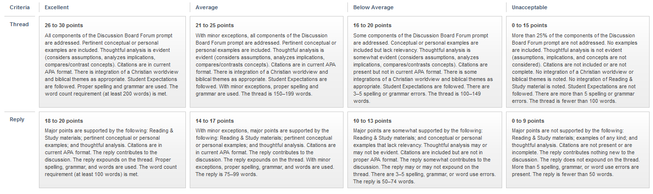
Discussion Board Grading Rubric

