CIT 140

Student must create a database for a store. The database must reflect the necessary tables and have integrity. Here is a suggested database layout for an imaginary Gadgets store. Use this as a guide. Do not copy the database, tables or fields.

Needed information:
- The store sells electronic gadgets: cell phones, players, radios, GPSs, etc.
- When describing the store, ignore employee salary information
- Provide a writeup that describes your reasoning and layout (10pts)

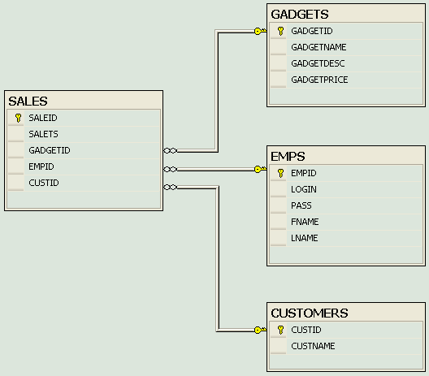

GADGETS
Column  Name | Data  Type | Length | NULLs  Allowed? | DEFAULT  Value | PRIMARY  KEY? | FOREIGN  KEY? | Refers  To Table
GADGETID | SMALLINT | — | No | — | Yes | No | —
GADGETNAME | VARCHAR | 15 | No | — | No | No | —
GADGETDESC | VARCHAR | 50 | Yes | — | No | No | —
GADGETPRICE | DECIMAL | 6 + 2 | No | 0 | No | No | —

EMPS
Column  Name | Data  Type | Length | NULLs  Allowed? | DEFAULT  Value | PRIMARY  KEY? | FOREIGN  KEY? | Refers  To Table
EMPID | SMALLINT | — | No | — | Yes | No | —
LOGIN | VARCHAR | 10 | No | — | No | No | —
PASSS | VARCHAR | 10 | No | — | No | No | —
FNAME | VARCHAR | 15 | No | — | No | No | —
LNAME | VARCHAR | 15 | No | — | No | No | —

CUSTOMERS
Column  Name | Data  Type | Length | NULLs  Allowed? | DEFAULT  Value | PRIMARY  KEY? | FOREIGN  KEY? | Refers  To Table
CUSTID | SMALLINT | — | No | — | Yes | No | —
CUSTNAME | CHAR | 50 | No | — | No | No | —

SALES
Column  Name | Data  Type | Length | NULLs  Allowed? | DEFAULT  Value | PRIMARY  KEY? | FOREIGN  KEY? | Refers  To Table
SALEID | SMALLINT | — | No | — | Yes | No | —
SALETS | DATETIME | — | No | — | No | No | —
GADGETID | SMALLINT | — | No | — | No | Yes | GADGETS
EMPID | SMALLINT | — | No | — | No | Yes | EMPS
CUSTID | SMALLINT | — | No | — | No | Yes | CUSTOMERS

Example:

GADGETID SMALLint not null primary key….

GADGETID SMALLINT NOT NULL FOREIGN KEY REFERENCES GADGETS(GADGETID)….

- Create 4 tables similar to the sample above.
- Add 10 rows in each table.
- Use the snipping tool to submit your code that reflects the created tables, queries, and database diagram. (above totaling in 90 points-- See Rubric on Schoology)

a.Write a query to show details for the entire items that have ‘r’ in the Gadget name.
b.Write a query to display the list of passwords for the entire employee whose login contains ‘m’. (or a similar Query)
c.Write a query to find how many employees are there.
d.Using a join, write a query to find number of Gadgets bought by each customer.
e.Create a select statement to find out the last date gadgets were ordered.

- Explain about your project in one page.(10 points)
At the completion of your work, submit all your code in one document. Create your Project description in another document. Provide each query on schoology separately.

