Paint 4 Pups Event. Do this one first.
Self-evaluation and reflection Requirement : Due on 5/3
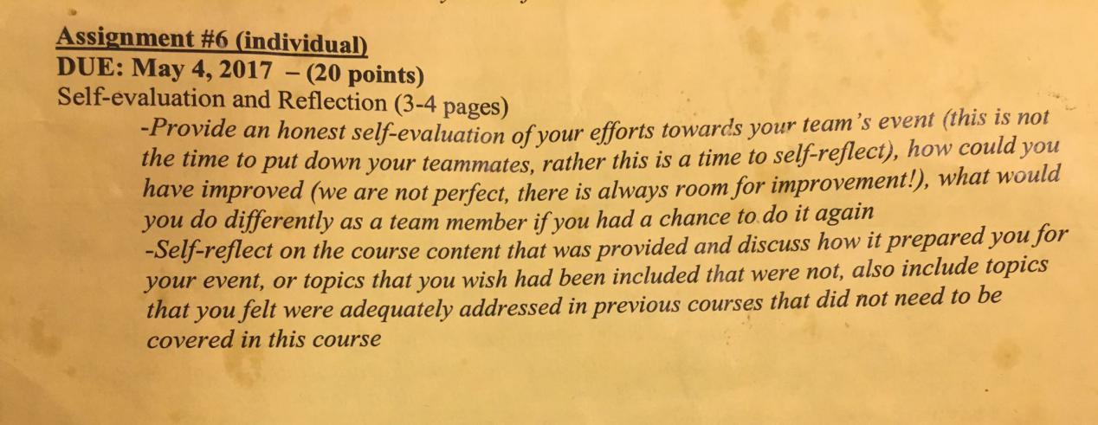

The topic of event which I prepared: Paint 4 Pups. Located in Paint the Town Columbia.
Our Team:
Event Coordinator Dylan
Marketing Development Coordinator Lindsay
Marketing Development Coordinator Allison
Strategic Planning Director, Local Business Liaison Lu
Local Business Liaison Donnell Local Business Liaison ME (My position)

Event Description

The purpose of this event is to help raise awareness and financial support for a local organization called No Kill Columbia. No Kill is a volunteer based, 501c3 animal advocacy non- profit organization. They are dedicated to saving the lives of beloved animal companions and promoting the awareness and education of the “No Kill Movement.” The basis of the No Kill Movement is to help reduce the number of unwanted and unplanned companion animals by emphasizing the importance of funding a low cost spay and neuter clinic in Columbia.
This low cost clinic provides the utmost quality to a high volume of pets in Columbia and mid Missouri. Their passion and drive to help these companions speaks volumes when they center their organization around every animal that is adoptable, and treatable, is worth saving. Being that this organization is nonprofit, any financial contributions they receive go towards saving the lives of the next animals in need.
The event we are planning for No Kill Columbia will be held at Paint the Town in Columbia, Missouri.
The event will be held on Sunday, April 29th 2017. There will be at least 60 reservations we will anticipate filling. Paint the Town has different sized canvas that will correlate in price and the percentage of money that will be donated to No Kill Columbia. Paint the Town has also agreed to donate a few select pieces of art on behalf of No Kill Columbia for their art auction.
Alcoholic and nonalcoholic beverages can be purchased and served throughout the event. Drinks will not be included in the percentage of money that will be donated to No Kill Columbia so the beverages will be purely for guests enjoyment and to add to the fun atmosphere that Paint the Town conveys. We will be providing baked goods and other snack type food selection for the guests to enjoy during the event by accepting donations for No Kill as the cost of purchasing the snacks.

What did I do?
We have a few local businesses in mind that we are going to be reaching out to for donations toward food in the form of cookies, cupcakes, and more. Our local business liaisons, I will be reaching out to these businesses and coordinating any donation contributions we receive for this event. Our team has been built around the concept of not requiring volunteers to help run this event, although we anticipate some of the dedicated volunteers that are the foundation of No Kill Columbia to use word of mouth to tell others about this event.
