Problem 1. Understanding Keys and Normalization
Read Access Comprehensive Ch.11, Database Design, Help with the Assessment Problem 1. And answer the following questions:
1. Figure below contains sample data for parts and for suppliers who supply those parts. In discussing the data with users, you find that part numbers - but not descriptions -uniquely identify parts, and that supplier names uniquely identify suppliers. Multiple suppliers can supply the same part. For example, air deflectors can be purchased from either Asterman or JMZ Technologies. Convert this relation into an equivalent set of relations in third normal form (3NF). In word document write out all transitions from the first normal form to the third normal form following format in the chapter 11, pp.AC696-AC705.

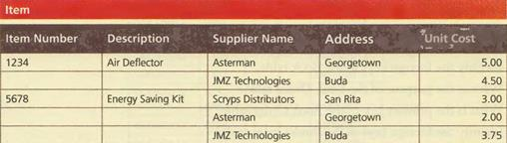

2. Figure below contains sample data for an Employee table. Use this figure to answer the following:
a. Is the table in first normal form (1NF)? Why or why not?
b. Is the table in second normal form (2NF)? Why or why not?
c. Is the table in third normal form (3NF)? Why or why not?
d. Identify the candidate keys for the table.

