Novant Health Decides to Build an Integrated Health Care Delivery Network

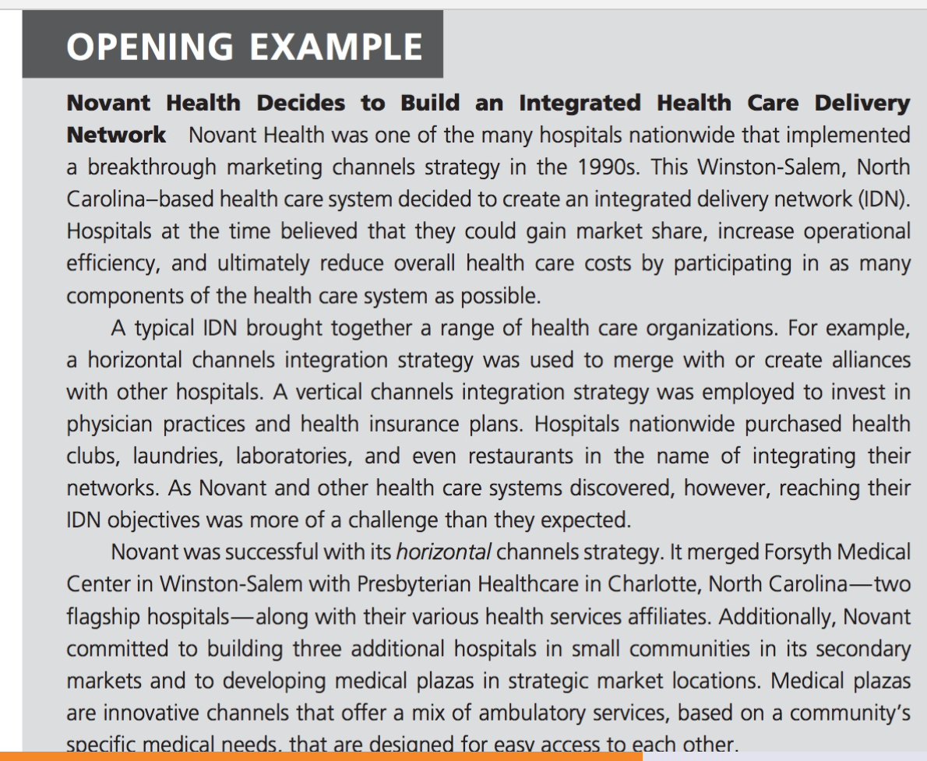

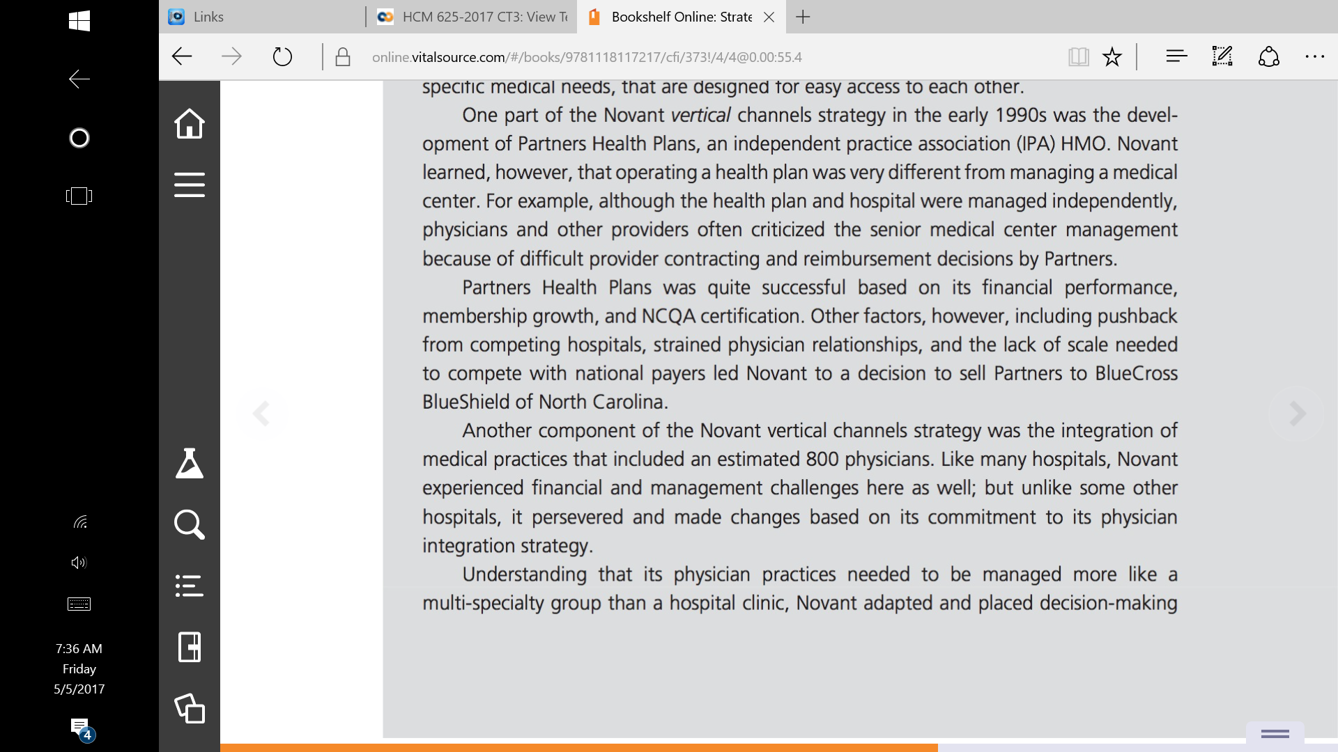
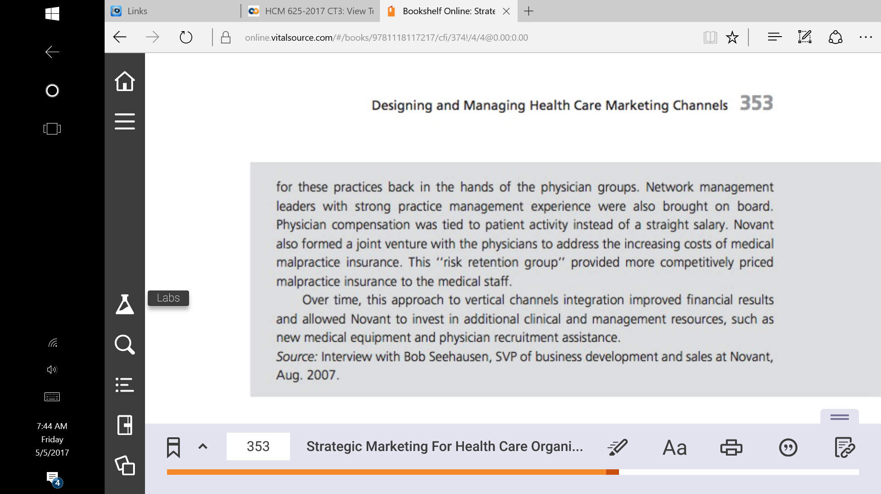

Read the ABOVE called, “Novant Health Decides to Build an Integrated Health Care Delivery Network.”
Write a 3 to 5 page paper (1000 to 1500 words) in APA format in response to the questions:

a. Explain whether or not you think Novant Health created a n effective marketing
channel system and value network, and why?
b. Argue whether you think the delivery channels were a good match for the
product or not.
c. Give suggestions on steps to integrate channels and manage conflicts.
Below is a recommended outline.
Cover page (See APA Sample paper)
Introduction
a. A thesis statement
b. Purpose of paper
c. Overview of paper
15. Body (Cite sources with in-text citations.)
a. Explain whether or not you think Novant Health created a n effective marketing channel
system and value network, and why?

b. Argue whether you think the delivery channels were a good match for the product or
not.

c. Give suggestions on steps to integrate channels and manage conflicts.

Conclusion – Summary of main points
a. Lessons Learned and Recommendations

5. References – List the references you cited in the text of your paper according to APA format.
(Note: Do not include references that are not cited in the text of your paper)

