

Hannah’s Scores and Monitoring Graph

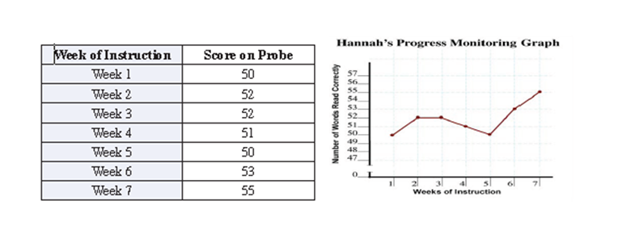

© 2014. Grand Canyon University. All Rights Reserved

