CENTENNIAL COLLEGE
COMP 212: PROGRAMMING 3
LAB #3
Due Date: Thursday, October 14, 2016, before midnight
FULL MARKS: 100
NAME_______________________________________________________________________
STUDENT NO.: _______________________________________________________________
SECTION:____________________________________________________________________
[Submit your assignment in the drop box titled as Lab#3. Copy and paste code into a Word document. Provide appropriate screen shots. Do not zip your file. Do not submit more than one file.]

- Develop a GUI application in C# that stores within a C# dictionary the student numbers (represented by K values) and the student names (represented by V values) of SETAS students at Centennial college. Student numbers and names could be added to the table as new students are admitted by SETAS. As students graduate, quit, or discontinue to attend the college, records are deleted using their K values. One could search for any enrolled student by using the K values as well. The entire current list may also be displayed with a button click. Finally, the display area could be cleared by the clicking the clear all button. The interface with some possible user interactions are shown below:
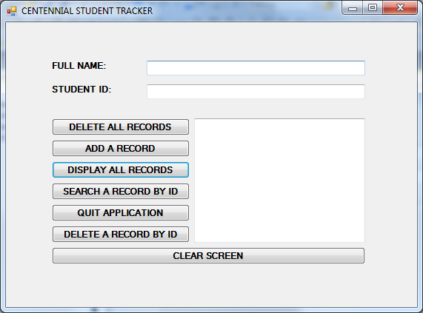

PLEASE NOTE:
- Include all kinds of data validation that you think would be appropriate.
- Inform the user about the success or failure of the operation sought for.
- Following screen shots show some possible interactions:

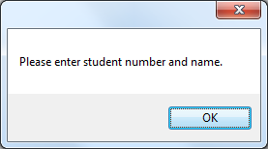

(If you miss to fill out any information in the form this message box would appear.)

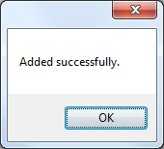

(When the student is successfully added to the dictionary.)
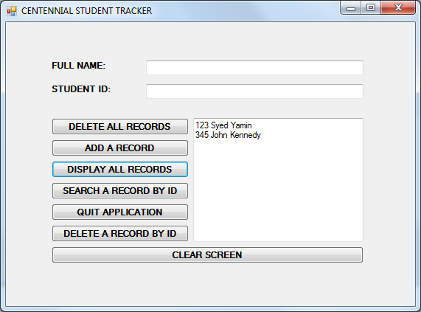

(Display All Records)

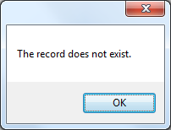
(When the student ID searched is not found in the dictionary.)

