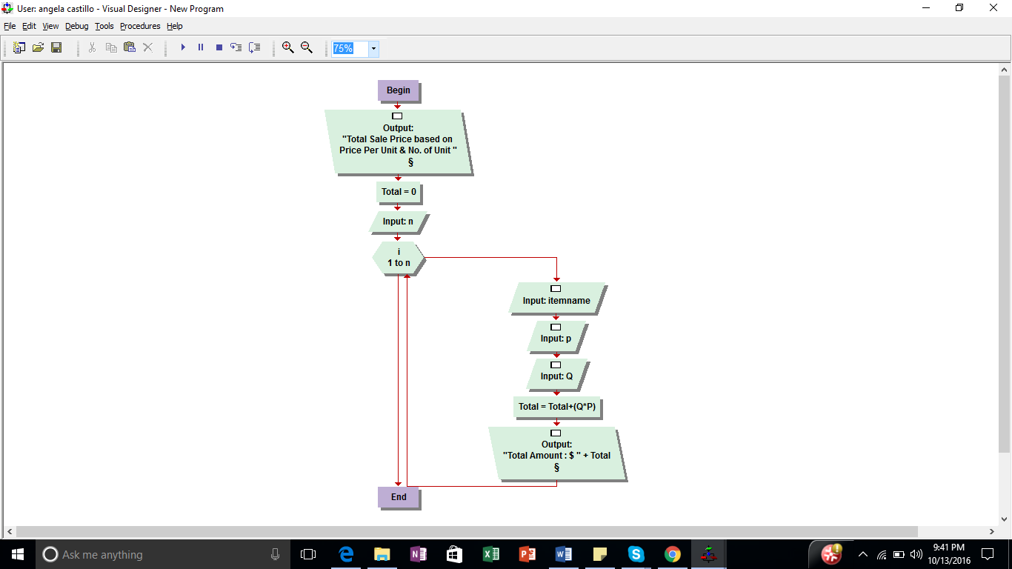

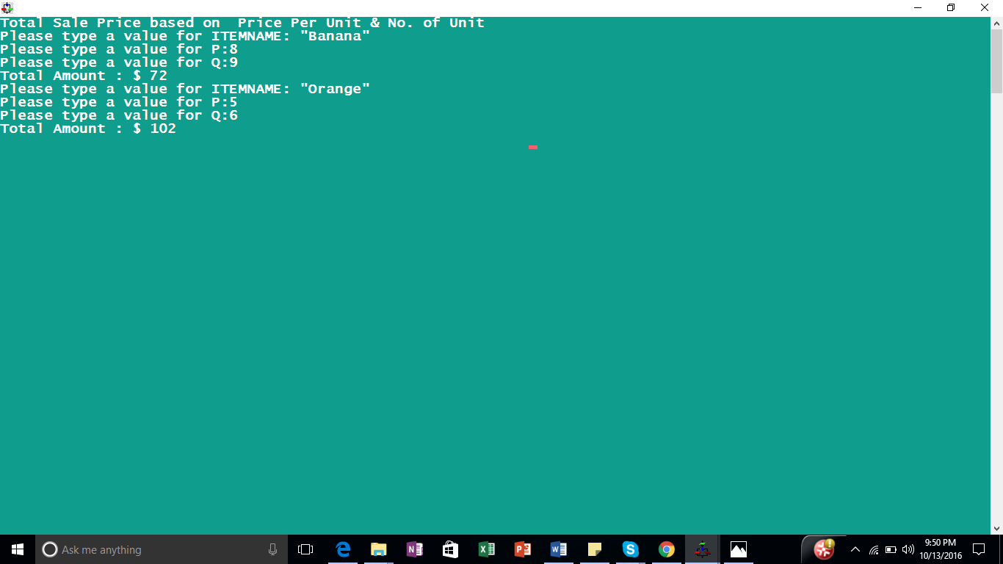

My summary of Technical experience is that I used the technical experiences of how to create loop, input, output and use of console. I used experience of setters of the class which sets all the instance variable of the class. Also, I used the experience of creating the flowchart with various symbols having different meanings.
Commands that were of greatest benefit
I used command to creating the Loop option of value based by us. Loop termination is good. It has a great benefit.
Overall Lab Experience
My overall lab experience was great. I have learned few things and used my prior experience which cleared some of my previous concepts. It was overall great experience.

