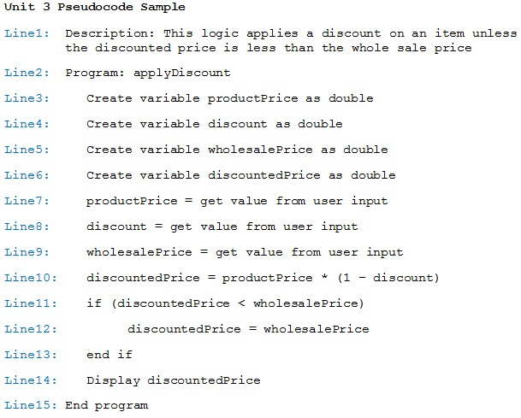
For the Pseudocode sample above, explain what it does line by line in the following table.
Lines | Explanation
Line1:
Line2:
Line3:
Line4:
Line5:
Line6:
Line7:
Line8:
Line9:
Line10:
Line11:
Line12:
Line13:
Line14:
Line15:

