Question 1
Look at the following chart of the e^{x} or EXP function. For an x value of 2 what would the slope of this line be? (remember the slope is variable and increases as x gets larger).
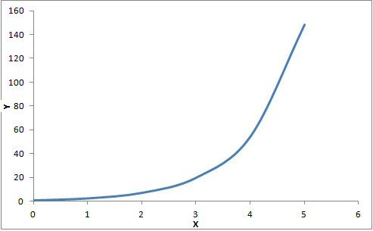
The slope would be about 3.5
The slope would be about 7.4

The slope would be about 20
The slope would be about -0.45

The slope would be about 2

Question 2
What process would likely be characterized by a negative exponential function?
That is y = Co e ^{-at}
The temperature of outside air from midnight to noon the next day when plotted.
The velocity of a car as it leaves a stoplight as a function of time.

The light output of a flashlight someone has left running in the garage over time.
The growth in weight of a tree over time.

The sound produced by a stick of dynamite as a function of time.

Question 3
What process would likely be characterized by a positive exponential function?
That is: y = Co e ^{bt}
The flow of a river over time.
The population growth of the world as a function of time.

The number of thieves in Congress as a function of time.
The temperature of a toaster shut off at t = 0

The accumulation of snow as a function of time during a snowstorm.

Question 4
A rope is wrapped four times around a steel post. The coefficient of friction between the rope and post is 0.45. Determine the force magnification of this setup.
Force magnification = 81,612 times
Force magnification = 44,478 times

Force magnification = 31,990 times
Force magnification = 23,445 times

Force magnification = 16,181 times

Question 5
A T1 tension force of 8 pounds is applied to a rope and post system which has 5 wraps of rope around a post. If the coefficient of static friction between the rope and the post is 0.27, determine the maximum frictional gripping force that can be developed.
About 45,000 pounds
About 129,000 pounds

About 119,000 pounds
About 67,000 pounds

About 39,000 pounds

Question 6
A rope and post restraining system has been designed to hoist material up to the top of a newly built lighthouse. If the coefficient of friction between the post and the rope (polypropylene) is 0.53, determine the minimum number of wraps required to lift a 16,000 pound (72,000 Newton) light beacon to the top. The maximum T1 tension force that can be applied is only 10 pounds (from old Mike who is pulling by hand)
N = 2
N = 4

N = 6
N = 5

N = 3

Question 7
Joe is trying to pull his old tractor out of a ditch. He wraps the rope 5 times around the front axle of the tractor and applies a force of 2,000 Newtons from another tractor to accomplish this pulling task. If the force magnification required to do this is 673, determine the minimum coefficient of friction that must exist between the rope and the axle of the stuck tractor.
minimum coefficient of friction required is 0.27
minimum coefficient of friction required is 0.21

minimum coefficient of friction required is 0.34
minimum coefficient of friction required is 0.39

minimum coefficient of friction required is 0.45

Question 8
When roping a calf, cowboy Josh Ellison wraps his pull rope three times around the horn of his saddle. If he can pull with only 3 pounds on the starting end of the rope (this is the T1 tension), determine the frictional force that can be developed to restrain the calf. Take the coefficient of friction between the horn material and the rope to be a high value of 0.78. (The rope is designed especially for this task to have a high friction value)

13.5 million pounds
7.28 million pounds

2.33 thousand pounds
589,000 pounds

154 thousand pounds
5.52 hundred thousand pounds

Question 9
Frank has found an old safe at the bottom of a mine shaft up in Spruce Mountains, south of Wells. Knowing the frictional force positive exponential curve he says to Joe:
"If I wind three wraps around this old post I can pull with a certain amount of force but if I wrap four turns I can triple the force I can pull with."
From this information determine the coefficient of friction u of his rope and post system. Assume T1 is a constant.
u = 0.773
u = 0.789

u = 0.993
u = 0.489

u = 0.175

Question 10
Assume that a cat, named Cricket, can pull with a force of 1.35 pounds and provides a T1 force to a rope and post system. How many wraps around the post is needed for Cricket's pull to help keep a weight equal to that of the Earth's Moon in equilibrium? Take that weight of the Moon to be 1.618 x 10²³ pounds and the coefficient of friction to be 0.5.
57.8 turns
17 turns

98.3 turns
34 turns

76.3 turns

