Physics 234 Spring 2015 Homework #6

1. Where's the image?
In the figure at the right is shown a thin lens (indicated by a gray rectangle) and a coordinate system. The x axis passes through the center of the lens and runs along its axis of symmetry with the positive x direction indicated by the arrowhead. The lens may be treated as of negligible thickness and has a focal length f.  The points {x,y} = {f,0} and {-f,0} are marked by black dots.  A small object is placed at the position {x,0}. For each of the four cases (i)-(iv) below, indicate whether the location of the image formed (= x') is:  - on the positive or negative side of the axis  - closer to the lens than the focal point or farther away. | 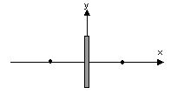
Thus your answers should take a form such as (x' > f > 0) to indicate (the image is on the positive side of the axis and further away than the focal point) or (0> x >f) to indicate the image is on the negative side of the axis between the lens and the focal point) respectively. Note that in some cases the focal length specified is negative and in some cases it is positive.
- -f < x < 0
- f < 0 < x
- x < f < 0
- 0 < f < x

2. On the mirror
While doing a tutorial lesson on "How to find out where something is by looking," two students, Ethelred and Guinivere, answered the question, "Where does the image [in the mirror] appear to be located?" by saying "On the mirror." Do you agree with them or not? If you disagree, where would you say the image is and how would you justify your answer to them? If you agree, propose different plausible position for the image in the mirror and explain why you prefer Ethelred and Guinivere's answer.

3. Modeling color – chromophores

Many biological molecules give color to objects by absorbing light of particular colors and reflecting other light. Some notable examples are beta-carotene (orange -- found in carrots and egg yolks), lycopene (red -- found in tomatoes), and chlorophyll (green -- found in many plants). The absorption spectra of beta-carotene is shown in the figure at the right. It absorbs strongly in the blue -- at about 450 nm -- so it leaves the red, yellow, and orange light that hits it to reflect back.*  * The figure is from a very old paper -- 1942 -- so the units given are Ångstroms (Å), not the SI units of nanometers (nm). 10 Å = 1 nm.)  The part of the molecule that is primarily responsible for the absorption of visible light hitting the molecule is called a chromophore. For beta-carotene, the molecular structure is shown below, and the chromophore is indicated in red on the chemical formula shown below that.  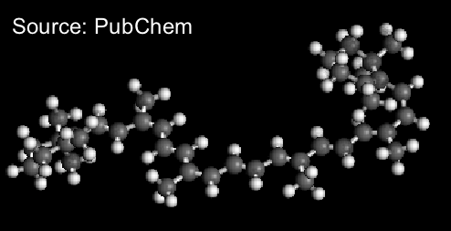 | 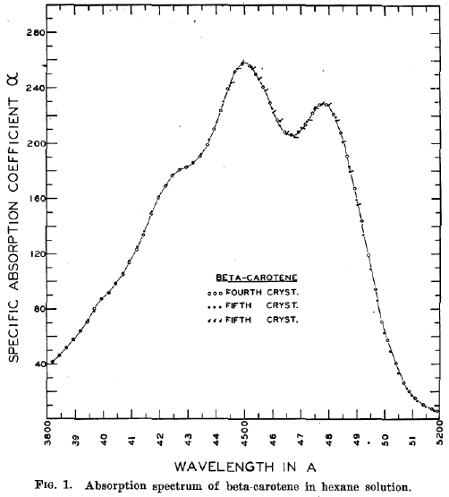  Source: F. Zscheile et al., Plant Physiology, 17(3), 331-346 (1942)
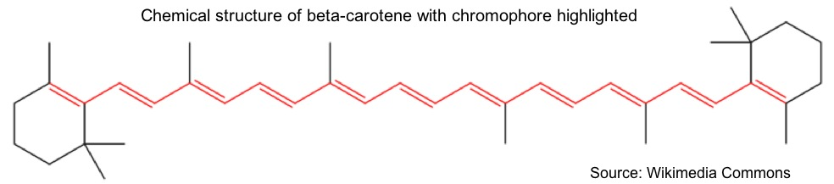

The chromophore consists of a long string of double bonds. A reasonable starting point might be to model the energy levels as if the electrons just could run back and forth freely along the molecule. The quantum physics tells us (see the reading Quantum string for a full derivation) if that's the case, the energy levels can be gotten assuming the electron waves are like the normal modes of an oscillating string. This model of the electron states gives the energy of the n-th level of a string of length L as
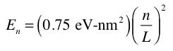
To model the excited states of the system we have to know a bit of chemistry. The electrons in the chromophore fill up the energy levels. You can only put two electrons in each state. There are 22 in the string of double bonds, so in the ground state all energy levels up to n=11 are filled.

Therefore, the first energy level that in the "ground state" is not occupied by electrons is n=12.

A. The first excited state of the molecule is defined as the state that is closest to the ground state in energy. It involves bringing an electron into the lowest free energy level of n=12. From which energy state should the electron be excited if we want to excite the lowest energy state above the ground state?

B. According to the data shown at the top, this chromophore (beta carotene) does a good job absorbing photons of wavelength lambda = 450 nm. What is the energy of this photon in eV?

C. Use the vibrating string model of the electrons in the chromophore to estimate the size of the chromophore, L. The actual length is about 3 nm. Is the model giving you a reasonable result?

4. The Microscope
A microscope is a device where a first lens makes a magnified real image of an object and that real image is then viewed with a second lens used as a magnifying glass to make a virtual image that is magnified further.
A. In a copy of the figure below (not to scale, but arranged so that the image formation works properly) draw a ray diagram showing the formation of the real and virtual images. (The "x" marks are the focal points belonging to the left lens. The "o" marks are the focal points belonging to the right lens.)
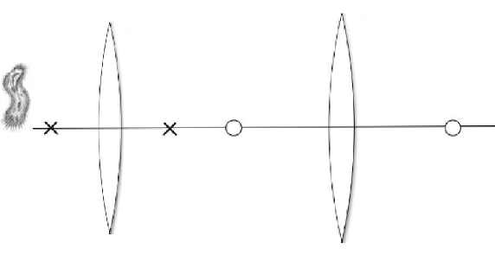
B. If the focal length of the left lens is 1 cm, the focal length of the right lens is 8 cm, and the distance between the two lenses is 15 cm, what will the magnification of the system be (i.e., How much bigger will the final image be than the object is?) when the object is at a distance of 1.125 cm from the left lens?

