Quiz 5
PHY 2540

Name:__________________________________

PART A: Qualitative Understanding (20 points)

Mark T (True) or F (False) beside each statement in questions 1 through 4. Each statement is worth 1 points.

1. Maxwell’s Equations:

________(a) In electrostatics, if a solid conductor has a charge Q at the center of a cavity inside it, the net electric flux through a closed surface drawn inside a solid conductor (not in the cavity) that encloses the charge is .

________(b) The net magnetic flux through a closed surface that encloses the part of the north pole of a bar magnet must be equal to the total flux through the same surface if it were to enclose the entire bar magnet.

________(c) If a rectangular conducting loop in Y-Z plane immersed in an external increasing magnetic field in the positive x direction, the induced current cannot be clockwise in the loop.

________(d) A moving charge produces magnetic field while a change in electric field with time does not produce a magnetic field.

________(e) A large change in magnetic flux cannot induce a small emf in a coil.

2. EM Waves:

________(a) An electromagnetic wave is caused by an accelerated motion of an electric charge.

_______(b) Since an electromagnetic (EM) wave is a transverse wave, the direction of the movement of the particles in the medium in which an EM wave propagates must be perpendicular to the direction of the propagation of the EM wave.

_______(c) If an EM wave described by the wave function, , then the direction of the propagation of the EM wave is possible along the positive y direction.

_______(d) For the EM wave with the given direction of propagation in part (c) above, the direction of the electric field is possible along the negative z direction.

_______(e) Again, for the EM wave in part (c), the magnitude of the magnetic field is directly proportional to the electric field in a given medium.

3. Geometric Optics:

_______(a) In order for a total internal reflection of an incident EM wave from vacuum to a glass surface (n = 1.5) to take place, the incident angle must be greater than 41.8 degrees.

_______(b) While the image of an object at the focal point of an optical instrument such as a mirror or a lens is located at infinity, the object distance of an image formed at the focal point can be located at any distance from the instrument.

_______(c) While a concave mirror can form both real and virtual image, a convex mirror can form only virtual image provided that the object is located at any point in front of the corresponding mirror.

_______(d) As you move an object from just outside to just inside the focal point of a converging lens, its image changes from real to virtual, but remain inverted.

_______(e) If the radii of a thin lens are doubled, the focal length of the lens decreases to .

4. Wave Optics:

_______(a) If the distance between the slits is halved in Young’s experiment, the width of the central maximum is doubled.

_______(b) The distance of the bright fringes from the central maximum must be dependent of color used to perform in Young’s experiment.

_______(c) In a single-slit diffraction experiment, as the width of the single slit is made smaller, the width of the central maximum diffraction becomes smaller.

_______(d) If the diffraction experiment is carried out in water using the same apparatus as in the air, the width of the central maximum in water is the larger than that in air.

_______(e) When a light ray passes through a thin film with the index of refraction greater than that in air, the reflected ray from the surface between the air and film undergoes a quarter-wavelength phase change.

5. Vision Correction:

(8 points) Calculate the power of the corrective lens required by a hyperopic (far sighted) eye whose near point is at 100.0 cm, with the assumption that an object at 25.0 cm in front of the eye is to be seen clearly. (Assume that the distance from the lens to the eye is negligible.)

6. Consider an arrangement of converging and diverging lenses as shown below.

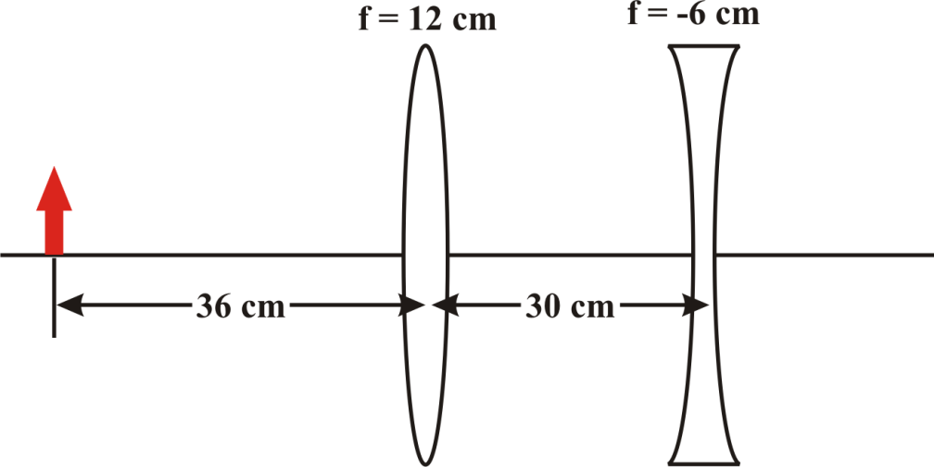

(a) (15 points) Relative to the convex lens where is the final image located for this system of lenses? Is the image real or virtual? Is it upright or inverted?

(d) (3 points) What is the total magnification for this system? Is the image magnified?

7. In a Young’s double-slit, with slit separation d, a Laser with a wavelength of d/10 produces interference pattern on a screen a distance 1.40 m away from the slits.

(a) (10 points) What is the distance between the third maximum and the fourth minimum on the same side of the central maximum? (Assume d = 0.5 mm)

(b) (10 points) Determine the difference in the vertical distance between the third and the fifth diffraction minima on the above screen due to the same laser shining on a single silt with width d/15. (Assume d = 0.5 mm)

