Homework 6
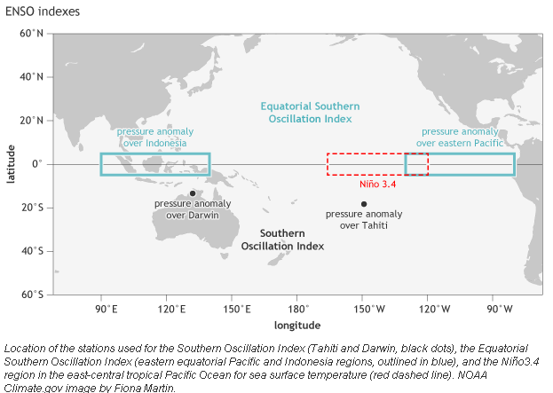
The original Southern Oscillation Index (SOI) defined as Tahiti minus Darwin (see figure above) SLP difference (hPa) has been complimented if not replaced by SST values (ºC) for the El Nino 3.4 region of the tropical eastern Pacific (5ºN-5ºS and 170ºW-120ºW) shown above. Using the selected monthly values for each index in Sheet 1 of the attached Excel file:
- Make a scatter plot to show the relationship between two indices
- Calculate the correlation coefficient between the two indices
- Assume SST values are the independent variable and the SOI values are the dependent variable, calculate a simple linear regression between the indices
- Interpret the regression dynamically

