Exercise 1:
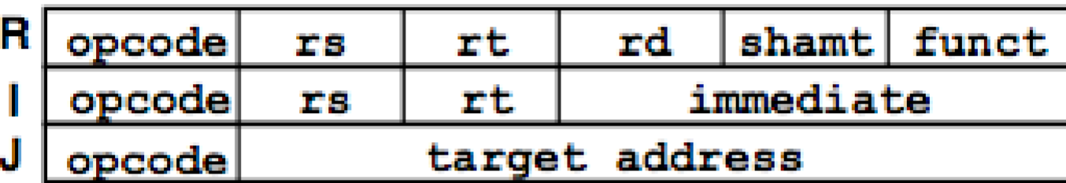
a.) I-type
Opcode: 000100 (6-bit operation code binary representation of the beq instruction; if ($rs == $rt) pc += i << 2)
rs: $t2 $10 01010 (5-bit binary representation of the first source register address)
rt: $zero $0 00000 (5-bit binary representation of the second source register address)
imm: strlen_end_loop 0000000000000110 (since the branch target is 6 instructions past the beq, we added a binary 6 to 0000000000000000 to show the offset of 6).
32-bit binary representation: 000000 01010 00000 0000000000000110 (added leading zeros to fill up the rest of the spots)
convert to 8-bit hexadecimal: 0x0140_0006
b.) If the code branched backwards to strlen_begin_loop instead, there would be an offset of -4 instead of 6.
Opcode: 000100 (6-bit operation code binary representation of the beq instruction; if ($s == $t) pc += i << 2)
rs: $t2 $10 01010 (5-bit binary representation of the first source register address)
rt: $zero $0 00000 (5-bit binary representation of the second source register address)
imm: strlen_begin_loop 1111111111111100 (since the branch target is 4 instructions behind the beq, we subtracted a binary 4 from 0000000000000000 to show the offset of -4).
32-bit binary representation: 000000 01010 00000 1111111111111100 (added leading zeros to fill up the rest of the spots)
convert to 8-bit hexadecimal: 0x0140_FFFC
c.) J-type
Opcode: 000010 (6-bit operation code binary representation of the j instruction; pc += i << 2)
Target address of strlen_begin_loop: 00000000000000000000000000 – 8 (since the branch target is 8 steps behind the j instruction)
32-bit binary representation: 000010 00000000000000000000000000
convert to 8-bit hexadecimal: 0x0800_0000

