- Facts:
Tim Loker has no family relationship to the Bryants family.
Tim Loker is five years old, which is under 18.
Tim Loker became a member of the Bryants household since August 12 of this year, which means by the end of this year, Tim will have been in the household for less than 5 months.
Bryants family provided 100% of Tim’s financial support, and intend to raise Tim as their kid.

- Issues: (Example from other cases)
Will Sara realize a loss on the sale of her land to CCM Inc.?
Can Sara recognize her realized loss?
What is the character of any recognized loss?
Given the character of the loss, to what extent can Sara deduct the loss in the computation of taxable income for the year of sale?

- Rules of law with citations to PRIMARY sources:
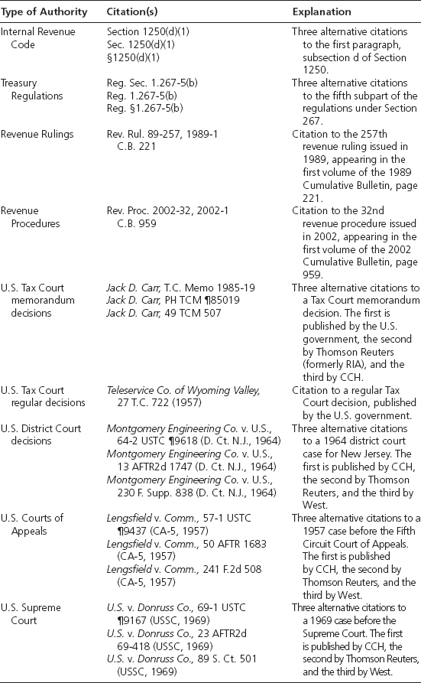
Sec. 267. Losses, expenses, and interest with respect to transactions between related taxpayers
a. | In general  No deduction shall be allowed in respect of any loss from the sale or exchange of property, directly or indirectly, between persons specified in any of the paragraphs of subsection (b).
  1. | Deduction for losses disallowed
b. | Relationships
   | The persons referred to in subsection (a) are:
  2. | An individual and a corporation more than 50 percent in value of the outstanding stock of which is owned, directly or indirectly, by or for such individual;
c. | Constructive ownership of stock
   | For purposes of determining, in applying subsection (b), the ownership of stock—
  3. | An individual shall be considered as owning the stock owned, directly or indirectly, by or for his family;
  4. | The family of an individual shall include only his brothers and sisters (whether by the whole or half blood), spouse, ancestors, and lineal descendants; and
  5. | … stock constructively owned by an individual by reason of the application of paragraph (2) or (3) shall not be treated as owned by him for the purpose of again applying either of such paragraphs in order to make another the constructive owner of such stock.
According to Section 267(a)(1), Sara cannot recognize her realized loss if she and CCM Inc. are related parties. According to Section 267(b)(2), Sara and CCM Inc. are related parties if Sara directly or indirectly owns more than 50 percent in value of CCM’s outstanding stock. You know that Sara does not own any CCM stock directly, but you are uncertain as to whether she owns any stock indirectly. Section 267(c)(2) provides that Sara is considered to own any CCM stock owned by her “family.” When you refer to the facts you established during your first meeting with Sara, you discover that you do not know how many shares of CCM stock are…

- Conclusion and Recommendations
- Positions you would consider taking/ areas you would like to analyze in more depth if you had more time

