Assessment Type: Assignment 1 Semester: 371

Course Code | CS 101 | Course Title | Introduction to computing
Submission Date and Time |  | Thursday 03 November 2016 before 9am

Students are requested to comply with all JUC examination rules and regulations strictly.

Submission Instructions
- Please submit your solution (the Java files).
- Make sure that you include your student ID, name and section number as Java comments at the beginning of each Java file. Files submitted without this information will simply be discarded.
- Any later submissions will not be accepted.

Problem 1: (5 marks)

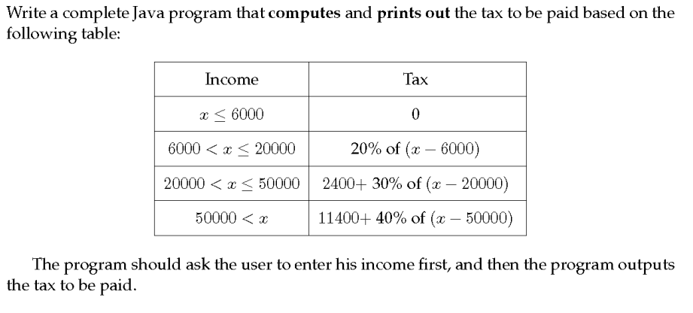

Problem 2: (3 marks)

