Prime Properties
Prime Properties is a small real estate company that specializes in residential properties. The owner, Maria Valdez, would like a website to showcase her listings and provide a point of contact for her clients, who are mainly middle-class working adults who are looking for a home in the northwest Chicago suburbs. Maria would like a home page, a listings page that contains information about her properties, a fi nancing page, and a contact page.
A site map for the Prime Properties website is shown in Figure 2.37 . The site map describes the architecture of the website, which consists of “Home” page with three main content pages: “Listings,” “Financing,” and “Contact.”
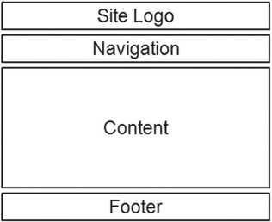
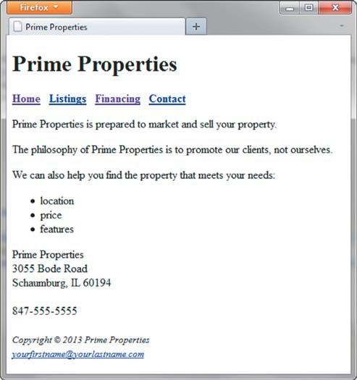
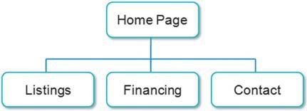
Website Case Study
73
Figure 2.37 Prime Properties site map
Figure 2.38 displays a wireframe sketch of the page layout for the website. It contains a site logo, a navigation area, a content area, and a footer area for copyright information. Figure 2.38 Prime Properties wireframe
You have three tasks in this case study:
1.
Create a folder for the Prime Properties website.
- Create the Home page: index.html.
- Create the Financing page: fi nancing.html.
Hands-On Practice Case Study
Task 1: Create a folder on your hard drive or portable storage device (thumb drive or SD card) called “prime” to contain your Prime Properties web page fi les.
Task 2: The Home Page. You will use a text editor to create the Home page for the Prime
Properties website. The Home page is shown in Figure 2.39 .
Figure 2.39 Prime
Properties index.html
74
Chapter 2 HTML Basics
Launch a text editor, and create a web page with the following specifi cations:
- Web Page Title. Use a descriptive page title. The company name is a good choice for a business website.
- Wireframe Logo. Use <h1> for the Prime Properties logo.
- Wireframe Navigation. Confi gure the following text using the <b> phrase element within a div element :
Home Listings Financing Contact
Code anchor tags so that “Home” links to index.html, “Listings” links to listings.html,
“Financing” links to fi nancing.html, and “Contact” links to contact.html.
- Wireframe Content.
- Code each line of the following text in its own paragraph:
Prime Properties is prepared to market and sell your property.
The philosophy of Prime Properties is to promote our clients, not ourselves.
We can also help you fi nd the property that meets your needs:
- Confi gure the following content in an unordered list:
location price features
- Code the following address and phone number contact information within a div element. Use line break tags to help you confi gure this area and add extra space between the phone number and the footer area.
Prime Properties
3055 Bode Road
Schaumburg, IL 60194
847-555-5555
5. Wireframe Footer. Confi gure the following copyright and e-mail link information within a div element. Format it with small text size (use the <small> tag) and italics font style (use the <i> tag)
Copyright © 2013 Prime Properties
Place your name in an e-mail link on the line under the copyright information. The page in Figure 2.39 may seem a little sparse, but don’t worry; as you gain experience and learn to use more advanced techniques, your pages will look more professional. White space (blank space) on the page can be added with <br> tags where needed. Your page does not need to look exactly the same as the sample. Your goal at this point should be to practice and get comfortable using HTML.
Save your page in the prime folder, and name it index.html.
Task 3: The Financing Page. Create the Financing page shown in Figure 2.40 . A technique that improves productivity is to create new pages based on existing pages so that you can benefi t from your previous work. Your new Financing page will use the index.html page as
a starting point.
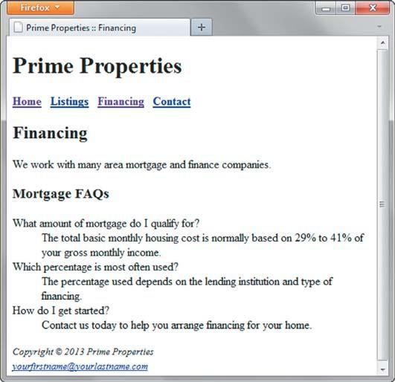
Website Case Study
75
Figure 2.40 Prime Properties fi nancing.html
Open the index.html page for the Prime Properties website in a text editor. Select File > Save As, and save the fi le with the new name of fi nancing.html in the prime folder. Now you are ready to edit the page.
- Web Page Title. Modify the page title. Change the text contained between the
<title> and </title> tags to the following:
Prime Properties :: Financing
- Wireframe Content.
- Delete the Home Page content paragraphs, unordered list, and contact information.
- Confi gure the following text in an <h2> element:
Financing
- Code the following sentence in a paragraph: We work with many area mortgage and fi nance companies.
- Confi gure the following phrase with an <h3> element:
Mortgage FAQs
- Use a description list to confi gure the FAQs. Confi gure <dt> elements for the questions and <dd> elements for the answers. The FAQ questions and answers are as follows:
What amount of mortgage do I qualify for?
The total basic monthly housing cost is normally based on 29% to 41% of your gross monthly income.
Which percentage is most often used?
76
Chapter 2 HTML Basics
The percentage used depends on the lending institution and type of fi nancing.
How do I get started?
Contact us today to help you arrange fi nancing for your home.
Save your page, and test it in a browser. Test the hyperlink from the fi nancing.html page to index.html. Test the hyperlink from the index.html page to fi nancing.html. If your links do not work, review your work with close attention to these details:
- Verify that you have saved the pages with the correct names in the correct folder.
- Verify your spelling of the page names in the anchor tags.
Test again after you make the changes.
You have the following tasks:
1.
Create a new folder for this Prime Properties case study.
- Create an external style sheet named prime.css that confi gures the color and text for the Prime Properties website.
- Modify the Home page to utilize an external style sheet to confi gure colors and fonts.
The new Home page and color swatches are shown in Figure 3.33 .
- Modify the Financing page to be consistent with the new Home page.
- Confi gure centered page layout.
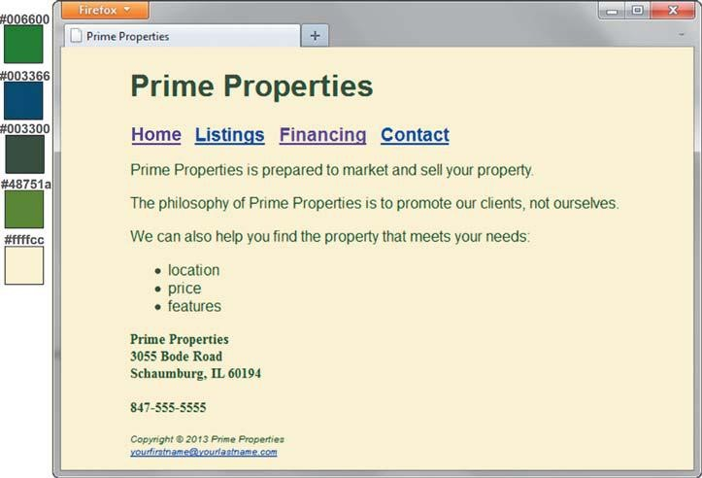
Website Case Study
125
Figure 3.33 New Prime Properties index.html
Hands-On Practice Case Study
Task 1: Create a folder on your hard drive or portable storage device called primecss.
Copy all the fi les from your Chapter 2 prime folder into the primecss folder.
Task 2: The External Style Sheet. You will use a text editor to create an external style sheet named prime.css. Code the CSS to confi gure the following:
1.
Global styles for the document (use the body element selector) with background color #ffffcc; text color #003300; and Arial, Helvetica, or any sans-serif font.
- Styles for the h2 element selector that confi gure background color #ffffcc and text color #003366.
- Styles for the h3 element selector that confi gure background color #ffffcc and text color #006600.
- Styles for the dd element selector that confi gure italics, font size smaller than the default (.90em), and 200% line height.
- Styles for an id named header that confi gure background color #ffffcc and text color #48751A.
- Styles for a navigation area (use a class named nav ) that displays text in bold, large (1.2em) font.
- Styles for a class named contact that confi gure boldface, font size smaller than the default (.90em), and Times New Roman or any serif font.
- Styles for the page footer area (use an id named footer ) with small font size (.60em) and italic text.
Save the fi le as prime.css in the primecss folder. Check your syntax with the CSS validator
( http://jigsaw.w3.org/css-validator ). Correct and retest if necessary.
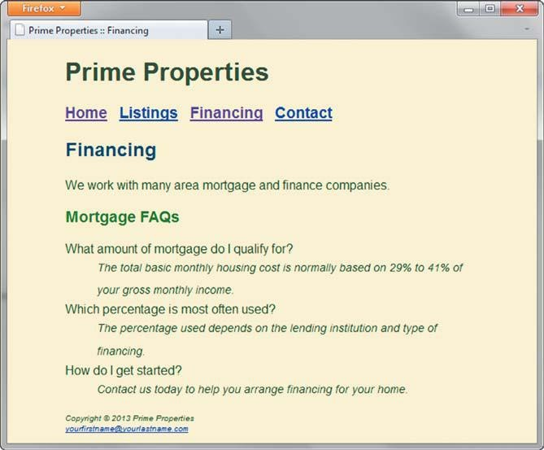
126
Chapter 3 Configuring Color and Text with CSS
Task 3: The Home Page. Launch a text editor, and open the index.html fi le. You will modify this fi le to apply styles from the prime.css external style sheet.
1.
Add a <link> element to associate the web page with the prime.css external style sheet fi le. Save and test your index.html page in a browser and you’ll notice that the styles confi gured with the body selector are already applied!
2. Confi gure the logo header area. Assign the <h1> element to the id named header . 3. Confi gure the navigation area. Assign the div that contains the navigation to the class named nav . Hint : <div class="nav">. Remove the <b> element from the navigation area, because the CSS will confi gure the bold font style.
- Confi gure the div containing the address and phone information. Assign this area to the class named contact .
- Confi gure the page footer area. Remove the <small> and <i> elements, because the font-size and font-style are confi gured as part of the footer id. Assign the div that contains the footer information to the id named footer.
Save the index.html fi le, and test in a browser. Your page should look similar to the one shown in Figure 3.33 .
Task 4: The Financing Page. Launch a text editor, and open the fi nancing.html fi le. You will modify this fi le in a similar manner: Add the <link> element, confi gure the logo header area, confi gure the navigation area, and confi gure the page footer area. Save and test your new fi nancing.html page. It should look similar to the one shown in
Figure 3.34 .
Figure 3.34 New fi nancing.html page
Website Case Study
127
Task 5: Center Page Layout with CSS. Modify prime.css, index.html, and fi nancing.html to confi gure page content that is centered with 80% width. Refer to Hands-On Practice 3.8 if necessary.
1.
Launch a text editor, and open the prime.css fi le. Add a style rule for an id named wrapper with width set to 80%, margin-right set to auto, and margin-left set to auto.
- Launch a text editor, and open the index.html fi le. Add the HTML code to confi gure a div element assigned to the id wrapper that “wraps,” or contains, the code within the body section. Save and test your index.html page in a browser and you’ll notice that the page content is now centered within the browser viewport as shown in Figure 3.33 .
- Launch a text editor, and open the fi nancing.html fi le. Add the HTML code to confi gure a div element assigned to the id wrapper that “wraps,” or contains, the code within the body section. Save and test your fi nancing.html page in a browser and you’ll notice that the page content is now centered within the browser viewport as shown in Figure 3.34 .
Experiment with modifying the prime.css fi le. Change the page background color, the font family, and so on. Test your pages in a browser. Notice how a change in a single fi le can aff ect multiple fi les when external style sheets are used.
This page intentionally left blank
Hands-On Practice Case
Task 1: Create a folder on your hard drive or portable storage device called prime4. Copy all the fi les from your Chapter 3 primecss folder into the prime4 folder. Obtain the images used in this case study from the student fi les. The images are located in the chapter4/ casestudystarters/prime folder. The images are primelogo.gif, primehomenav.gif, primehomebtn.gif, primelistingsnav.gif, primelistingsbtn.gif, primefi nancingnav.gif, primefi nancingbtn.gif, primecontactnav.gif, primecontactbtn.gif, schaumburg.jpg, schaumburgthumb.jpg, libertyville.jpg, libertyvillethumb.jpg, primevertical.png, primehorizontal.png, and primediagonal.png. Save the fi les in your prime4 folder. Task 2: The Home Page. Launch a text editor, and open the index.html fi le from your prime4 folder. Modify the index.html fi le to look similar to the web page shown in
Figure 4.46 .
1.
Replace the “Prime Properties” text contained within the h1 element with the primelogo.gif. Be sure to include the alt, height, and width attributes on the <img> tag for the graphic.
2. Update the navigation area.
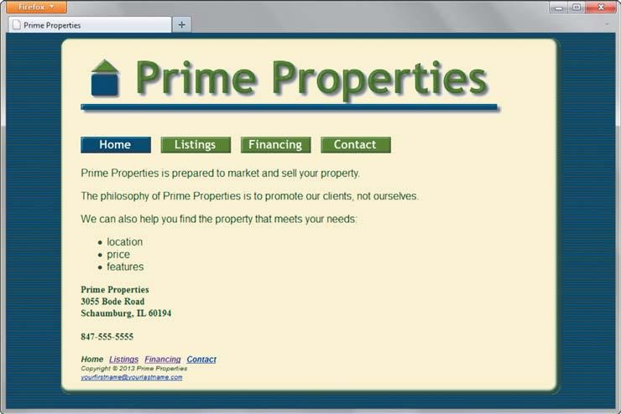
190
Chapter 4 Visual Elements and Graphics
Figure 4.46 Prime Properties Home page
- Since you will be replacing the main navigation with image links, it’s a good ideato provide for accessibility by including a set of text navigation links in the footer section of the web page. Copy the navigation div, and paste it inside the footer area above the copyright line.
- Refer to Figure 4.46 , and replace the main navigation text hyperlinks with imagelinks. The navigation buttons use color as a visual cue for visitors. The navigation button for the current page has a blue background. The navigation buttons for other pages have a green background. To confi gure this area for the Home page, use primehomebtn.gif (link to index.html), primelistingsnav.gif (link to listings.html), primefi nancingnav.gif (link to fi nancing.html), and primecontactnav.gif (link to contact.html). Use appropriate attributes on the <img> tag: alt, height, and width. Save and test your new index.html page. It will be similar to Figure 4.46 but you’ll notice that a few fi nal touches (like the dark-blue page background) are missing; you’ll confi gure these with CSS in Task 5.
Task 3: The Financing Page. Launch a text editor, and open the fi nancing.html page from your prime4 folder. Replace the “Prime Properties” heading with the primelogo.gif. Confi gure the navigation areas in a similar way as in the home page. In the top navigation, use primehomenav.gif (link to index.html), primelistingsnav.gif (link to listings.html), primefi nancingbtn.gif (link to fi nancing.html), and primecontactnav.gif (link to contact.html).
Save and test your new fi nancing.html page.
Task 4: The Listings Page. Use the Financing page as the starting point for the Listings page.
Launch a text editor, and open the fi nancing.html fi le in the prime4 folder. Save the fi le as listings.html. Modify your fi le to look similar to the Listings page, as shown in Figure 4.47 .
1.
Change the title to an appropriate phrase.
- Confi gure the top navigation area to display primehomenav.gif (link to index.html), primelistingsbtn.gif (link to listings.html), primefi nancingnav.gif (link to fi nancing. html), and primecontactnav.gif (link to contact.html).
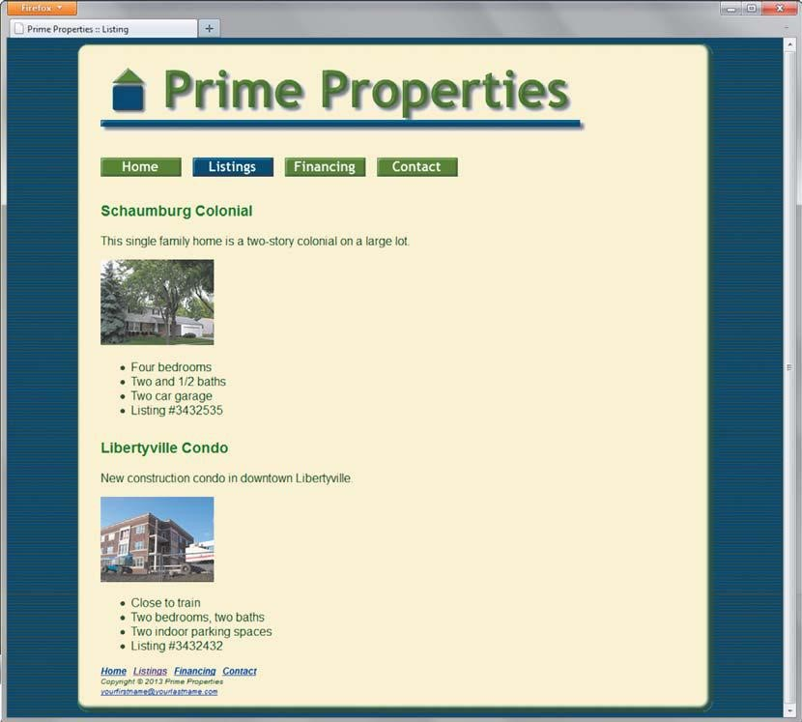
Website Case Study
191
Figure 4.47 Prime Properties listings.html
- Replace the h2 element text “Financing” with “Listings”.
- Delete the text between the Listings heading and the footer section of the web page. 5. The section describing each listing consists of an h3 element, an image link, a paragraph, and an unordered list.
Schaumburg Colonial Listing
- Confi gure an h3 element with the following text:
Schaumburg Colonial
- Confi gure a paragraph with the following text:
This single family home is a two-story colonial on a large lot.
- Confi gure the schaumburgthumb.jpg as an image link to schaumburg.jpg. Codeappropriate attributes on the <img> tag, including src, alt, height, and width.
- Confi gure an unordered list with the following text:
Four bedrooms
Two and 1/2 baths
Two car garage
Listing #3432535
192
Chapter 4 Visual Elements and Graphics
Libertyville Condo Listing
- Confi gure an h3element with the following text:
Libertyville Condo
- Confi gure a paragraph with the following text:
New construction condo in downtown Libertyville.
- Confi gure the libertyvillethumb.jpg as an image link to libertyville.jpg. Code appro-priate attributes on the <img> tag, including src, alt, height, and width.
- Confi gure an unordered list with the following text:
Close to train
Two bedrooms, two baths
Two indoor parking spaces
Listing #3432432
Save the listings.html fi le. If you test your page in a browser, you’ll notice that it looks diff erent from Figure 4.47 ; you still need to confi gure style rules.
Task 5: Configure the CSS. Open pacifi c.css in in a text editor. Edit the style rules as follows:
- Modify the style rules for the body element selector to confi gure a very darkbackground color (#000033). Choose either primevertical.png, primehorizontal. png or primediagonal.png to use as the background image.
- Modify the style rules for the #wrapper id. Confi gure #FFFFCC as the backgroundcolor. Confi gure a minimum width of 700px (use min-width ), no top padding, no right padding, 20 pixels of bottom padding, 30 pixels of left padding, and a 1 pixel blue (#00332B) ridge border with rounded corners. Also confi gure an inset box shadow with the following CSS:
-webkit-box-shadow: inset -3px -3px 3px 3px #00332B; -moz-box-shadow: inset -3px -3px 3px 3px #00332B; box-shadow: inset -3px -3px 3px 3px #00332B;
- Modify the style rules for the h3 element selector to have 10 pixels of top padding.• The background properties on the header id selector, h2 element selector, and h3 element selector interfere with the inset box shadow in some browsers. Remove the background-property style rule from these selectors.
- Confi gure the img element selector to display no border.
Save the prime.css fi le. Test your pages (index.html, fi nancing.html, and listing.html) in a browser. If your images do not appear or your image links do not function, examine your work carefully. Use Windows Explorer or Mac Finder to verify that the images are saved in your prime folder. Examine the src attributes on the <img> tags to be sure you spelled the image names correctly. Another useful troubleshooting technique is to validate the HTML and CSS code. See Chapters 2 and 3 for Hands-On Practice exercises that describe how to use these validators.
Practice Case
1.
Examine the site map in Figure 2.37 . What type of site organization is used for the Prime Properties website? Is it the most appropriate organization for the site? Why or why not?
2. Review the recommended web design practices from this chapter. Use the Web Design Best Practices Checklist ( Table 5.1 ) to evaluate the Prime Properties site you created in earlier chapters. Cite three design practices that have been well implemented. Cite three design practices that could be implemented in a better way. How else would you improve the website?
Web Project
Task 1: Create a Folder. Create a folder called prime6. Copy all of the fi les from your Chapter 4 prime4 folder into the prime6 folder. You will modify the prime.css fi le and each web page fi le (index.html, listings.html, and fi nancing.html) to implement the two-column page layout shown in Figure 6.40 . See the new Prime Properties home page in Figure 6.41 .
Task 2: Configure the CSS. Open prime.css in a text editor. Edit the style rules as follows:
1.
Confi gure the left column area. Add a new style rule for the left id to confi gure an area that fl oats to the left and is 150 pixels wide.
2. Confi gure the navigation hyperlinks to use CSS for the background color and border instead of using image links. We’ll set up the CSS in this step.
a. Use a contextual selector to add a new style rule for the anchor tags within the nav
id that removes the underline from hyperlinks. Also confi gure the anchor tags to
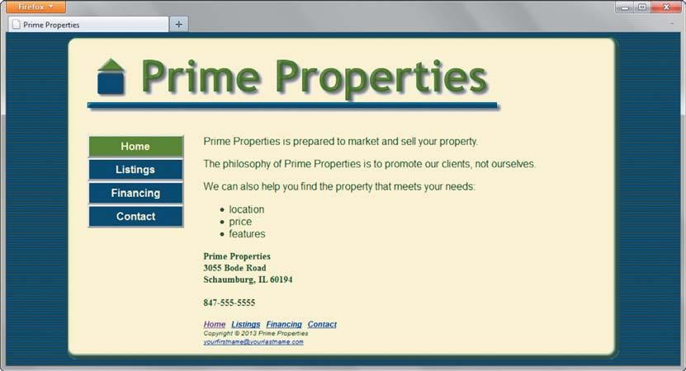
Website Case Study
273
Figure 6.41 The new Prime Properties two-column home page (index.html) use block display, centered text, bold font, text color #FFFFCC, a 3 pixel gray
(#CCCCCC) outset border, and 5 pixels of padding.
#left a { text-decoration: none; display: block: text-align: center; color: #FFFFCC; font-weight: bold; border: 3px outset #CCCCCC; padding: 5px;}
b. Confi gure the :link , :visited , and :hover pseudo-classes for the navigation hyperlinks. Use the following background colors: #003366 (unvisited hyperlinks) and #48751A (visited hyperlinks). Confi gure a 3 pixel inset #333333 border for hyperlinks in the hover state.
#left a:link { background-color: #003366; }
#left a:visited { background-color: #48751A; }
#left a:hover { border: 3px inset #333333; }
- You will organize the navigation hyperlinks within an unordered list in later tasks. The navigation area in Figure 6.41 does not show list markers. Use a contextual selector to confi gure unordered lists in the navigation area to display without list markers.
Also confi gure the unordered list to have no margin and no left padding.
#left ul { list-style-type: none; margin: 0; padding-left: 0; }
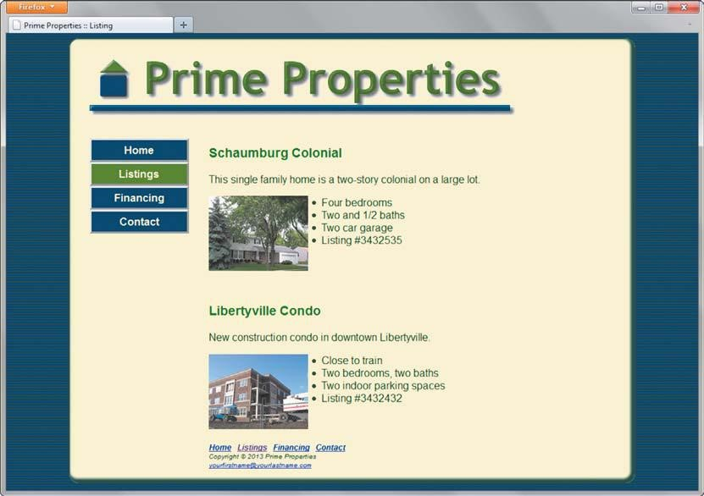
274
Chapter 6 Page Layout
- Confi gure the right column area. Add a new style rule for the right id to confi gure an area with a 180 pixel left margin and 20 pixels of right and bottom padding
( padding: 0 20px 20px 0; ).
- Modify the footer id. Confi gure a style rule to clear fl oats.
- Refer to the Listings page in Figure 6.42 and notice how the images fl oat on the left side of the description. Confi gure a new class named floatleft that fl oats to the left with 20 pixels of right and bottom padding.
- Confi gure a new class named clear that clears the left fl oat.
Save the prime.css fi le.
Task 3: Modify the Home Page. Open index.html in a text editor and modify the code as follows:
1.
Confi gure the left column. Locate the div assigned to class="nav" that is immediately below the h1 element. Remove class="nav" and assign this div to id="left" .
- The navigation image links are the only content in the left column. Remove other code, including any characters that may be present. Replace the image links with text image links. Then, code an unordered list to organize the navigation hyperlinks. Each hyperlink should be contained within <li> tags.
- Confi gure the right column. This area contains the content (paragraphs, unordered list, and contact information) and the footer section. Code a <div> that surrounds this area. Assign the <div> to id="right" .
Save the index.html fi le. It should look similar to the web page shown in Figure 6.41 . Remember that validating your HTML and CSS can help you fi nd syntax errors. Test and correct this page before you continue.
Figure 6.42 The new Prime Properties two-column Listings page
Website Case Study
275
Task 4: Modify the Listings Page. Open listings.html in a text editor.
1.
Confi gure the left-column navigation area, navigation hyperlinks, and right column in the same manner as the home page.
- Confi gure the house and condo images to fl oat to the left. Add class="floatleft" to these image elements.
- Add a blank line above the second h3 element on the page. Clear the fi rst fl oated thumbnail image by coding a line break tag that is assigned to the clear class.
Save your new listings.html page and test it in a browser. Use the CSS and HTML validators to help you fi nd syntax errors.
Task 5: Modify the Financing Page. Open fi nancing.html in a text editor. Confi gure the left-column navigation area, navigation hyperlinks, and right column in the same manner as the home page. Save your new fi nancing.html page and test it in a browser. Use the CSS and HTML validators to help you fi nd syntax errors.
In this case study, you changed the page layout of the Prime Properties website. Notice that with just a few changes in the CSS and HTML code, you confi gured a two-column page layout.
OPTIONAL: Prime Properties Case Study: HTML5 Extension
Get more practice with the new HTML5 structural elements by creating a new version of the Prime Properties website. Create a folder called prime6HTML5 to contain your Prime
Properties website fi les. Copy the fi les from the prime6 folder.
1.
Modify the prime.css fi le in a text editor. Confi gure new styles and use HTML element selectors for the header, nav, and footer elements.
- All style declarations previously associated with the header id will apply tothe header element selector. Replace the header id with the header element selector.
- Replace all instances of the #left selector with the nav element selector.
- Replace all instances of the #footer selector with the footer element selector.
- Add the following CSS to be compatible with most older browsers:
header, nav, figure, footer { display: block; }
2. Modify each web page in a text editor. Confi gure the HTML5 elements.
- Confi gure an HTML5 header element to contain the h1 element. Removeid="header" from the h1 tag.
- Replace the opening and closing tags for the div assigned to the left id with theHTML5 nav element.
- Replace the opening and closing tags for the div assigned to the footer id withthe HTML5 footer element.
- Note the image links on the Listings page. Use the HTML5 fi gure element tocontain each image link. Confi gure the fi gure element to use the floatleft class. Remove the floatleft class from the image tags. Code a line break above the footer element that is assigned to the clear class.
276
Chapter 6 Page Layout
- Add the following code in the head section of the web page after the link elementto assist Internet Explorer 8 and earlier versions:
<!--[if lt IE 9]> <script src=" http://html5shim.googlecode.com/svn/trunk/html5.js
">
</script>
<![endif]-->
Save your fi les. Display your pages in a modern browser. Your new case study web pages should look similar to the previous version. This optional exercise provided you with additional practice using the new HTML5 elements.
Web Project
See Chapter 5 for an introduction to the Web Project case study. As you completed the
Chapter 5 Web Project case study activities, you completed a Web Project Topic Approval, Web Project Site Map, and Web Project Page Layout Design. In this case study, you will use your design documents as a guide as you develop the pages for your Web Project using CSS in an external style sheet for both formatting and page layout.
Hands-On Practice Case
1.
Create a folder called project. All of your project fi les and graphics will be organized in this folder and in subfolders as needed.
- Refer to your Site Map to view the pages that you need to create. Jot down a list of the fi le names. Add these to the Site Map.
- Refer to the Page Layout Design. Make a list of the common fonts and colors used on the pages. These may become the CSS you confi gure for the body element. Note where typical elements used for organization (such as headings, lists, paragraphs, and so on) may be used. You may want to confi gure CSS for these elements. Identify various page areas such as header, navigation, footer, and so on, and list any special confi gurations needed for these areas. These will be confi gured as classes in your CSS. Create an external style sheet, called project.css, which contains these confi gurations.
- Using your design documents as a guide, code a representative page for your site.
Use CSS to format text, color, and layout. Apply classes and ids where appropriate.
Associate the web page to the external style sheet.
Save and test the page. Modify both the web page and the project.css fi le as needed.
Test and modify them until you have achieved the look you want.
- Using the completed page as a template wherever possible, code the rest of the pages on your site. Test and modify them as needed.
- Experiment with modifying the project.css fi le. Change the page background color, the font family, and so on. Test your pages in a browser. Notice how a change in a single fi le can aff ect multiple fi les when external style sheets are used.
Prime Properties
See Chapter 2 for an introduction to the Prime Properties case study. Figure 2.37 shows a site map for the Prime Properties website. In this case study, you will confi gure the website to display on mobile devices using the single-column layout shown in Figure 7.14 . You will create a new mobile style sheet, modify the current styles, and update the Home, Financing, and Listings pages. Use the Chapter 6 Prime Properties website as a starting point for this case study. When you are fi nished, the website will look the same (see Figure 6.41 ) in desktop browsers. The mobile display should be similar to Figure 7.29 or
7.30 . You have six tasks in this case study:
1.
Create a new folder for this Prime Properties case study.
- Modify the Home page to target mobile devices and deliver a mobile style sheet.
- Modify the Financing page to be consistent with the Home page.
- Modify the Listings page to be consistent with the Home page.
- Create a new style sheet (primemobile.css), which will confi gure a single-column page layout.
- Modify the desktop style sheet (prime.css).
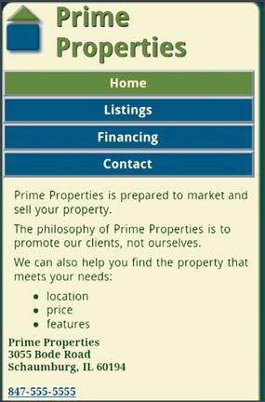
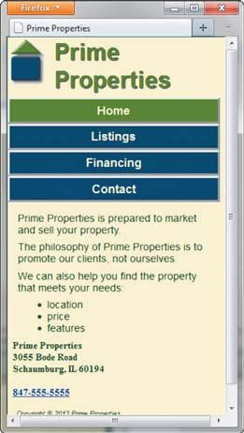
Website Case Study
325
Figure 7.29 The new mobile home Figure 7.30 It’s possible to page displayed on smartphone approximate the mobile display of a web page using a desktop browser
Hands-On Practice Case Study
Task 1: Create a Folder. Create a folder called prime7. Copy all of the fi les from your Chapter 6 prime6 folder into the prime7 folder. Copy the primemobile.gif fi le from the chapter 7/starters folder in the student fi les.
Task 2: Modify the Home Page. Open index.html in a text editor. Edit the code as follows:
1.
Confi gure a new link element in the head section that associates the web page with primemobile.css. Use CSS media queries to target smartphone mobile devices. Refer to Section 7.5 .
- Confi gure a viewport meta tag that confi gures the width to the device-width and sets the initial-scale to 1.0. Refer to Section 7.5 .
- The Prime Properties logo image is too wide for display on a mobile device. If a mobile browser scales down the image, the text may be diffi cult to read. Your design strategy will be to remove the img tag from the web page and confi gure “Prime Properties” text within the h1 element. You’ll confi gure this area with CSS in Tasks 5 and 6. The HTML code is
<h1 id="header">Prime Properties</h1>
- The home page displays a phone number in the contact information area. Wouldn’t it be handy if a person using a smartphone could click on the phone number to call the company? You can make that happen by using tel: in a hyperlink. Confi gure a hyperlink assigned to an id named mobile that contains the phone number as shown below:
<a id="mobile" href="tel:847-555-5555">847-555-5555</a>
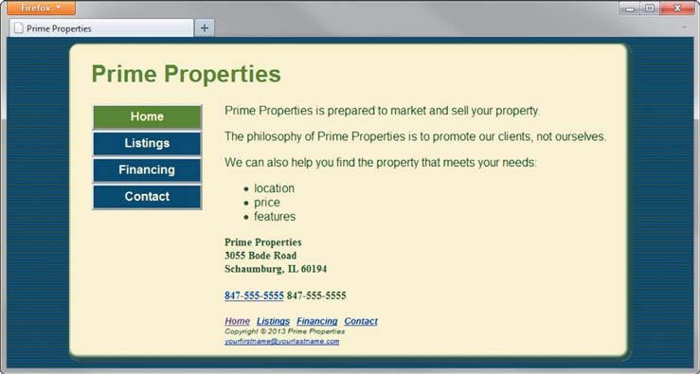
326
Chapter 7 More on Links, Layout, and Mobile
But wait a minute, a telephone link could confuse those visiting the site with a desktop browser. Code another phone number directly after the hyperlink. Code a span element assigned to an id named desktop around the phone number as shown below:
<span id="desktop">847-555-5555</span>
Don’t worry about the two phone numbers that are now on the page. You’ll confi gure CSS in Tasks 5 and 6 to show the appropriate phone number (with or without the telephone link) to your website visitors.
Save the index.html fi le. It should look similar to the web page shown in Figure 7.31 when displayed in a desktop browser. Remember that validating your HTML can help you fi nd syntax errors. Test and correct this page before you continue.
Figure 7.31 Temporary desktop browser display before new styles are confi gured Task 3: Modify the Financing Page. Open fi nancing.html in a text editor. Add the link element and viewport meta tag in a manner consistent with the home page. Reconfi gure the header area and logo image in the same manner as the home page. Save and test your new fi nancing.html page in a browser. Use the HTML validator to help you fi nd syntax errors.
Task 4: Modify the Listings Page. Open listings.html in a text editor. Add the link element and viewport meta tag in a manner consistent with the home page. Reconfi gure the header area and logo image in the same manner as the home page. Save and test your new listings.html page in a browser. Use the HTML validator to help you fi nd syntax errors.
Task 5: Configure the Mobile CSS. Create the mobile style sheet based on the desktop style sheet. Open prime.css in a text editor. Save the fi le as primemobile.css. Edit the style rules as follows:
1.
Modify the body element selector. Set margin and padding to 0. There’s no need to display the background image. Set the background-image property to the value none . 2. Modify the wrapper id selector. Set left margin to 0, right margin to 0, padding to 0, width to 100%, and minimum width to 0.
Website Case Study
327
- Modify the header id selector. Recall that in Tasks 2, 3, and 4 you removed the logo image element from the web page background. Confi gure the small logo (primemobile.gif) as a background image with no repeats. Set the height to 70 pixels to correspond to the background image. Confi gure 0.4em bottom padding, no margin, and a 1 pixel text-shadow (use #000033 shadow color).
- Confi gure an h1 element selector. Set left padding to 2em. The text “Prime Properties” will display in the header area on mobile devices. Set the text-indent property to 0.
- Confi gure the left id selector. The mobile layout uses a single column. Set fl oat to none , 100% width, 0 padding, and 0 margin.
- Confi gure the anchor tags in the left id. Modify the style declaration for the
#left a selector. Set padding to 0.3em. Set width to 92%.
- Modify the #left ul selector. Set padding and margin to 0.
- Modify the right id selector. Set padding to 0.5em, margin to 0, and font size to 90%. 9. Modify the floatleft class selector. Set the fl oat property to none . Set right and bottom padding to 0.
- Modify the h3 element selector. Set top padding to 0. Set margin to 0.
- Modify the h2 element selector. Set margin to 0.
- Modify the dd element selector. Set the line-height property to 100%.
- Modify the footer id selector. Set top and bottom padding to 0.
- Confi gure a new style rule to set a 0.3em margin for p, dt, dd, and ul elements in the content area ( right id).
#right p, #right ul, #right dd, #right dt { margin: 0.3em; }
- Modify the nav class (the repeated navigation in the footer section of the page). Use display: none; to prevent it from displaying.
- Remember the telephone number hyperlink you created in Task 2? Confi gure the CSS for the phone number display as shown below:
#mobile { display: inline; }
#desktop { display: none; }
Save the primemobile.css fi le. Use the CSS validator to help you fi nd syntax errors. Task 6: Modify the Desktop CSS. Open prime.css in a text editor. Edit the style rules as follows:
1.
Modify the header id selector. Set the text alignment to left. Recall that in Tasks 2, 3, and 4 you removed the logo image element from the web page background. Confi gure the desktop logo (primelogo.gif) as a background image that does not repeat. Set the height to 100 pixels, which corresponds to the height of the background image.
- Confi gure an h1 element selector. Use the text-indent property (refer to Chapter 3 ) to make this text available to screen readers but not display directly on the web page. The new style rule is h1 { text-indent: -99999px; }
328
Chapter 7 More on Links, Layout, and Mobile
- Remember the telephone number hyperlink you created in Task 2? Confi gure the CSS for the phone number display as shown below:
#mobile { display: none; }
#desktop { display: inline; }
Save the prime.css fi le. Use the CSS validator to help you fi nd syntax errors. Display your pages in a desktop browser. The pages should look the same as they did before you started this case study (see Figure 6.41 ). Next, test the mobile display. Either publish your pages to the Web and display with a mobile device/emulator OR temporarily modify the href value (change prime.css to primemobile.css) on the fi rst link element. Display your page and reduce the width of the browser. Your mobile display should be similar to Figure 7.29 or 7.30 . Select the hyperlinks to view the Listings and Financing pages. They should be similar to the home page. Prime Properties is mobile!
Web Project
See Chapters 5 and 6 for an introduction to the Web Project case study. In this case study, you confi gure the website to display in mobile devices using the single-column layout shown in Figure 7.14 . You will create a new mobile style sheet and modify the web pages as indicated in Section 7.5 . Hands-On Practice Case Study
1.
Create a new style sheet for mobile display.
- Modify each web page to associate with the new style sheet for mobile display.
- Display your pages in a desktop browser. The pages should look the same as they did before you started this case study. Next, display your pages in a mobile device or emulator. Your pages should be optimized for mobile display.
Prime Properties
See Chapter 2 for an introduction to the Prime Properties case study. Figure 2.37 shows a site map for Prime Properties. Use the Chapter 6 Prime Properties website as a starting point for this case study. You will modify the Listings page (listings.html) to display the information in an HTML table. You will use CSS to style the table. You have three tasks in this case study:
1.
Create a new folder for this Prime Properties case study.
- Modify the style sheet (prime.css) to confi gure style rules for the new table.
- Modify the Listings page to use a table to display information as shown in Figure 8.16 .
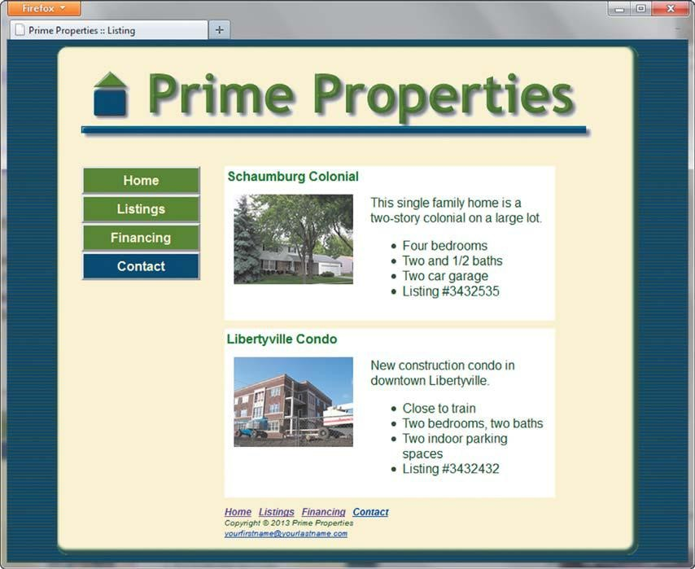
354
Chapter 8 Tables
Figure 8.16 Listings page with tables
Hands-On Practice Case Study
Task 1: Create a Folder. Create a folder called prime8. Copy all the fi les from your
Chapter 6 prime6 folder into the prime8 folder.
Task 2: Configure the CSS. Modify the external style sheet (prime.css). Open prime.css in a text editor. Review Figure 8.16 and note the property listing information, which is coded in two HTML tables. Add style rules to the prime.css external style sheet to confi gure the following:
1.
A table with a background color (#ff ff ff ), 80% width, no border, and a 10 pixel bottom margin
- A th element selector with left-aligned text in a green color (#006600)
- A td element selector that is aligned vertically to the top and has 10 pixels of padding
- No top margin for the paragraphs and h3 elements in the table
Save the prime.css fi le.
Task 3: Modify the Listings Page. Open listings.html in a text editor. The listings information currently uses the <h3> , image, paragraph, and unordered lists elements. You will reconfi gure this area with two tables—one for each real estate listing. Each table will have two rows. Refer to Figure 8.16 . The fi rst row in each table consists of one table
Web Site Case Study
355
cell which spans two columns that contain the real estate listing name. The second row in each table consists of two table cells. The fi rst table cell in this row contains the image (remove the floatleft class from the image element). The second table cell contains the paragraph and unordered list.
Save your page and test it in a browser. If the page does not display as you intended, review your work, validate the CSS, validate the HTML, modify as needed, and test again.
Web Project
See Chapters 5 and 6 for an introduction to the Web Project case study. You will modify the design of one of the pages to display information in an HTML table. Use CSS to style the table.
Hands-On Practice Case Study
1.
Choose one of your project web pages to modify. Sketch a design of the table you plan to create. Decide on borders, background color, padding, alignment, and so on.
- Modify your project’s external CSS fi le (project.css) to confi gure the table (and table cells) as needed.
- Update your chosen web page and add the HTML code for a table.
Save and test the page. Modify both the web page and the project.css fi le as needed.
Test and modify until you have achieved the look you want.
This page intentionally left blank

